|  |
| --- |
| 新东方在线英语学习 |
| 新概念 1 册 |



扫一扫。更多有趣的英语资讯。

##### 讲师介绍

霍娜

新东方教育科技集团优秀教师北京市海淀区优秀教师

##### 课程介绍

1. **课时**：72 课

##### 课程设计：

预习- 单词讲解- 课文讲解- 语法讲解- 单词和重点句型讲解- 知识拓展

##### 学习建议：

听课文录音预习→看视频课程→跟读课文 3-5 遍→完成练习题→看参考译文复述

##### 期待效果：

**语音词汇：**

快速认读单词，学会记单词的科学方法；

##### 基础语法：

能够独立组织正确的句子；

##### 听力口语：

听懂慢速的日常对话，说出简单的句子。

##### 新概念英语第一册霍娜

**Lesson 1&2 预习**

* 1. **发音：th 和 v 的发音，字母 A-F 的自然拼读发音；**
  2. **课文：打扰别人时用的口语句型；**
  3. **语法：一般疑问句**

**Lesson 1 单词讲解**

1. Excuse [ɪkˈskju:s; ɪkˈskju:z] : 原 谅Excuse me.

sk k -->发音变为g

1. 对不起，打扰；
2. 借过，让一让；
3. 失陪, 先走；
4. 麻烦再说一遍。
5. me[miː] 主格 宾格I me

为什么英文会有主格和宾格之分？ 简单句的常用句型结构：

主+ 谓+ 宾

主格 宾格

I me

you you

she her

he him

it it

我爱他。

I love him. 你爱我。

You love me.

1. yes[ jes] [ jɛs] :是的

yes 是的yes? “什么事？”

1. is [ɪz] （be 动词现在时，第三人称单数） be — is，am，are
2. this[ðɪs] : 这

this book: 这本书

that student: 那位学生

1. your [ jɔ:(r)] [ jʊər; jʊr] :你的your friend: 你的朋友your name: 你的名字
2. handbag[‘hæn(d)bæg] : 手提包

hand: 手

bag:包

1. pardon [ˈpɑːdn] ['pɑrdn] 原谅，再说一遍Pardon？
2. it [ɪt] :它

可代替物体、时间、天气

It is a handbag. 它是个手提包。It is 2:00. 现在是两点。

It is sunny today.今天天气晴朗。

1. thank [θæŋk] you: 谢谢你

Thanks! Thanks a lot !

1. very ['verɪ] [ˈvɛrɪ] much: 非常地

I very love you. I love you very much. Very thank you. Thank you very much.

##### Lesson 1 课文讲解

1. Excuse me.
   1. 对不起，打扰了；
   2. 借过一下，让一让；
   3. 失陪了；
   4. 麻烦再说一遍。
2. Yes? 什么事？
3. Is this your handbag? 这是你的手提包吗？
4. Pardon？

麻烦您再说一遍。Sorry？

Excuse me?

Say it again.

##### Lesson 1 语法讲解

**1. 一般疑问句**

功能：询问

构成：be 动词置于句前be—— is，am，are

这是你的名字。 这是你的名字吗？

This is your name. This is your name 吗 ？

Is this your name?

I am great. Am I great?

Are you great?

You are my friend. Are you my friend? She is pretty. Is she pretty?

你是 Sam 吗？ Are you Sam?

这是你的朋友吗？ Is this your friend? 他是老师吗？ Is he a teacher?

##### Lesson 2 单词句型讲解

1. pen [pen] [pɛn]: 钢笔
2. pencil ['pens(ə)l; -sɪl] ['pɛnsl]: 铅 笔felt [fɛlt] pen 水彩笔
3. book [bʊk]: 书a good book a new book

book1，book 2，book 3， book 4

1. watch: [wɒtʃ] [wɑtʃ] :手表a new watch

Swatch

1. coat [kəʊt] : 外 套
2. dress [dres] [drɛs] : 连衣裙
3. skirt [skɜːt] :短裙
4. shirt [ʃɜːt] : 衬 衫

a white shirt， 一件白色的衬衫

1. car [kɑː] [kɑr] : 小 车bus: 公共汽车

coach: 长途客车

1. house [haʊs]: 大房子公寓楼:

flat（ 英 ） apartment（美）

##### Is this your…? 这是你的…吗？

**Lesson 1&2 知识拓展**

自然拼音

A /æ/ hand

B /b/ bag

C /k/ /s/

c+ e, i, y 时，读 /s/

c+ 其他字母时，读 /k/

cat, city, cell phone, cyber name 自然拼音

D /d/ dig

E /e/ egg

F / f/ fat

##### Lesson 3&4 预习

1. **语音：英式和美式发音的异同； 字母 F-J 的自然拼读；**
2. **课文：衣帽存放处取东西的场景；**
3. **语法：否定句**

**Lesson 3 单词讲解**

1. umbrella [ʌm'brelə] [ʌm'brɛlə] n. 雨伞sunshade ['sʌnʃeɪd] 遮阳伞
2. please [pliːz] int. 请invite
3. here 英式[hɪə] 美式[hɪr] adv. 这 里there 那里

where 哪 里

1. my [maɪ] 我 的

我的学校：my school 我的朋友：my friend 你的：your

你的学校：your school 你的朋友：your friend

1. ticket ['tɪkɪt] n. 票

a train ticket: 一张火车票

a movie ticket: 一张电影票

1. number [‘nʌmbə] n. 号码，数字这是几？ What’s the number? 1 号：one number

No. 1

1. five [faɪv] 五
2. sorry ['sɒrɪ] ['sɔri] 对不起
3. sir [sɜː] n. 先 生
4. cloakroom [‘kləʊkruːm ] n. 衣帽存放处，衣帽间a cloakroom ticket 衣帽寄存号码牌

##### Lesson 3 课文讲解

1. My coat and my umbrella, please. 我的外套和雨伞, 请。

请拿一下我的外套和雨伞。

n. + please的适用场景 （你要什么，用名词+please就足够了）

n. + please

* 1. 点餐时 A roast duck , please.
  2. 购物时 This shirt, please.
  3. 检票时 Your ID card, please.

Tickets, please.

1. Here is my ticket. 这里, 是我的票。

My ticket is here. 我的票在这里。

（句子原本样子应该是my ticket is here ，英语很喜欢把这里(here)，那里(there)放句子前头，用于强调的语气

1. Here’s your umbrella and your coat.

这里是你的雨伞和外套。is? (这里你觉得奇怪吗,后跟两个名词为什么还用is ?把here放前头的时候，影响is ,还是are的情况，只跟第一个名字的单复数相关，这就是所谓的就近原则 )

Your umbrella and your coat are here.

你的雨伞和外套在这里。

Here’s your umbrella and your coat.

这里是你的雨伞和外套。

##### Lesson 3 语法讲解

**否定句**

功能：说不

构成：is not/ am not/ are not

这是我的名字。 这不是我的名字。

This is my name. This is not my name. 这不是我的车：This is not my car.

我不是老师：I am not a teacher.

它们不是我的书：They are not my books is not= isn’t

She is not here.= She isn’t here.

am not= ’ m not

I am not Linda.= I’ m not Linda. are not= aren’ t

You are not Tom.= You aren’t Tom.

##### Lesson 4 单词句型讲解

1. suit [sju:t; su:t] 一套衣服
2. school [skuːl] 学 校

小学：primary school

初中：middle school，secondary school 高中：high school

大学：university

1. teacher ['tiːtʃə] n. 老 师

王老师：Mr. Wang/ Miss Wang (国外不喜欢用teacher wang,男士用Mr,女士用Miss)

1. son [sʌn] n. 儿 子
2. daughter['dɔːtə] ['dɔtɚ] n. 女 儿**Is this your…? 这 是 你 的 … 吗 ？ No, it isn’t.**

##### Yes, he is.

**No, she isn’t.**

**Lesson 3&4 知识拓展**

自然拼音

G /g/ gas, get

H /h/ hat, him

I /ɪ/ city, big

J /ʤ/ jet, jelly

K /k/ kill, kiss

L / l / lot, let, girl, small 英文字母何时需要大写？

1. 字母 I 在表示 “我”的时候；

I am a student.我是一个学生。

1. 每句话的首字母；

Hi. This is my friend.你好，这是我的朋友。

1. 姓 & 名首字母

Sam \ Lily\ Venus\ Bush

1. 国家、国籍、城市的首字母

China\ Chinese\ Beijing\ Paris

1. 尊称的首字母

Mr. Lee 李先生Miss Lee 李小姐Mrs. 李太太

##### Lesson 5&6 预习

1. **发音: 字母 M-O 的自然拼读；**
2. **课文：初次见面的问候和介绍；**
3. **语法：冠词**

**Lesson 5 单词讲解**

1. **Mr. [ˈmɪstər] : 先生**

Miss **[mɪs]** 未婚女性Mrs. **[ˈmɪsɪz]** 已婚女性王先生: Mr. Wang

李叔叔: Uncle Li

芙蓉姐姐: Sister Furong

##### good [gʊd] ： 好

well：身体好

##### morning ['mɔːnɪŋ] ：早晨

Good morning. 早上好

##### new [njuː] ：新的

old： 旧 的

##### student ['stjuːd(ə)nt] : 学 生

浊化：

s+ 清辅音，读作浊辅音，比如： sport /p/ /b/

star /t/ /d/

skirt /k/ /g/

##### nice [naɪs]： 美好的

|  |  |  |
| --- | --- | --- |
| bike | kite | fine… |
| take  nose | name  hope… | bate… |
| cute  i-e | tube… |  |
| a-e |  |  |
| o-e… |  |  |

例外：love…

1. **meet [miːt] : 遇 见**meet you\ him\ her… 主格 宾格

I me

you you

he him

she her

##### too [tuː] : 也 （肯定、疑问句末）

I love you, too.

Do you love me, too?

##### France [frɑːns] : 法 国

French [frentʃ] : 法国人、法语、法国的I am in France. 我在法国。

I can speak French. 我会说法语。

##### Germany ['dʒɜːmənɪ] : 德国

German ['dʒɜːmən] : 德国人、德语、德国的This car is from Germany.

这辆车来自于德国。This is a German car. 这是一辆德国车。

1. **Japan [dʒə'pæn] : 日 本**Japanese[ˌdʒæpə'ni:z] : 日本人、日语、日本的I am in Japan. 我在日本。

This is a Japanese dress.

这是日本的服饰。

##### Korea [kə'rɪə] : 韩 国

Korean [kə'riən] : 韩国人、韩语、韩国的

##### China[ˈtʃaɪnə] : 中 国

Chinese [tʃaɪˈniːz] : 中国人、中文、中国的

##### Lesson 5 课文讲解

1. **Good morning. 早上好。**

Morning!

下午见面打招呼：Good afternoon. 晚上见面打招呼: Good evening. 晚上道别时: Good night.

##### 介绍

This is . 这是我的简历。

This is my resume.

Here is my resume.

1. **Nice to meet you.** 见到你很高兴。Great to meet you. Great to see you.

It’s nice to meet you. It’s great to see you.

##### 详细介绍

She is . He is .

姓名、国籍、职业等基本情况

##### Lesson 5 语法讲解

1. **冠词**
   1. **概念：**戴在名词头上的帽子,

没有特殊情况不能摘帽子。

a nice car/ a big house/ a good name

* 1. **包括：**a /an /the
  2. **意思：**a\an 一个、一间、一台、一…… the 这，那，这些，那些

the student 这\那个学生

the students 这\那些学生

##### 分类：

定冠词 the —— 确定的、知道的

不定冠词 a\an —— 不确定的、不知道的There is a monk. 那有一个和尚。

The monk is Jack . 那个和尚叫 Jack .

##### a\an 的区别

an+ 元音发音开头的单词，其余用 a an egg

an orange

an hour

戴在名词头上的帽子, 没有特殊情况不能摘帽子。**特殊情况：**国家（简写）、国籍、人名、城市名。I am from China.

I like Beijing.

She is Japanese.

##### Lesson 6 单词句型讲解

1. **make [meɪk] : 牌 子** What make is ? What make is your car? What make is your hat?

##### Sweden ['swidən] : 瑞 典

Swedish ['swi:dɪʃ] : 瑞典人、瑞典的

##### England [ˈɪŋɡlənd] : 英格兰

English ['ɪŋɡlɪʃ] : 英国人、英语、英国的

##### America [ə'merɪkə] : 美 国

American [əˈmerɪkən] : 美国人、美国的the United States of America

I am in America. 我在美国。

I can speak American English. 我会说美式英语。

##### Italy ['ɪtəlɪ] : 意大利

Italian [ɪˈtælɪən] : 意大利人、意大利语、意大利的I am in Italy. 我在意大利。

He can speak Italian. 他会说意大利语。

##### What make is your car?



**Lesson 5&6 知识拓展**

1. **自然拼音**

Mm /m/ man, milk, monkey, Tim

Nn /n/ not, no, man, town

Oo /D/ ox, orange, olive

##### 西方人的名字

顺序有异男女有别注重发音

##### lesson 7&8 预习

1. **发音：P-R 自然拼读；**
2. **课文：询问工作的口语句型；**
3. **语法：人称代词和 be 动词的搭配。**

**Lesson 7 单词讲解**

1. **I [aɪ] 我** （主格）

**me: 我**（宾格）

I love English. He loves me .

##### 主格 宾格

I me

you you

he him

she her

it it

我爱他。

I love him. 你爱她。

You love her. 他爱我。

He loves me.

她爱你。

She loves you.

##### am [æm] be 动词现在时第一人称单数

be: am /are /is I am…= I’m…

##### are [ɑ:(r) ] be 动词现在时复数

You are…= You’re… We are…= We’re… He is… = He’s… She is… = She’s…

It is… = It’s…

##### be: am /are /is

I _am in Beijing.

He is in Shanghai

They are in New York . Who are you?

What color is your car? His name is Steven Your car is new

My shirts are here. Who is the boy?

What is your car number?

##### name [neɪm] n.名字

my name/ an English name/ a Chinese name

##### what [ wɒt ] 什 么

1. **nationality [ˌnæʃəˈnælətɪ] n. 国籍**

station location

##### job [dʒɒb ] n.工作 (职业)

a good job Good job!

##### keyboard [ˈkiːbɔːd] n.电脑键盘

key: 钥 匙board: 板 子

##### operator ['ɒpəreɪtə] n. 操作人员

-or

director: 导 演

##### engineer [endʒɪ'nɪə] n. 工 程 师

-er

teacher: 老 师

##### Lesson 7 课文讲解

1. I am a new student.

我是一个新学生。

1. My name’s Robert. 我的名字是 Robert.
2. Are you French?

你是一个法国人吗？

1. I’m Italian.

我是一个意大利人。

**冠词：**戴在名词头上的帽子, 没有特殊情况不能摘**。特殊情况：**国家（简写）、国籍、人名、城市名

我是一个中国人。I am Chinese.

他在英国。

He is in England. 我们在北京。

We are in Beijing.

1. **What nationality are you? 你是什么国籍？** 1）那你是什么国籍的呢？

What nationality are you?

2） 我的国籍是…

My nationality is… I’m...

I’m Chinese\ English\ American.

##### What’s your job? 你是干什么工作的？

1）那你是干什么工作的呢？ What’s your job?

2）我的工作是…

My job is…

I’m a teacher\doctor\ student. I have no job. I’m a student.

##### Lesson 7 语法讲解

1. **一般疑问句**

**功能：询问**

**构成：is / am / are 置于句前**

Are you French? You are French. Are you a teacher? You are a teacher. She is a doctor. Is she a doctor?

He is a student. Is he a student?

I am Chinese. Are you Chinese? This is my teacher. Is this your teacher? This is your car. Is this your car?

##### 特殊疑问句

**什么？谁？谁的？哪儿？哪个？… What…**

你的工作是什么？ Your job is what?

##### 特殊疑问词+be+名词(n.)

**What is your job? 你的名字是什么？ What is your name?**

**特殊疑问词+be+名词(n.) 你的国籍是什么？**

**What is your nationality?**

**你的车牌号是什么？**

**What is your car number? 特殊疑问词+be+名词(n.)**

**你的邮箱是？**

**What is your E-mail? 你的微信是？**

**What is your Wechat?**

**My Wechat is Tophuona3…**

**Lesson 8 单词句型讲解**

1. **policeman [pə'liːsmən] : 警 察**

police: 警 方police car: 警 车

##### policewoman [pə'liːswʊmən] 女警察

1. **taxi driver: 出租车司机**

出租车：taxi 的士： cab

##### airhostess ['ɛəhəustis] : 空 姐

air: 空气\ 航空

airline 航线\ 航空公司host: 主 人

##### -ess：表示女性的后缀

host 主人, hostess 女主人

waiter 男服务员, waitress 女服务员actor 演员, actress 女演员

tiger 老虎, tigress 母老虎

##### postman ['pəʊs(t)mən] : 邮递员

post 邮政mailman

E-mail

##### nurse [nɜːs] : 护 士

1. **mechanic [mɪ'kænɪk]：机械师**
2. **hairdresser ['heədresə(r)] : 理发师**
3. **housewife['haʊswaɪf] : 家庭主妇**

house 房 子wife 妻子

##### milkman ['mɪlkmən] : 送牛奶的人

man: 表示人的后缀policeman postman superman

##### Lesson 7&8 知识拓展

自然拼音

Pp /p/ pig, pen, panda, puppy

Qq /kw/ queen, question, quit

Rr /r/ rose, rice, rabbit

##### Lesson 9&10 预习

1. **发音：S-U 自然拼读；**
2. **课文：日常打招呼的用语；**
3. **语法：特殊疑问词 how。**

**Lesson 9 单词讲解**

1. **hello [həˈləʊ] 你好**

hey [heɪ] hi [haɪ]

##### how [haʊ] : 如何，怎样

How are you?

##### today [tə'deɪ] :今天

tonight: 今 晚

##### well [wel] ：身体好

1. **fine [faɪn] ：状况良好**
2. **thanks [θæŋks] : 感 谢**Thanks a lot. 多谢。Thank you very much.

##### good-bye ['gud'bai] : 再 见

1. **see [siː] : 看 见**

See you. 回见。

##### Lesson 9 课文讲解

1. **标题：How are you today?**

How are you doing today?

1. **How are you? 的 回 应 ：** Fine. Thank you, and you? Great. Wonderful!

Not bad.

Very bad. \Terrible.

1. **How are you? 句 型 替 换**How is your uncle? How is Lucy?

How are your father and mother？

##### Lesson 9 语法讲解

1. **特殊疑问词：how**

① 意思：如何，怎样

② 口语句型：How are you?

How to +动词？

How to open/use/do it?

##### Lesson 10 单词句型讲解

* 1. **fat[fæt]: 胖 的 adj.**

a little heavy

##### woman ['wʊmən] : n.女人

lady**['leɪdɪ] 女 士an old woman** an old lady

##### thin [θɪn] : adj. 瘦 的

slim [slɪm] 苗条的

You are so slim. 你好苗条啊！

##### tall [tɔːl]: adj. 高的（人、树、建筑物）

He is very tall.他个子很高。tall buildings 高楼大厦

a tall tree 参天大树

##### dirty ['dɜːtɪ]: adj.脏的

* 1. **clean [kliːn]: adj.干净的**

Nice and clean. 干干净净。

##### hot [hɒt]: adj.热的

It is hot today. 今天天气很热。The girl is very hot. 那女孩性感。

…is hot now. …现在很火。

##### cold [kəʊld] : adj. 冷的，冷漠的

It is very cold today. 今天天气很冷。

I have a cold welcome. 我受到了冷遇。

##### old [əʊld] :adj. 老的、旧的

It is an old story. 这是一个古老的故事。That is my old book. 那是我的旧书**。**

##### young [jʌŋ] : adj. 年轻的

He is a young man. 他是个年轻人。

##### busy['bɪzɪ] : adj. 忙碌的

It is a busy day. 真是忙碌的一天。He is very busy . 他特别的忙。

##### lazy['leɪzɪ] : adj. 懒惰的

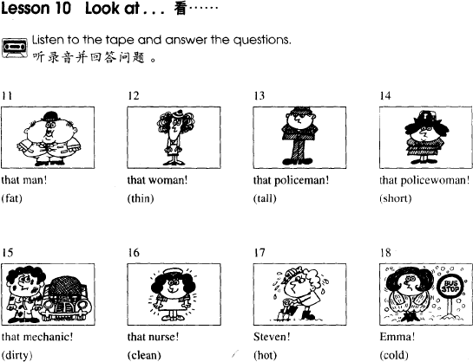

重点句型和词组：

① Look at… 看

meet you\him\her…

look at me\him\her…

② look at & see ， 看 & 看 见

Look at that man. He is very busy.

I see him in the street. 我在街上看见他了。



##### Lesson 9&10 知识拓展

自然拼音

Ss /s/ sad, sit, solid, set

Tt /t/ ten, tap, tip, top

Uu/ʌ/ umbrella, cup, but

##### Lesson 11&12 预习

1. **发音：V-X 自然拼读；**
2. **课文：用 who 寻找东西的主人；**
3. **语法：名词所有格**

**Lesson 11 单词讲解**

1. **whose [huːz] : 谁 的**

whose pen\ whose shirt\ whose car…

##### blue [bluː]: 蓝色

① 忧 郁的 You are blue today.

② 不健康的 It’s a blue movie.

③ 贵 族的 blue blood

1. **perhaps[pəˈhæps] : 大概**Perhaps it is. 可能是这样吧~ Perhaps so.

Perhaps not. 可能不是这样~

##### white[waɪt] : 白 色

the White House 白 宫white lie 善意的谎言

1. **catch [kætʃ] :v. 抓住、接着**catch the thief 抓住小偷catch the ball 接 球

##### Lesson 11 课文讲解

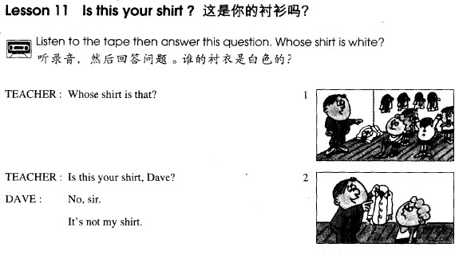

1. **Whose shirt is that? 那是谁的衬衫？**

whose shirt\ whose car\ whose friend…

##### That is whose shirt?

特殊疑问词+ be+ 名词

**Whose is that shirt?**

特殊疑问词+名词+ be+ …

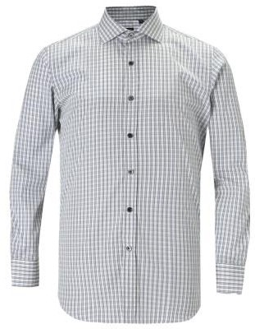

特殊疑问词+ be+ 名词

特殊疑问词+名词+ be+ …

##### whose +名词（不限）

**what+名词（color,make,time,nationality）**

What color is it? 这是什么颜色？

What make is your car?你的车什么牌子的？ What time is it? 几点了？

What nationality are you?你是什么国籍？ 特殊疑问词+ be+ 名词.

特殊疑问词+名词+ be+ … **whose + be + 名 词whose + 名 词 + be+…**

##### Whose is that shirt?那件衬衫是谁的？ Whose shirt is that?那是谁的衬衫？ 这是谁的车？

**Whose is this car? Whose car is this? 那 是 谁 的 包 ？ Whose is that bag? Whose bag is that?**

1. **My shirt’s blue. Is this shirt Tim’s?**

**Tim’s shirt’s white.**

**My shirt is blue. 我的衬衫是蓝色的。Is this shirt Tim’s?这是你的衬衫吗？**

**Tim’s shirt is white.Tim 的衬衫是白色的。**

**Lesson 11 语法讲解**

**1. 谁谁谁 “的”**

我的：my Lucy 的：Lucy’s

你的：your Sam 的：Sam’s

他的：his 王先生的：Mr.Wang’s

她的：her 李叔叔的：Uncle Li’s Lucy 的朋友：Lucy’s friend

Sam 的书：Sam’s book

王先生的包：Mr.Wang’s bag

李叔叔的手表：Uncle Li’s watch 那位女士的车：the lady’s car



##### 周杰伦的女儿 baby 的儿子

**Jay’s daughter Baby’s son 的： 名词+ ’s+名词（有生命）**

**练习：**

① 他的女朋友的新房子。

his girlfriend’s new house

② 她的姐姐的同学。

her sister’s classmate.

##### Lesson 12 单词句型讲解

1. **father ['fɑːðə] : n. 父 亲Dad\ Daddy 爸爸**
2. **mother ['mʌðə] : n.母亲Mom\Mum\ Mummy 妈妈**
3. **blouse ['blaʊz] : n.女式衬衫**
4. **sister ['sɪstə] : 姐姐,妹妹younger sister 妹妹elder sister 姐 姐**
5. **tie [taɪ] : 领 带**
6. **brother ['brʌðə] : 哥哥,弟弟younger brother 弟 弟elder sister 哥哥兄**
7. **his [hɪz] : 他 的**
8. **her [hɜː] : 她 的**

|  |  |
| --- | --- |
| **物主代词** | **形容词性** |
| **我的** | **my** |

|  |  |
| --- | --- |
| **你的** | **your** |
| **他的** | **his** |
| **她的** | **her** |

**我的书：my book**

**你的房子：your house 他的领带：his tie**

**她的裙子：her dress**

**他的朋友：his friend**

|  |  |
| --- | --- |
| **物主代词** | **形容词性** |
| **我的** | **my** |
| **你的** | **your** |
| **他的** | **his** |
| **她的** | **her** |

**练习：**

**① 她妹妹是他的女朋友。**

**Her sister is his girlfriend.**

**② 他太太是她的好朋友。**

**His wife is her good friend.**

**③ 他哥哥是她的老板。**

**His brother is her boss. 这是她男朋友的手表。**

This is she boyfriend’s watch. This is she’s boyfriend’s watch. This is her boyfriend’s watch.

##### Whose is this handbag?

**Whose handbag is this? It’s Stella’s.**

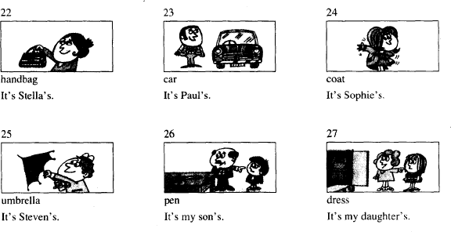

**Lesson 11&12 知识拓展自然拼音**

**Vv /v/ very, vivid, voice, five**

**Ww /w/ wet, witch,wave, what**

**Xx/ks/ fox, box, exit Lesson 11&12 知识拓展**

**看电影学英语的方法：**

* 1. **选片：**
  2. **字幕：**
  3. **数量；**
  4. **辅助。**

**Lesson 13&14 预习**

1. **发音：Y-Z 自然拼读，复习；**
2. **课文：询问颜色；**
3. **语法：特殊疑问句**

**Lesson 13 单词讲解**

1. **color \ colour ['kʌlə(r)] : 颜 色**

What color? What color is it?

What color is your ? What color is your car?

##### What+ 名词（make, time, nationality）

What nationality are you? 你是什么国籍？ What make is your car? 你的车什么牌子的？ What time is it? 几点了？

##### green[griːn] : 绿 色

green tea 绿 茶

a green hand 新 手

##### come [kʌm] ： 来

Come here. 过 来

1. **upstairs [ʌp'steəz] ：楼上**Come upstairs. 上 楼 来Go downstairs. 下 楼 去

##### smart [smɑːt] [smɑrt] : 时髦的，漂亮的

beautiful \ smart

##### hat [hæt] : 帽 子cap[kæp] hood[hʊd]

1. **same [seɪm] : 相同的**

the same color \ name \ city … They have the same name.

##### lovely ['lʌvlɪ] : 可爱的，漂亮的

beautiful \ smart \ lovely \ nice

##### Lesson 13 课文讲解

1. **What color is your ?**
2. **Come and see it.**

Come and meet my Mom. Come and sit down. … Come and do it.

##### Here it is. = It is here.

**Here + 主语+ be**

我在这。I am here. =Here I am. 他在这。He is here.= Here he is. 咱开始吧。 Here we go. …

##### 漂亮 \ 好看

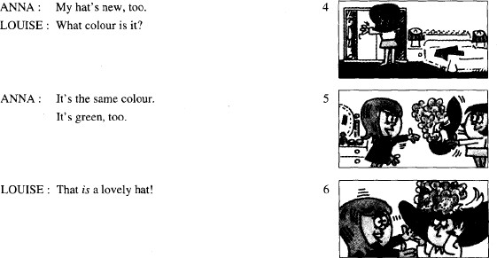**beautiful smart lovely nice…**

**be cuckold [**'**kʌk(ə)ld] 被戴绿帽子**

**Lesson 13 语法讲解**

**特殊疑问句**

1. **特殊疑问词：**

**what, whose, how…**

1. **语序：**

**特殊疑问词+ be+ 名词**

**特殊疑问词+名词+ be+ …**

what+ be+ 名 词what+ 名词+ be

##### 2. 语序：

**what+ be+ 名 词what+ 名 词 + be** What is your name? What is your job?

What color/time/make/nationality is ?

##### 2. 语序：

**whose+ be+ 名 词whose+ 名 词 + be** Whose is this shirt?= Whose shirt is this? Whose is that phone?= Whose phone is that?

##### 2. 语序：

**how+ be+ 名 词**

How are you? How is Sam?

How is the weather?

##### Lesson 14 单词句型讲解

1. **case [keɪs] : 箱 子**

suitcase 手提箱

##### carpet ['kɑːpɪt] ['kɑrpɪt] : 地 毯

car 汽 车 + pet 宠 物 = 地 毯

1. **dog [dɒg] :狗**puppy['pʌpɪ] 小 狗pup [pʌp]

a lucky dog 幸运儿**What color is your ?** umbrella

car shirt coat

case, carpet, blouse, tie …

##### Lesson 13&14 知识拓展

自然拼音

Yy / j / yes, yoyo, yellow, yet

/ ɪ / happy, lovely, cloudy

Zz / z /] zip, zero, zigzag, zebra Aa /æ/ hand, cat, ax

Bb /b/ bag, bet, lab Cc /k/ /s/

c+ e, i, y 时，读 /s/

c+ 其他字母时，读 /k/

cat, city, cell phone, cyber name

Dd /d/ dig, dad, desk

Ee /e/ egg, elephant

Ff / f/ fat, frog, staff

Gg /g/ gas, get, goat

Hh/h/ hat, him, house

Ii /ɪ/ city, big, silly

**Jj/ʤ/ j**et, **j**elly, **j**og

**Kk /k/ k**ill, **k**iss, **k**ick

**Ll / l / l**ot, **l**et, gir**l**, sma**ll Mm /m/ m**an, **m**ilk, Ti**m**

**Nn /n/ n**ot, **n**o, ma**n**, tow**n**

**Oo /D/ o**x, **o**range, **o**live

p /p/ pig, pen, panda, puppy Qq /kw/ queen, question, quit Rr /r/ rose, rice, rabbit

Ss /s/ sad, same, bus, first

Tt /t/ Tom, top, tea, it

Uu /ʌ/ cup, but, cut

**Vv /v/ v**ery, **v**i**v**id, **v**oice, fi**v**e

**Ww /w/ w**et, **w**itch**,w**ave**, w**hat

**Xx /ks/** fo**x,** bo**x,** exi**t**

**Yy / j / y**es, **y**o**y**o, **y**ellow, **y**et

**/ ɪ /** happ**y**, lovel**y**, cloud**y**

**Zz / z / zip**, **z**ero, **z**igzag, **z**ebra

##### Lesson 15&16 预习

1. **发音：字母组合-1 的发音；**
2. **课文：海关场景词汇及句型；**
3. **语法：名词变复数。**

**Lesson 15 单词讲解**

1. **customs ['kʌstəmz] : 海关**

customer ['kʌstəmə] 顾 客

##### officer ['ɔfɪsɚ] : 官 员

customs officer 海关官员

CEO 首席执行官 Chief Executive Officer

##### girl [gɜːl] : 女孩

my girl my boy

##### Danish ['deɪnɪʃ] ['denɪʃ] : 丹麦人、丹麦的

Denmark ['denma:k] 丹 麦Chinese& China

##### friend [frend] : 朋 友

boyfriend\ girlfriend\ a good friend\ a new friend\ an old friend…

##### Norwegian [nɔ:'wi:dʒən]: 挪威人

Norway ['nɔ:weɪ]: 挪 威

Chinese& China

##### passport 英['pɑːspɔːt] 美['pæspɔrt] 护照

pass 通过 port 港口

##### visa ['vizə] 签证

1. **brown: 棕色的**

红茶 brown tea

红糖 brown sugar

##### tourist: 旅游者

|  |  |  |
| --- | --- | --- |
| -ist | dentist | artist scientist… |
| -er | teacher | worker driver… |
| -or | doctor | director… |

**Lesson 15 课文讲解**

1. **Your passports, please. 请出示您的护照。**

n.+ please.

① 点餐时：A roast duck , please.

② 购物时：This shirt, please.

③ 检票时：Your ID card, please.

##### We are Danish. 我们是丹麦人。

They are Norwegian. 他们的是丹挪威人。我 I am 我们 we are

你 you are 你们 you are

他 he is 他们 they are

她 she is 她们 they are

##### 这些是你们的箱子吗？ Are these your cases?

1. **我们的箱子是棕色的。Our cases are brown.**

**复数关乎整个句子，而非一个单词~ 这是我的书。**

This is my book.

##### 这些是我们的书。

These are our books.

##### 那是她的车。

That is her car.

##### 那些是他们的车。

Those are their cars.

##### 我们的 our +单数或者复数他们的 their+单数或者复数our books\ their cars

**our mum\ school… their teacher\ house… 我们的教室很大。**

Our classroom is large.

##### 他们的车是蓝色的。

Their car is blue.

##### 我们的书都在这。

Our books are here.

##### 他们的外套都是蓝色的。

Their coats are blue.

##### Here they are. 给 你

They are here. 他们在这。

##### That’s fine.

**就这样吧！ 行啦！了！**

护照：passport 现金：cash

机票：return ticket

在美国的住址：the address in America 去干吗？What’s your purpose of visit? 去旅游：For sightseeing/study.

##### Lesson 15 语法讲解

1. **名词的单数&复数**

单数：1

复数：2 或以上a car- two cars

a bag- three bags 名 词 n.！

##### 单数-复数的规则

**①一般的名词+s**

a girl—girls

an officer—officers a coat—coats

a boy—boys

##### ②以 s、sh、x、ch 结尾的+es/iz/

a bus—buses a box—boxes

a brush—brushes(刷子)

##### ③以 f、fe 结尾的变 f,fe – ves\vz\

a wife—wives

a shelf—shelves

a knife—knives（小刀） a leaf—leaves（树叶）

##### ④ 土豆、西红柿、黑人、英雄+ es\z\

a potato- potatoes a tomato- tomatoes a Negro- Negroes

a hero- heroes

##### ④ 其他+ s \z\

a zoo—zoos

a radio—radios a photo- photos

##### ⑤ 辅音字母+y 结尾的名词，变 y-i+ es\iz\

a baby—babies a lady—ladies a fly— flies

##### 单数-复数名词在句子中单数+ is

**复数+ are**

The tourists are from Norway. The teacher is American.

These cars are brown. My students are young.

##### 通常以复数形式出现的词：

jeans pants shorts glasses

##### 单数+ is

**复数+ are**

My pants black . Her glasses broken. The umbrella brown. The ladies young.

##### Lesson 16 单词句型讲解

1. **Russian ['rʌʃən] : 俄罗斯人**Russia ['rʌʃə] 俄罗斯Chinese& China
2. **Dutch [dʌtʃ] : 荷兰人**Holland['hɒlənd] Netherland

##### these [ðiːz] : 这 些

this 这个- these 这些that 那个- those 那些这是他的手表。

This is his watch.

这些是他们的手表。These are their watches

##### red [red] : 红色的

red lights

##### grey [greɪ] : 灰色的

gray

grey hair 花白的头发

1. **black [blæk] : 黑色的**black tea 红 茶black coffee 纯咖啡black man 黑 人

##### yellow ['jeləʊ] : 黄色的

1. **orange ['ɔrɪndʒ] : 橘黄色的**

**Lesson 15&16 知识拓展**

**字母组合-1**

**\ i: \ \ ɪ \**

**\ ə: \ \ ə \**

**\ a : \ \ ʌ \ Phonics**

**\ i: \ ea \ i: \**

**\ i: \ ea Tea \ t i: \**

**Clean \ kli:n\ Eat \ i: t\**

**一辅一元，**

**前辅后元。ee \ i: \**

**\ i: \ ee**

**Beef \bi:f\ Feet \fi:t\ Sleep \sli:p\ Meet \mi:t\ I i \ɪ\**

**\ i: \ \ ɪ \**

**Deed \di:d\ Did \dɪd\ Seat \si:t\ Sit \s ɪ t\ Beach \bi:…\ Bitch \b ɪ …\ Seek \si:k\ sick \s ɪ k\**

**Deal \di:l\ dill \d ɪ l\**

**Heat \hi:t\ hit \h ɪ t\**

**\ ə: \**

**\ ə \**

**\ ə: \ ir**

**Sir \s ə: \ bird \b ə: d\ Firm \f ə: m\ girl \g ə: l\**

**\ ə \ er**

**Dancer \ꞌdænsə\ cleaner \kli:nə \**

**Sister \ꞌ sɪstə \ summer \ꞌ sʌmə\**

**\ a :\**

**\ a : \ ar**

**Hard \ha:d\ mark \ma:k\ Farm \fa:m\ bar \ba:\**

**\ a : \ \ ʌ \**

**Cart \ca:t\ cut \k ʌ t\ Barge \ba:ʤ\ budge \bʌʤ\ R i c k \r ɪ k\**

**D i r t y \də:t\**

**B e a t \bi:t\**

**\ i: \ ee，ea \ ɪ \**

**\ ə: \ ir \ ə \ er**

**\ a : \ ar \ ʌ \**

**Lesson 17&18 预习**

1. **发音：字母组合的发音；**
2. **课文：特殊疑问句&单复数**
3. **语法：句子中的单复数匹配。**

**Lesson 17 单词讲解1.employee [ɪmplɔɪˈi:] : 雇员**

employ 雇用

employer 雇佣者，雇主

-er …的人

-ee 被…的人

trainer 培训者，trainee 被培训的人

##### hard-working [ˈhɑːdˈwɜːkɪŋ] ：勤奋的

构 词 ：adj.+ doing good-looking 好看的easy-going 好相处的

##### sales rep：推销员

复数：sales reps

全称：sales r*e*presentative（销售代表）

##### man [mæn] : 人，男人

Hi, man! 哥们最近好啊！ 复数：men

##### office ['ɔfɪs] : 办公室

office buildings 办公大楼office hours 办公时间

##### assistant [ə'sɪst(ə)nt] : 助 手

an office assistant 办公室助理a shop assistant 商场售货员

a classroom assistant 助 教

##### Lesson 17 课文讲解

1. **打招呼：**

Hello, Hi, Hey How are you?

How are you doing?

##### How do you do?

**幸会，使用场合非常正式**

**回 答 —— How do you do!**

1. **Come and meet our employees.**

过来坐吧：Come and sit down.

过来喝一杯：Come and have a drink. 过来见见我的朋友：

Come and meet my friend.

##### What are their jobs? What is your job? 句子的复数:

名词、代词、动词

##### This is my name. These are their names.

**That is her car. Those are our cars.**

**He is an assistant.**

**They are assistants.**

**Who is the young girl? Who are the young girls?**

**What is your job? What are their jobs?**

**He is a tourist. They are tourists.**

**4**

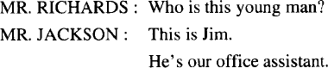

who 特殊疑问词，谁特殊疑问词+ be+ 名词

特殊疑问词+名词+ be+ …

who 特殊疑问词，谁特殊疑问词+ be+ 名词这人是谁？

Who is this man？ 这些人是谁？

Who are these men?

who 特殊疑问词，谁特殊疑问词+ be+ 名词那个年轻人是谁？

Who is that young man? 那些年轻人是谁？

Who are those young men?

##### Lesson 17 语法讲解

1. **名词的单复数**

**① 规则：**

books jobs

buses, boxes, brushes, benches, potatoes wife-wives, leaf-leaves

baby-babies

##### ②不规则:

man-men, woman-women foot-feet, tooth-teeth

child-children

单复同形：sheep-sheep, fish-fish

##### 句子的复数

**单数名词+ is… 复数名词+ are…**

Her feet are here.

The men are keyboard operators. This assistant is busy.

The children are in the classroom. My hair is black .

##### 2. 句子的复数

**单数名词+ is… 复数名词+ are…**

My tooth are hurt. My tooth **is** hurt.

The ladies is pretty. The ladies **are** pretty

These child is busy. This child **is** busy.

##### 句子的复数

**单数名词+ is… 复数名词+ are…**

There is three fish. There **are** three fish.

This is his wives. This is his **wife**.

##### Lesson 18 单词句型讲解

**What are their jobs? 他们的工作是什么？ They are… 他们是…**

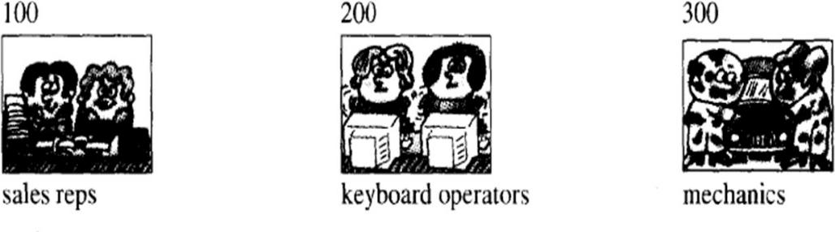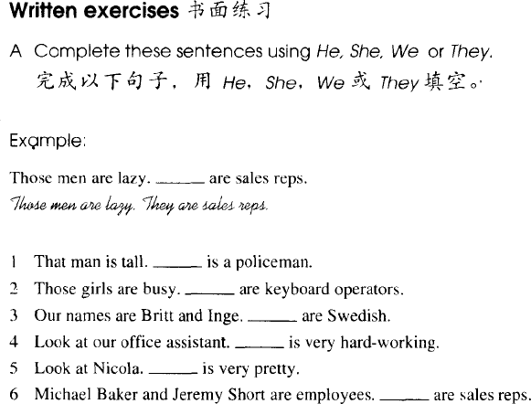

**Lesson 17&18 知识拓展**

**西方人的姓氏来源**

* 1. **西方人先有名还是先有姓？**
  2. **西方人姓氏来源：**

职业： Taylor(裁缝)，Baker(面包师)… 颜色： White(白色)，Brown(棕色)… 生活：Bird(鸟)，Rice(大米)…

住址：Bridge(桥)，Hill(山)…

名字+son: Peterson, Johnson, Jackson…

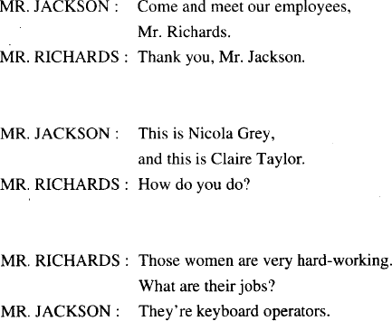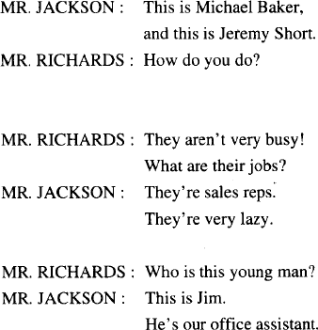

##### 字母组合-2

**\** ɔ **: \ aw \** ɔ **: \**

##### \ ɔ : \ aw

**Law \l** ɔ **:\ raw \r** ɔ **:\**

**Paw \p** ɔ **:\ saw \s** ɔ **:\ au \** ɔ **: \**

**\ ɔ : \ au**

**Daughter \'d ɔ : tə\ ght \t\**

**bought fight brought right**

**\ ɔ : \ au**

**Daughter \'d ɔ : tə\ Saucer \s ɔ : sə\**

**\ ɔ : \ \ D \**

**\ ʊ \**

**\ ʊ \ oo（k\d）**

**Look \l ʊ k\ book \b ʊ k\ Good \g ʊ d\ wood \w ʊ d\**

**\ u : \**

**\ u : \ oo (t)**

**Tooth \t u : θ \ boot\b u : t \ Shoot \ʃ u : t\ loot \l u : t \**

**\ e \**

**\ e \ ea**

**Head \hed\ bread \bred\ Weather \'w eðə\ dead \ded\ ea \ e \**



**\ i: \ aw,au\ ɔ: \**

**oo \ ʊ \**

**oo \ u :\**

**ea \ e \**

**Lesson 19&20 预习**

1. **发音：字母组合-3 发音；**
2. **课文：又…又…**
3. **语法：单复数匹配。**

**Lesson 19 单词讲解**

1. **matter ['mætə(r)] : n. 事 情**

What’s matter? What’s the matter?

##### children ['tʃɪldrən] : 孩子们child 孩 子

**kid- kids**

1. **tired['taɪəd]: adj. 累，疲乏**

I am tired.

Are you tired?

I am not tired.

##### boy [bɔɪ] : n. 男 孩

1. **thirsty ['θɜːsti] : adj. 口渴的He’s thirsty.**
2. **Mum [mʌm] : 妈 妈**Mom( 美 ), mummy, mommy

##### sit down ['sɪtˌdaʊn] : 坐 下

Sit down, please. Have a seat.

##### right [raɪt] : 好，可以

All right.

##### ice cream [aɪs kriːm] : 冰激凌

ice creams



##### cream [kriːm] : 霜

eye cream face cream body cream

面霜 眼霜 身体乳



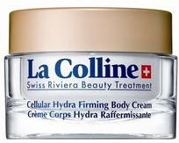

##### Lesson 19 课文讲解

1. **Tired and thirsty. 又累又渴**

beautiful and kind 美丽又善良tall and handsome 又高又帅young and rich 又年轻又富有tall, rich and handsome 高富帅

##### What’s the matter, children?

**孩子们怎么了？**

* + What’s up?
  + What’s wrong?
  + What’s wrong with you?

##### Are you all right now? 你们好点没?

all right=ok

Are you ok now?

Let’s go and buy some ice creams. All right.= OK.

1. **There’s an ice cream man. 那有一个卖冰激凌的人。**There be(is\ are) 句 型

快递员：mailman

送牛奶的人：milkman 渔夫：fisherman

雪人：snowman

##### Two ice creams, please. 买两个冰激凌。

**n. + please**

1. **These ice creams are nice. 这些冰激凌真好吃。**

这个冰激凌真好吃。This ice cream is nice.

##### Lesson 19 语法讲解

**1. 单复数概念在句子中的使用：**

Those children are tired. We are thirsty.

This child is very young. What color is your car?

How are your Dad and Mum?

Whose are those dresses?

Are your shoes white?

**The\These\Those** children are tired.

**Their\Our\Her\His\My** mother is busy.

**My\Your\Our\Their\Her** friends are tall.

**My\Your\His\Her** brother is a taxi driver.

##### Lesson 20 单词句型讲解

1. **big [bɪɡ]: 大 的**

风大、雨大、雪大：heavy 声音大：loud

年纪大：old

面积大：large

##### small [smɔːl] : 小 的

小雨：light rain 声 音 小 : quiet 年纪小：young 面积小：small

##### open ['əʊpən] : 开着的

The door is open.

##### shut [ʃʌt] : 关着的

The window is shut. The window is closed.

##### light [laɪt] : 轻 的

1. **heavy ['hevi] : 重 的**
2. **long[lɒŋ]: 长 的**

时间、东西 a long time a long knife

##### shoe [ʃuː] : 鞋

a shoe: 一只鞋

a pair of shoes: 一双鞋我的鞋脏了。

My shoes are dirty.

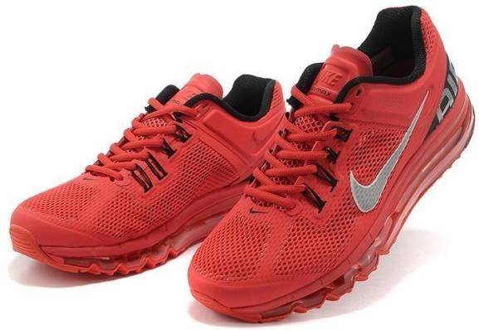

##### grandfather ['ɡrænfɑːðə(r)] : 祖父、外祖父

1. **grandmother ['ɡrænmʌðə(r)] : 祖母、外祖母**

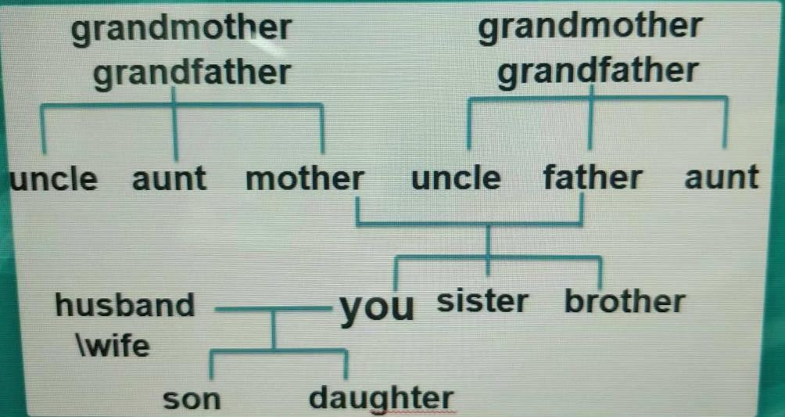

**① in- law ：结婚后的亲属关系**

mother in-law father in-law sister in- law brother in- law

##### ② ex- ：前任的

ex-girlfriend ex-boyfriend ex-wife

ex-husband

**③ step ：后的，继的**step mother step father step sister

step brother

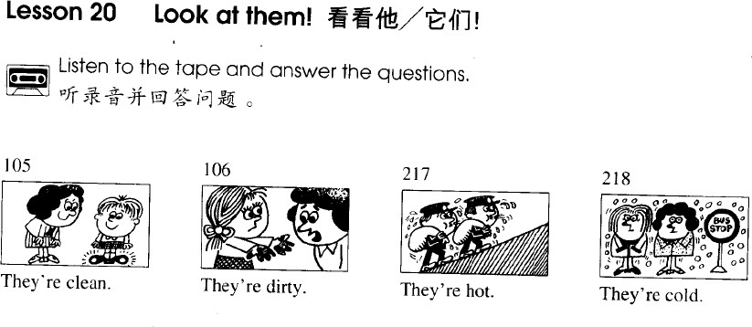

##### Lesson 19&20 知识拓展

**are is**

### are：第二人称，复数is：单数

**am：I**

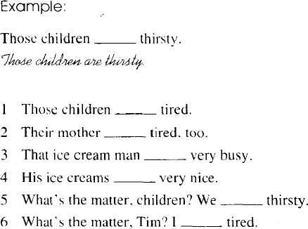

**is**

**are**

**am**

**are**

##### Lesson 19&20 知识拓展

**字母组合-3**

**\ eɪ \**

**\ aɪ \**

**\ əʊ \**

**\ eɪ \**

**a-e \eɪ\**

**\eɪ\ a-e Take \teɪk\ 元 + 辅 + e**

**元音字母发自己的本音，**

**e 不发音~**

**a-e e-e i-e o-e u-e take these like hope cute**

**\eɪ\ a-e**

**Take \teɪk\ name \ neɪm \**

**Late \leɪt\ face \ feɪks\**

**\eɪ\ a-e**

**Table plane shave ge \ ʤ \**

**page fridge stage judge**

**ay \eɪ\**

**\eɪ\ ay**

**Day \deɪ \ way \ weɪ \ Pray \pr eɪ \ say \s eɪ \ ey \eɪ\**

**\eɪ\ ey**

**Grey \gr eɪ \ they \ ð eɪ \ Hey \h eɪ \ ley \l eɪ \**

**例外:**

**key, monkey \ i:\**



**\eɪ\ a-e**

**ay ey**

**\ aɪ \**

**i-e \ aɪ \**

**\ aɪ \ i-e**

**Bike \b aɪ k\ nice \n aɪ s\ Kite \k aɪ t\ fine \f aɪ n\**

**\ aɪ \ i-e White \w aɪ t\ wh- \w\ \h\ what, why who, whole**

**\ aɪ \ i-e**

**White \w aɪ t\ smile \sm aɪ l\ Slide \sl aɪ d\ crime \kr aɪ m\ ie \ aɪ \**

**\ aɪ \ ie**

**Tie \t aɪ \ lie \l aɪ \ Pie \p aɪ \ die \d aɪ \**

**\ əʊ \**

**o-e\ əʊ \**

**\ əʊ \ o-e**

**Note \nəʊ t\ hope \h əʊ p\ Wrote \r əʊ t\ phone \f əʊ n\ Ph \f\**

**Photo phrase Graph physical oa \ əʊ \**

**\ əʊ \ oa**

**Boat \b əʊ t\ goat \g əʊ t\ Coat \k əʊ t\ float\fl əʊ t\ ow \ əʊ \**

**\ əʊ \ o-w**

**Yellow \'jeləʊ \ follow \'fɒl əʊ\ Slow \sl əʊ \ window\'wɪnd əʊ\**

**\ eɪ \**

**\ aɪ \**

**\ əʊ \**

* 1. **ay ey \ eɪ \ i-e ie \ aɪ \**

**ow oa \ əʊ \**

**微信公众号：和娜娜老师学英语**

**Lesson 21&22 预习**

* + 1. **发音：字母组合-4 发音；**
    2. **课文：one**
    3. **语法：简单句，特殊疑问词 which**

**Lesson 21 单词讲解**

1. **give [ɡɪv] : 给**

give me\ her\ him\ them\ us… 把那本书给我。

Give me the book.

##### one [wʌn] : 一个 pron.(代词)

the blue one= the blue coat/dress… the short one= the short girl/pencil… I like the cheap one.

我喜欢便宜的那个。

1. **which [wɪtʃ] ：哪一个,哪一些**Which book? 哪 本 书 ？ Which books? 哪 些 书 ？ Which tourist? 哪位游客？ Which tourists? 哪些游客？

##### 3. which：哪一个,哪一些

哪本书好？

Which book is good?

哪些游客来自于北京？

Which tourists are from Beijing?

##### Lesson 21 课文讲解

1. **You give me a book.**

**主 谓 宾 宾**

|  |  |  |
| --- | --- | --- |
| I | meet | him. |
| 主 | 谓 | 宾 |

1. **This one? 这本吗？**

=This book?

##### Not that one.不是那本。

= Not that book.

##### The red one. 红色那本。

= The red book.

##### Lesson 21 语法讲解

1. **特殊疑问词：which what/how/whose**

**特殊疑问词+ be+ 名词**

**特殊疑问词+名词+ be+ … 特殊疑问词+ be+ 名词**

**特殊疑问词+名词+ be+ …**

**Which is your car? 哪一辆是你的车？ Which car is yours? 哪一辆车是你的？ 特殊疑问词+ be+ 名词**

**特殊疑问词+名词+ be+ … 哪一本是你的书？**

**Which is your book?**

**Which book is yours?**

1. **简单句的句型结构：**

①. 主 + 谓

②. 主 + 谓 + 宾

③. 主 + 谓 + 宾 + 宾

④. 主+ 谓+ 宾+ 宾补

⑤. 主 + 系 + 表

##### Lesson 22 单词句型讲解

* 1. **empty ['empti] : 空 的**An street 空 荡 的 街An house 寂 静 的 夜

A hole inside my heart 没有你在身边

I’m all alone and the rooms are

getting smaller 心里面对你的思念一遍一遍

##### full [fʊl] : 满 的

I’m full.

我饱了。

a full stop 句 号

a full time job 一份全职工作a part time job 一份兼职工作

##### large [lɑːdʒ] [lɑːrdʒ] : 大的（强调面积）

China is a large country.

中国是一个幅员辽阔的国家。This room is large.

这房间很大。

##### little ['lɪtl] ：小的

a little girl 一个（可爱的）小女孩a small girl 一个体型很小的女孩

##### sharp [ʃɑːp] ：锋利的

The knife is sharp. Cats have sharp claws

##### blunt [blʌnt] ：钝的

The knife is blunt. 这刀很钝。

My pencil is blunt. 我的铅笔很钝。

##### small[smɔːl]：小的

Small world…

世界真小，又见面了。

##### big [bɪɡ] ：大的（体积）

* 1. **box [bɒks] ：盒子，箱子**

a small box a big box

##### glass [ɡlɑːs] [ɡlæs] ：玻璃杯子

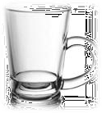

* 1. **cup [kʌp] ：茶杯**

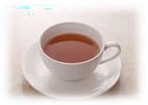

* 1. **bottle ['bɒtl] ：瓶子**

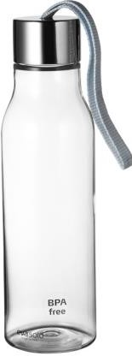

* 1. **tin[tɪn]：罐头瓶、易拉罐**



* 1. **knife [naɪf] ：刀子**
  2. **fork [fɔːk] ：叉子**
  3. **spoon [spuːn] ：勺子**

chopsticks['tʃɒpstɪks] 筷 子

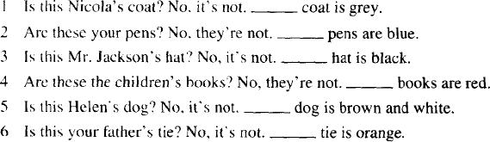

##### Lesson 21&22 知识拓展

1. **中西方人不同的餐饮工具**
   1. 中国：碗+筷，bowls and chopsticks
   2. 西方：刀+叉, knives and forks

##### 字母组合-4

**Phonics**

**\ aʊ \**

**\ ɔɪ \**

**\ ɪə \ Phonics：\ aʊ \ Ao**



**Hao lao nao**

**你好 老师 脑袋ow \ aʊ \**

**\ aʊ \ ow**

**Now \n aʊ \ how \h aʊ \ Cow \k aʊ \ allow \ə' laʊ \ ou \aʊ\**

**\aʊ\ ou**

**House \haʊs\ blouse \blaʊz \ Ow \ əʊ \**



**\ aʊ \**

**\ ɔɪ \ oy \ɔɪ\**

**\ ɔɪ \ oy**

**Toy \t ɔɪ \ boy \b ɔɪ \**

**Joy \ dʒ ɔɪ \ oyster \ 'ɔɪ stə \**

**\ ɔɪ \ oi**

**Oil \ ɔɪ l\ coin \kɔɪn\ Moist \mɔɪst\**

**\ ɪə \ 注意:**

**\ ɪə \ \ ɪr \**

**ear \ ɪə \**

**\ ɪə \ ear**

**Dear \dɪə \ near \nɪə \ Fear \fɪə \ hear \ hɪə \ 例外:**

**early, earth, earn**

**\ə:\ \ɜː\**

**\ ɪə \ eer**

**Deer \d ɪə \ beer \bɪə \ Steer \stɪə \ jeer \ dʒɪə \**

|  |  |  |
| --- | --- | --- |
| **ow** | **ou** | **\ aʊ \** |
| **ear** | **eer** | **\ ɪə \** |
| **oy** | **oi** | **\ ɔɪ \** |

**微信公众号：**

**和娜娜老师学英语**

**Lesson 23&24 预习**

1. **发音：字母组合-5，元音复习；**
2. **课文：ones，后置定语**
3. **语法：介词**

**Lesson 23 单词讲解**

1. **on [ɒn]英式, [ɑːn] 美式: prep. 在…之上on the table**

**on the floor**

1. **shelf [ʃelf] : 架子、隔板shelves**

**Lesson 23 课文讲解**

1. **Which glasses?**

**哪几个、哪些杯子？**

which + 单数名词，表示哪个which + 复数名词，表示哪些

##### Give me some glasses.

**给我一些玻璃杯。**

**some [səm] : 一些 +复数名词**

some books

some cups

some boxes

some knives…

##### The ones on the shelf.

**one- ones**

I like the red coat.

I like the red one.

I like the red coats.

I like the red ones.

##### The ones on the shelf. 那些在架子上。Ｘ 架子上的那些。

the ones on the shelf

介词短语

##### 介词短语后置，倒着翻译！

the book on the desk 书桌上的那本书

the cup on the table 桌上的那个杯子

the knife in the box 盒子里的那把刀

the man in the room 房间里的那人

地板上的那些鞋：

the shoes on the floor 沙发上的那位女士

the lady on the sofa

##### Lesson 23 语法讲解

1. **介词 prep.**

**介词：媒婆，连接两个词或词与句子。媒婆：on(在…上面)**

**The book on the desk.**

**句子？ 短语！**

**The book is on the desk.**

**句子中使用介词时，别忘记动词！ I sit on the floor.**

**There is a shoe on the floor.**

**那个玻璃杯在桌上。**

**The glass is on the table. the glass on the table:**

**桌上的那个玻璃杯**

**那把勺子在盘子上。**

**The spoon is on the plate.**

**the spoon on the plate：盘子上那把勺子那个瓶子在盒子上。**

**The bottle is on the box.**

**the bottle on the box: 盒子上那个瓶子**

**介词 prep.**

**介词：媒婆，连接两个词或词与句子。媒婆：**

**on (在…上面) in (在…里面)**

**句子中使用介词时，别忘记动词！**

**Lesson 24 单词句型讲解**

* 1. **desk [desk] : 课 桌**
  2. **table ['teɪbl] : 桌 子**

a bed table\ a tea table

##### plate [pleɪt] : 盘 子

* 1. **cupboard ['kʌbəd] : 食 厨**
  2. **cigarette [ˌsɪɡə'ret] : 香 烟**
  3. **television ['telɪvɪʒn] : 电视机**

TV

##### floor [flɔː(r)] : 地 板

It’s on the floor.

##### dressing table: 梳妆台

* 1. **magazine [ˌmæɡə'ziːn] : 杂 志**
  2. **bed [bed] : 床**
  3. **newspaper ['njuːzpeɪpə(r)] : 报 纸**

news 新 闻paper 纸 张

##### stereo ['steriəʊ] : 立体声音响

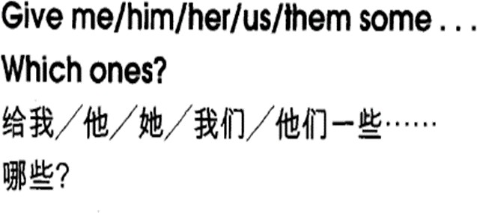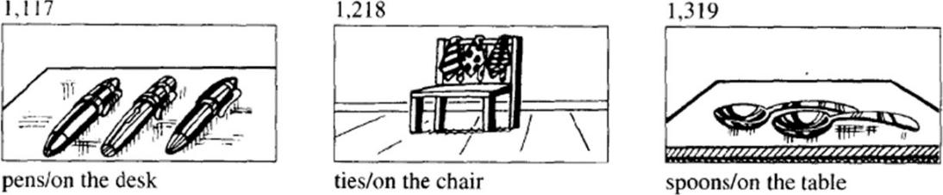

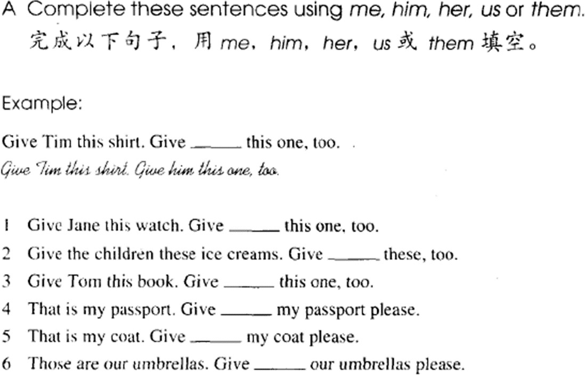

**Lesson 23&24 知识拓展**

**字母组合-5**

**Phonics**

**\ eə \ 注意:**

**\ eə \ \ er \ \ɛə\ Phonics**

**air \ eə \**

**\ eə \ air**

**air \ eə \ fair \ feə \ hair \ heə \ pair \ peə \**

**\ eə \ ear**

**wear \ weə \ rear \ reə \ pear \ peə \ fear \ feə \**

**\ ɪə \**



**ear \ eə \**

**\ ə: \**

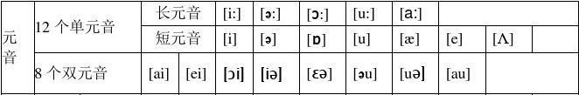

**\ i: \ ee，ea**

**\ ə: \ ir**

**\ a : \ ar**

**\ ə \ er**

**\ ɔ : \ aw,au**

**\ ʊ \ oo**

**\ u : \ oo**

**\ e \ ea**

**\ ɔ: \ aw,au**

**\ ʊ \ oo**

**\ u :\ oo**

**\ e \ ea**

**\ eɪ \ a-e ay ey**

**\ aɪ \ i-e ie**

**\ əʊ \ ow oa**

**\ aʊ \ ow ou**

**\ ɪə \ ear eer**

**\ ɔɪ \ oy oi**

**Practice:**

**saucer \‘sɔ: sə\ head \ h e d \ float \ fləʊt \ grey \ greɪ \**

**practice**

**barge \ ba : ʤ\ sweet \ swi:t \ wood \ wʊd \ moist \ mɔɪst \**

**Lesson 25&26 预习**

1. **发音：字母组合-6，辅音组合；**
2. **课文：总-分**
3. **语法：There be 句型**

**Lesson 25 单词讲解**

1. **Mrs. ['mɪsɪz] :夫人**
2. **kitchen ['kɪtʃɪn] :厨房**

in the kitchen

##### refrigerator [rɪ'frɪdʒəreɪtə(r)] :电冰箱

fridge[frɪdʒ]

##### right [raɪt] ：右边 n.

on the right 桌子在右边。

The desk is on the right.

##### left [left] ： 左 边 n.

on the left 床在左边。

The bed is on the left.

##### electric [ɪ'lektrɪk] : 带电的，可通电的

an electric cooker an electric shaver

##### cooker ['kʊkə(r)]: 炉子，炊具

1. **middle ['mɪdl] ： 中间 n.** in the middle of 在 … 的 中 间 桌子在屋子的中间。

The table is in the middle of the room

##### of [əv] （属于）……的 prep.

1. **room [ruːm] n. 房间living room dining room bedroom bathroom**
2. **cup: 杯 子**

**Lesson 25 课文讲解**

**1.**

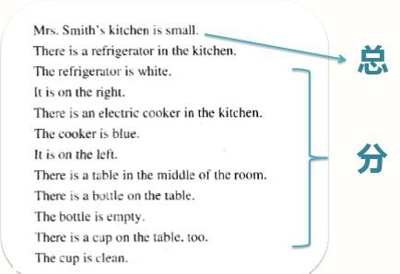

1. **描述物体的方式：**

There is … in the kitchen. The … is blue.

It is on the left.

##### 所在位置 颜色

**具体位置 状态**

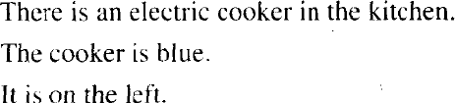

**所在位置：there be 句 型颜色：It is+ 颜色**

**具体位置：on the right\left, in the middle of… 状态: It is clean\ empty\ big\ small…**

**卧室里有一张床，是白色的， 它在屋子的中间，上面很干净。**

**There is a bed in the bedroom. It is white.**

**It is in the middle of the room.**

**And it is very clean.**

**桌上有一个茶杯，是绿色的， 它在碟子上面，它是空的。There is a cup on the table. It is green.**

**It is on the plate. And it is empty.**

1. **冠词用法复习**

**There is an … cooker. The cooker is…**

**There is a refrigerator. The refrigerator is…**

**There is a bottle. The bottle is…**

**There is a cup. The cup is …**

**总结：**

**初次出现，不了解，不确定，用不定冠词 a\an, 再次出现，了解了，确定了，用定冠词 the.**

**那有一个人，这人穿着蓝色的衣服，他是一位机械师。There is a man.**

**The man is in blue.**

**And he is a mechanic.**

**Lesson 25 语法讲解**

1. **There be 句 型**

**② 构成： There be(is, are)+地点**

**②用法：**

**拥有 have**



**有 存 在 There be…**

**③分类： There is…+单数**



**There be…**

**There are…+复数名词**

**④翻译： There is one in my heart. 那有一个人在我心里。**

**我心里有一个人。**

There is a cooker in the kitchen. There is a fridge in the kitchen. There are two chairs in the kitchen.

Lily’s bedroom is large.

There is a bed in the bedroom.

It is brown. And it is in the middle of the room.

##### ⑤就近原则

**There is a table and four chairs**

**There are four chairs and a table.**

**There are some students and a teacher.**

**There is a teacher and some students.**

**中考真题**

* **David, there a dictionary and some books on the desk. Please put them away.**
* **OK, Mum, I will do it right now.**
  1. **is**
  2. **are**
  3. **has**
  4. **have**

**Lesson 26 单词句型讲解**

1. **where [weə(r)] : 哪 里**

**特殊疑问词+ be+ 名词**

**特殊疑问词+名词+ be+ …**

**Where is/are+ 名词…?**

Where are you? 你在哪？

##### in [ɪn] : 在…里面

**钱在包里。**



**the money in the bag 包里的那钱**

**The money is in the bag.**

**Where is it?**

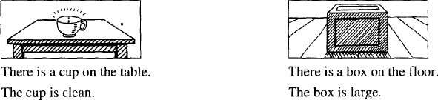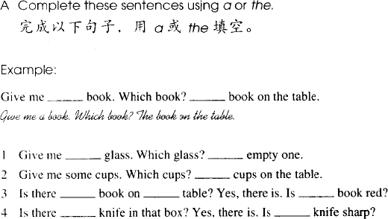

**Lesson 25&26 知识拓展**

1. **介 词 in**

**① 恋爱： in love**

他恋爱了: He is in love.

##### ② 三合一： three in one

**③综合能力部**

All in one

##### ④in+ 语言，用…

Please speak in English.

##### ⑤in + 颜 色

**穿着…颜色的衣服**

The girl is in red.

##### ⑥in cash: 使用现金

pay in cash

##### ⑦in the rain: 冒 雨

They walk in the rain.

##### Phonics 字母组合-6 sh \ ʃ \

**su \ ʒ \ th \ θ \ th \ ð \**

**sh \ ʃ \**

**English \ 'ɪŋɡlɪʃ \ she \ ʃi:| \**

**brush \ brʌ ʃ \ shoe \ʃu: \**

**su \ ʒ \**

**measure \'meʒə \ leisure \ 'leʒ ə \**

**th \ θ \**

**three \ θri: \ thank \ θæŋk \ thin \ θIn \ beneath \ bɪˈni:θ \**

**th \ ð \**

**that \ ðæt \ these \ ði:z \ they \ ðeɪ \ thus \ ðʌs \**

**Lesson 27&28 预习**

* 1. **发音：字母组合-7，辅音组合；**
  2. **课文：There be 句型的复数**
  3. **语法：介词**

**Lesson 27 单词讲解**

1. **living room ['liviŋ ru:m] : 客厅**
2. **near [nɪə(r)] : prep. 靠近、旁边**

电视靠近桌子。

the television near the table 桌子旁边的电视

The television is near the table.

##### window ['wɪndəʊ] : 窗 户

1. **armchair ['ɑːmtʃeə(r)] : 扶手椅**

arm 胳 膊 + chair 椅 子

##### door [dɔː(r)] : 门

1. **picture ['pɪktʃə(r)] : 图画、照片**
2. **wall [wɔːl] : 墙**

the Great Wall 长 城

##### Lesson 27 课文讲解

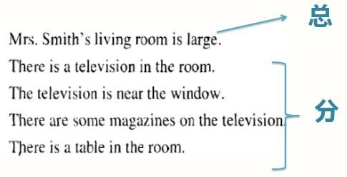

**There is a television in the room.**

**The television is near the window.**

房间里有一个电视。

这个电视在窗户旁边。

##### a/an: 一个，一台，一…

**the: 这个，那个，这些，那些**

There is a television in the room.

There are some magazines on the…

##### There is a + 单 数 名 词 … There are some+ 复数名词…

**客厅里有一个沙发。这个沙发是紫色的。**

There is a sofa in the living room. The sofa is purple.

##### 客厅里有一个电视。墙上有很多图片。

There is a television in the living room. There are some pictures on the wall.

##### Lesson 27 语法讲解

**介词 prep.**

**介词：媒婆，连接两个词或词与句子。媒婆：**on-在…上面

in-在…里面

of-属于

near-靠近，旁边

##### The television is near the window.

**句子中使用介词时，别忘记动词！**

I sit on the floor.

There is a shoe on the floor. 超市在银行附近。

The supermarket is near the bank.

钱在包里。

The money is in the bag.

the money in the bag：包里的那些钱那银行在学校附近。

The bank is near the school.

the bank near the school: 学校附近的那银行

##### Lesson 28 单词句型讲解

1. **trousers ['traʊzəz] : 长 裤**

pants[pænts] jeans 牛仔裤shorts 短 裤

shoes\ socks\ gloves\ glasses

##### Where are they?

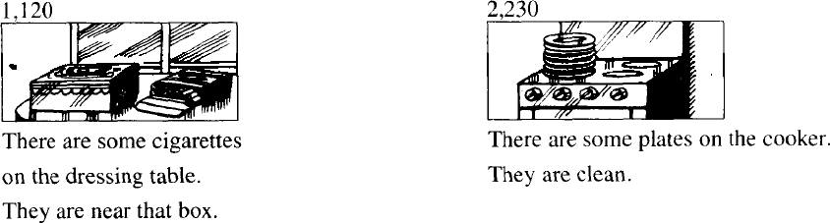

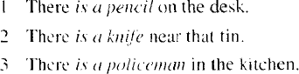

* 1. ***There are some pencils on the desk.***
  2. ***There are some knives near that tin.***
  3. ***There are some policemen in the kitchen.***

**Lesson 27&28 知识拓展**

**有始有终**

**There is a beginning, a middle, and an end.**

**Phonics：字母组合-7 ch, tch, \ tʃ \**

**ge \ dʒ \**

**tr \ tr \ ts \ ts \ dr \ dr \ ds\ dz \**

**ch \ tʃ \**

**cheese \ tʃi:z \ French \ frentʃ \**

**China \ 'tʃaɪnə \ lunch \ lʌntʃ \**

**tch \ tʃ \**

**match \ mætʃ \ batch \ bætʃ \**

**catch \ kætʃ \ bitch \ bɪtʃ \**

**ge \ dʒ \**

**orange \ ˈɒrɪndʒ \ page \ peɪdʒ \**

**bridge \ brɪdʒ \ judge \ dʒʌdʒ \**

**tr \ tr \**

**tree \ tri: \ trip \ trɪp \**

**travel \ ˈtrævl \ troy \ trɔɪ \**

**dr \ dr \**

**drop \ drɒp \ drive \ draɪv \**

**dry \ draɪ \ dream \ dri:m \**

**ts \ ts \**

**shirts \ 'ʃɜ:ts \ skirts \ skɜ:ts \**

**boots \ bu:ts \ tickets \ tɪkɪts \**

**ds\ dz \**

**birds \ bɜ:dz \ lands \ lændz \**

**hands \ hændz \ goods \ gʊdz \**

**ch, tch, \ tʃ \ ge \ dʒ \**

**tr \ tr \ ts \ ts \**

**dr \ dr \ ds\ dz \**

**Lesson 29&30 预习**

1. **发音：字母组合-8，元音辅音组合；**
2. **课文：句型模仿**
3. **语法：祈使句**

**Lesson 29 单词讲解**

1. **shut [ʃʌt] ：关着的，关**

The door is shut. adj. 门是关着的。Shut the door. v. 关门。

##### bedroom ['bedruːm]：卧室

in the bedroom

##### untidy [ʌn'taɪdi]：不整齐的

un- 不, 表示否定clean-unclean easy-uneasy happy-unhappy

##### must [mʌst] : 必 须

情态动词— 情感, 态度You must go out.

Can you go out please?

##### open ['əʊpən]：开着的，打开

The window is open. adj. 窗户是开着的。Open the window. v. 打开窗户。

##### air [eə(r)] ：n. /v. 使空气流通

The air is fresh. 空气清新。

Open the window and air the kitchen. 打开窗户, 让厨房通下气。

What is the color?什么颜色的？

Color the picture. 给图片上色。

I like milk. 我喜欢牛奶。

Milk it. 给奶牛挤奶。

This is my book. 这是我的书。

Book a ticket. 预定一张票。

There is some water in the glass.

杯子里有水。

Water the flower. 给花浇水。

There is some dust .

那有灰尘。Dust the table.

把桌上的灰尘清扫掉。

##### put [pʊt] ：放置,搁

把书放桌上:

Put the book on the table. Put your hand in your pocket. 把手揣衣兜里。

##### clothes [kləʊðz] ：衣服（单复数同形）

people\ hair\ fish\ sheep…

##### wardrobe ['wɔːdrəʊb] ：大衣柜

把外套放在大衣柜里面。

Put your coat in the wardrobe.

##### closet ['klɒzɪt] 衣橱，衣帽间

1. **sweep [swiːp] ：清扫**

Sweep the floor please.

##### Lesson 29 课文讲解

1. **What must I do? 我该干什么？**

What must I say \ read\ clean…?

Where must I go\ live\ stay…?

Who must I meet \ love\ invite …?

Which must I like\ take\ find?

##### make the bed 整理床铺

make the bed sweep the floor dust the table

##### then [ðen] 然 后

First … Then/ and… And then…

##### Lesson 29 语法讲解祈使句：用来表示命令、请求、建议等；

* 1. 表示命令：动词原形+ … Shut the door.
  2. 表示请求：please+ 动词原形+… Please give me it.
  3. 表示建议：Let’s+ 动词原形+… Let’s go, ok?

##### 祈使句特点：

* + 1. 没有主语
    2. 动词打头Come in.

Shut the door.

Open the window.

Air the room…

##### Lesson 30 单词句型讲解

1. **empty ['empti] ：空的，使变空**

My mind is empty. adj. 我的大脑一片空白。

Empty the bottle please. v. 请把瓶子倒空。

##### read [riːd] ：读、看

看书、看报看杂志 :

read a book

read a newspaper read a magazine

##### sharpen['ʃɑːpən]：使锋利adj. + en = v.

sharp + en= 使锋利short + en= 缩 短weak + en= 削 弱

##### put on ['pʊtˌɒn, -ˌɔːn] 穿上，戴上take off [teɪk ɒf] 脱下，卸下

1. **turn on [tɜːn ɒn] 打 开**

**turn off ['tɜːnˌɔːf, -ˌɒf] 关掉**

打开带电的设备

turn on\off the television turn on\off the radio turn on\off the light

turn on\off the tap(水龙头)…

##### 句型：What must I do?

What must I say \ read\ clean…? Where must I go\ live\ stay…?

Who must I meet \ love\ invite …? which must I like\ take\ find?

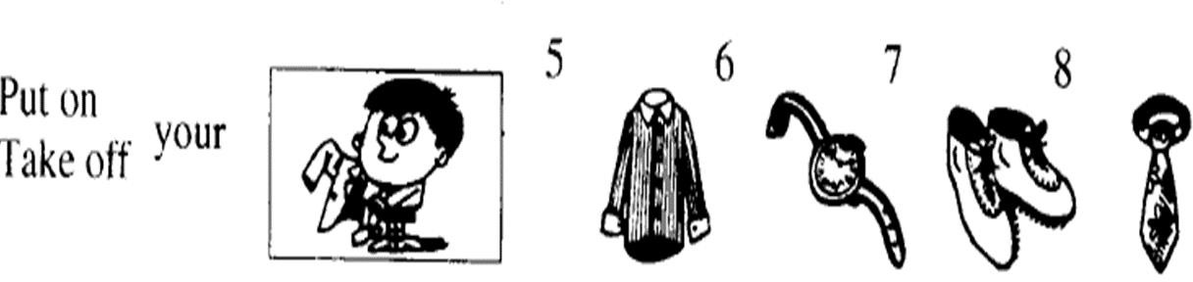

Put on/take off your coat. Put on/take off your shirt. Put on/take off your watch. Put on/take off your shoes. Put on/take off your tie…

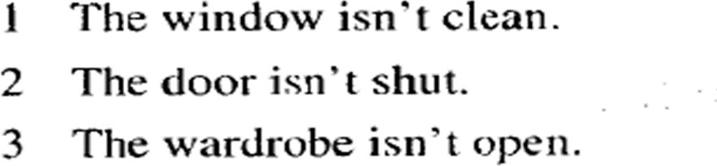

*Clean it! - Clean the window! Shut it! – Shut the door!*

*Open it! – Open the wardrobe!*

##### Lesson 29&30 知识拓展

**洗手间的说法：** bathroom restroom washroom toilet

loo lavatory

lady’s room \ man’s room

##### 字母组合-8 （元音+辅音组合）

**-all \ ɔ :l \ wall ball**

**fall small**

**-ary \ ərɪ \ January ordinary**

**-ew \ ju : \ new few**

**knew view**

**kn \ n \**

**knife knee**

**know knock**

**\ aɪt \ ight**

**fight night**

**light bright**

**-ire \ aɪə \**

**fire tired**

**hire wire**

**-ought \ ɔ:t \**

**bought thought**

**brought sought**

**-all \ ɔ :l \ -ary \ ərɪ \**

**-su \ ʒ \ -ire \ aɪə \**

**-ew \ ju : \ -ought \ ɔ:t \**

**Lesson 31&32 预习**

1. **发音：英语中的连读；**
2. **课文：一家人岁月静好的画面；**
3. **语法：现在进行时态**

**Lesson 31 单词讲解**

**2. garden ['ɡɑːdn] ['ɡɑːrdn] : 花园**

in the garden 在花园里a gardener 园艺师

##### under ['ʌndə(r)] : prep. 在…的之下

under the sun 阳光下under the sea 海 底

床下面有一把椅子。

There is a chair under the bed.

##### tree [triː] : 树

树下 under the tree 家谱 a family tree

##### climb [klaɪm] : v. 爬，攀登

上 - 下

climb the mountain 爬山

##### 6. who [huː] : 谁

**特殊疑问词+ be+ 名词特殊疑问词+名词+ be+ …**

Who are you? 你是谁？

Who is this lady? 这位女士是谁？ Who is that man? 那位男士是谁？

##### run [rʌn] : v. 跑

run after 追 赶

I run after the bus. 我追赶公交车。

a runner 跑步运动员

Liu xiang is a runner.

##### grass [ɡrɑːs] [ɡræs] : 草 地

在草地上:

on the grass

##### after ['ɑːftə(r)] ['æftər] :

prep. 在…之后

3 点以后：after 3:00 After you！ 您先请。

##### across [ə'krɒs]: prep. 穿 过

go across the street walk across the street run across the street

##### cat [kæt] : 猫

**名词、代词、介词、动词、形容词、冠词…… 动词！**

* 1. **动词是句子的灵魂；**
  2. **所有的时态都通过改变动词来实现；**
  3. **动词短语**

**Lesson 31 语法讲解时态**

**时间**

过去

现在将来

**状态**一般进行

完成

**现在进行时态**

**时间：现在状态：进行**

**此时此刻正在做的动作。**

read-reading eat- eating

She is drinking. sleep- sleeping play- playing

sing- singing swim- swimming run- running write- writing

##### do：“动词中心说”

**do+ing：**

reading

eating

drinking.

sleeping

playing

singing

swimming

running

writing

##### 一般+ing；

1. **以不发音的 e 结尾, 去 e +ing（take-taking）**
2. **辅+元+辅（汉堡包结构），双写辅音字母+ing,**

**除 opening，sharpening，listening. 现在进行时态的构成：**

**主语+ is/am/are + doing**

He is reading.

He is eating.

She is drinking.

He is sleeping.

He is playing.

They are singing. He is swimming. He is running.

She is writing.

##### 现在进行时态的一般疑问：

**Is/Am/Are+ 主语+doing？**

Is she eating?

Is she swimming? Is she teaching? Are they walking?

What is she doing?

She is teaching.

Where is she teaching?

She is teaching in the classroom.

What is she teaching?

She is teaching math.

He is running.

She is writing.

##### Lesson 31 课文讲解

There are two people in the room. They are talking.

There is a boy in the tree.

He is climbing the tree. There is a girl under the tree. She is reading.

##### She is sitting under the tree.

她正坐在树下。sit-sitting

##### He is climbing the tree.

他正在爬树。climb-climbing

##### I beg your pardon?

我祈求您的原谅，您可以再说一遍吗？ beg[beɡ] 恳求，祈求

Pardon? Excuse me? Sorry?

Say it again.

##### What about …? …怎么样？

**①反问**

I am a teacher. What about you?

I am learning English. What about you?

##### ②提议

I want rice. What about you?

##### 他正穿过那片草地。

He is acrossing the grass. across prep.

v.+ing

He is going\ walking\ running across the grass.

##### It’s running after a cat.

**它正在一只猫后面跑。run after 追 赶**

**它正在追赶一只猫。**

**Lesson 32 单词句型讲解**

1. **type [taɪp] : v. 打 字**

type-typing

##### letter ['letə(r)] : 信

a love letter 情 书

##### basket ['bɑːskɪt] ['bæskɪt] : 篮 子

basketball 篮球

##### eat [iːt] : v. 吃eat-eating

1. **bone [bəʊn] : 骨 头**
2. **clean[kliːn]: v. 清 洗**clean adj.干净的The room is clean.

房间很干净。

clean the room v. clean- cleaning

##### tooth [tuːθ] : 牙 齿

**复 数 teeth foot- feet toothbrush**

1. **cook [kʊk] : v. 做 饭**

cooking

My mother is cooking.

##### milk [mɪlk] : 牛 奶

1. **meal [miːl] : 饭，一顿饭**

cook a meal

##### drink [drɪŋk] : v. 喝

drink-drinking

She is drinking some water.

##### tap[tæp]: 水龙头

**water faucet ['fɔːsɪt] 美**

turn on the tap turn off the tap

##### What’s she\he\it doing?

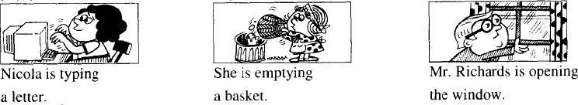

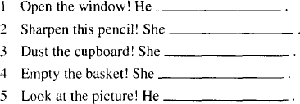

1. is opening the window.
2. Is sharpening…
3. Is dusting…
4. Is emptying…
5. Is looking at…

##### Lesson 31&32 知识拓展

**连读：**

1. 辅音+元音的连读；

pu**t o**n/ ta**k**e **o**ff/ pic**k u**p clea**n it u**p/ unde**r i**t

I**t i**s a**n o**ld book.

She wa**s in an o**ffice. Is**n**’t **i**t?

He**r**e **a**re fou**r e**ggs…

1. 辅+ 半元音： Than**k y**ou. I lo**v**e **y**ou.

Nice to mee**t y**ou. Di**d y**ou get there? Coul**d y**ou help me？

1. Let me ha**v**e **a** loo**k at i**t.
2. No**t at a**ll.
3. Please pic**k it u**p.
4. I’d like to ea**t i**t.

##### Lesson 33&34 预习

* 1. **发音：省读；**
  2. **课文：写日记**
  3. **语法：现在进行时态**

**Lesson 33 单词讲解**

1. **day [deɪ] ：日子、天**today，今天yesterday，昨天holiday，假日

##### cloud [klaʊd] ： 云

天空中飘着几朵云。

There are some clouds in the sky.

##### sky [skaɪ] : 天 空

in the sky

##### sun[sʌn]

sunhat sunglasses

sunblock ['sʌnblɒk]

##### shine [ʃaɪn] : 照 耀

The sun is shining. 阳光灿烂。

##### with [wɪð] ：和…在一起

prep. 介 词

人与人，人与物，物与物

He is **with** his new girlfriend.

他和他的新女朋友在一起。

I am **with** my new sunglasses.

我戴着我的新墨镜。

The house is **with** a garden.

这栋房子带着一个花园。

##### family ['fæməli] ：家庭

a family meeting 家庭会议

We are a family. 我们是一家人。

Are you the family of…? 你们是…的家属吗？

##### 家庭，家人，家属

1. **walk [wɔːk] ：走路，步行**

I walk to school. 我步行上学。

1. **over ['əʊvə(r)] ：跨越、上方**He is walking over the bridge. 他正走着跨过那座桥。

The bird is flying over the river.

##### bridge [brɪdʒ]：桥

天桥：overbridge

过桥：over the bridge 他正在过桥：

He is overing the bridge.

He is going\walking\running over the bridge.

##### boat[bəʊt] ：小船

1. **river ['rɪvə(r)] ： 河**
2. **ship [ʃɪp] ：轮船**
3. **aeroplane ['eərəpleɪn] ：飞机**
4. **fly [flaɪ] ： 飞**

**Lesson 33 语法讲解**

**时态**

|  |  |  |  |  |  |
| --- | --- | --- | --- | --- | --- |
|  | | |  | | |
|  |  | | | |  |
| **时间**过去现在  将来 | |  | | **状态**一般进行  完成 | |

**现在进行时态：主+ is\am\are+ doing**

He is swimming in the river.

##### 现在进行时态：主+ is\am\are+ doing

He is reading on the grass.

##### 现在进行时态：主+ is\am\are+ doing

He is doing his homework.

##### 现在进行时态：主+ is\am\are+ doing

He is running on the road.

##### 你正在干什么？

What are you doing?

**我正在吃饭。**I am eating.

##### 你正在哪吃饭？

Where are you eating?

**我正在家吃饭。**I am eating at home.

##### 你在吃什么？

What are you eating?

**我在吃面条。**I am eating noodles.

##### 你在和谁一起吃？

Who are you eating with?

我和我妹妹一起吃。I am eating with my sister.

##### Lesson 33 课文讲解

1. **描述天气：it 作主语**

今天天气很好。It is a fine day today. 春天天气很糟糕。 It is bad in spring. 夏天天气很好。It is nice in summer.

##### 描述天气的句型结构： It is+ adj.+ 时间

1. **…is with his family.**

**with: 介 词**

the house with a swimming pool 带着游泳池的房子

The house **is** with a swimming pool

这个房子带着游泳池。the girl with her friends

和她的朋友在一起的那个女孩

The girl **is** with her friends.

那个女孩和她的朋友在一起。

##### 课文仿写：

今天的天气真好。

天空中飘着几朵白云，但是阳光灿烂。

我和我的男朋友在一块儿。我男朋友正在开车。我正在读一本有趣的书。

##### 课文仿写：

一只小鸟正从天上飞过。

一些人从天桥上走过，他们很忙。

##### 课文仿写：

今天的天气真好。It is fine today.

天空中飘着几朵白云，但是阳光灿烂。

There are some clouds in the sky. But the sun is shining. 我和我的男朋友在一块儿。我男朋友正在开车。

I am with my boyfriend. My boyfriend is driving. 我正在读一本有趣的书。

I am reading an interesting book.

##### 课文仿写：

一只小鸟正从天上飞过。 A bird is flying in the sky.

一些人从天桥上走过，他们很忙。

Some people are walking over the bridge. They are very busy.

##### Lesson 34 单词句型讲解

1. **1.sleep[sliːp] : v. 睡 觉**

sleep- sleeping

##### shave[ʃeɪv] : v. 刮胡子

shave- shaving shaver 刮胡刀

##### cry[kraɪ] : v. 哭

cry-crying

##### wash [wɒʃ] : v. 洗

wash my face\ wash your hands

##### water- wash- wave- wine- well- wet…

1. **wait [weɪt] : v. 等 待**

wait for me 等等我

##### look at listen to

**What are they doing?**

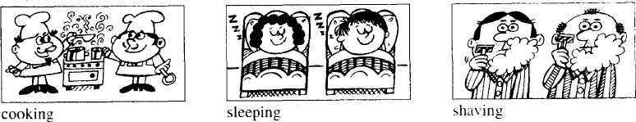

**Lesson 33&34 知识拓展**

1. **英语中的省读：**

/t/,/d/,/k/,/g/,/p/,/b/+ 辅音开头的词Goo**d** night.

hel**p** me ba**d** boy Si**t** still.

I don’**t** li**k**e them.

##### 句子的结构：

主 + 谓

主+ 谓+ 宾

主+ 谓+ 宾+ 宾主+ 谓+ 宾+ 宾补主+ 系+ 表

She is beautiful.

主 系 表

I wash my hands.

主 谓 宾

##### 系动词：is, am, are

**实义动词：wash, run, walk…**

They are busy.

主 系 表He is running.

|  |  |  |
| --- | --- | --- |
| 主 | 谓 |  |
| She | is reading | a book. |
| 主 | 谓 | 宾 |

##### 动词的分类：

1. **连系动词**
2. **情态动词**
3. **实义动词**
4. **助动词**

She is beautiful.

You must do it.

I wash my hands.

She is running.

##### Lesson 35&36 预习

* 1. **课文：描述照片**
  2. **语法：名词所有格**
  3. **知识拓展：所属**

**Lesson 35 单词讲解**

**18. photograph ['fəʊtəɡrɑːf] ['fəʊtəɡræf] :**

**n. 照 片**

photo

ph \ f \ : phone。

##### village ['vɪlɪdʒ] : 村 庄

in the village

##### valley ['væli] : 山 谷

in a valley

##### between [bɪ'twiːn] : prep. 在…之间

The lady is between her daughter and her friend.

##### between A and B

9:00-10:00 来吧！

Come between 9：00-10:00.

Just between you and me, don’t tell others. 天知地知，你知我知.

##### hill [hɪl] : 小 山

**mountain['maʊntən]: 大 山**

1. **another [ə'nʌðə(r)] : 另一个**

Here is another photo of my school.

##### wife [waɪf] : 妻 子

wives 复 数

The wives are playing Majiang when their husbands are drinking.

##### along [ə'lɒŋ] : prep. 沿 着

We are driving along the main road. 我们沿着主路行驶。

##### bank [bæŋk] : 河 岸

the bank of the river 河 岸bank-银行

##### water ['wɔːtə(r)] : 水

1. **swim [swɪm] : v. 游 泳**

swim-swimming

He is swimming in the water.

##### building ['bɪldɪŋ] : 大 楼

the school building 教学大楼

##### park [pɑːk] : 公 园

in the park park v. 停 车park the car

##### into['ɪntə] : prep. 进 入

I come into the bedroom. I jump into the water.

##### Lesson 35 语法讲解

1. **谁谁谁“的”**

我的 my 我们的 our

你的 your 你们的 your

她的 her 他们的 their 他的 his

##### ’s

**名词所有格有生命的**

Lucy 的朋友：Lucy’s friend Lily 的书：Lily’s book

我妈妈的包：my mother’s bag 我爸爸的手表：my father’s watch

##### of: 倒着说！

我学校的照片: the photo of my school 这首歌的名字: the name of the song 我的车的颜色: the color of my car

这房间的窗户: the window of the room 那只小狗的名字:

the dog’s name

物主代词

那本书的颜色:

the color of the book 我妈妈的手提包:

my mother’s handbag 那位男士的妻子:

the man’s wife

他们的教室:

their classroom 世界地图:

the map of the world 我们的老师:

our teacher 那部电影的名字:

the name of the movie 我老板的办公室:

my boss’s office

##### Lesson 35 课文讲解

1. **a photograph of our village**

a photo of my book a photo of my school

##### My wife and I are walking along the bank of the river.

**我和我妻子正沿着河岸走。**

①我和我同学… My classmate and I… 我和我爸爸… My father and I…

② are…

1. **Here is another photograph… another 另一个 (大于等于 3) the other 另一个（等于 2）** I have two best friends.

One is a teacher, the other is a doctor.

##### Some children are coming out of the building.

① some+ children

② are

③ come out of：从…出来walk out of：从…走出来run out of：从…跑出来

##### Some of them are going into the park.

① some of them 他们中的一些some of us 我们中的一些

② are

③ go into： 进 入 … walk into：走进去run into：跑进去

##### Lesson 36 单词句型讲解

1. **beside [bɪ'saɪd] : prep. 在…的旁边**

There is a bed table beside the bed.

##### off [ɒf] [ɔːf] : prep. 离开

turn off: 关 掉take off: 脱 掉drive off: 开 走jump off: 跳 离

##### Where is…?

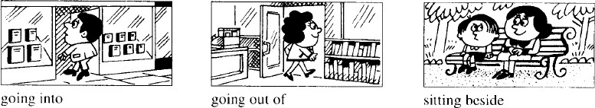

**He is going into the book store.**

1. **swim… He is across the river. (swimming)**
2. **sit… She is on the grass. (sitting)**
3. **run… The cat is along the wall. (running)**

**Lesson 35&36 知识拓展**

**名词所有格**

**Jim 的房间：Jim’s room Jack 的房间：Jack’s room**

**Jim and Jack’s room：Jim 和 Jack 的房间**

**房间属二人共有**

**Jim’s and Jack’s rooms：Jim 和 Jack 的房间**

**房间属二人各自所有 Lucy 和 Sara 的男朋友：**

**Lucy and Sara’s boyfriend**

**Lucy’s and Sara’s boyfriends**

**The lady over there is mother.**

1. **Julia and Shelley’s**
2. **Julia’s and Shelley’s**
3. **Julia and Shelley**
4. **Julia’s and Shelley**

**Lesson 37&38 预习**

1. **词性：副词**
2. **课文：描述打算和计划；**
3. **语法：一般将来时态。**

**Lesson 37 单词讲解**

**19. work [wɜːk] : v.工作**

I work in NO School.

##### hard [hɑːd] [hɑːrd] : adv.努力地

…的 adj. (形容词)

…地 adv. (副词)

* 1. 功能：

形容词：修饰名词

a busy day, a pretty girl… 副词：修饰 adj.\ v.\ adv.

① 修 饰 adj.

* I am tired. - I am very tired. - I am so tired.
* I am too tired. - I am awfully tired.

② 修 饰 v.

I love you.

I love you very much.

I love you deeply.

* 1. 副词的位置：通常情况，形前动后

I am very tired.

I swim well. 我游泳游的很好。

I love you very much. 我非常爱你。

* 1. hard 词性讨论：

hard work: 艰苦的工作work hard: 努力地工资**勤奋的/艰苦的 adj.**

##### 努力地 adv.

1. **make [meɪk] : 做**

What make is it? 这是什么牌子的？ make the bed: 整理床铺

make a bookcase: 制作一个书架

##### bookcase ['bʊkkeɪs] : 书 架

bookshelf

##### hammer ['hæmə(r)] : 锤 子

1. **paint [peɪnt] : v. 涂色，上色，画draw [drɔː] ： 画**

painting: n. 画

Chinese paintings 中国国画

##### pink [pɪŋk] : 粉色的

1. **favourite['feɪvərɪt] : 最喜欢的favorite**

favorite color \ city \ school \ book \ star… What’s your favorite…?

Who’s your favorite…?

你最喜欢的城市是哪个？ 你最喜欢的明星是谁？

##### Lesson 37 语法讲解

**时态**

|  |  |  |  |  |  |
| --- | --- | --- | --- | --- | --- |
|  | | |  | | |
|  |  | | | |  |
| **时间**过去现在  将来 | |  | | **状态**一般进行  完成 | |

**一般将来时态：**

**① 何时用？**

**预先计划和打算要做的事**

**② 固定结构:**

**主+ is\am\are+ going to**

**③ 注意事项：**

**主+ is\am\are+ going to+ 动词原型主+ is\am\are+ going to+ 地点名词我打算周末去游泳。**

**I am going to swim this weekend.**

**他打算买辆新的。**

**He is going to buy a new car.**

**我们打算去上海。**

**We are going to Shanghai.**

**I am gonna be happy this year. 口语中: going to = gonna**

**= I’m going to be happy this year.**

**is/am/are going to be + 非动词is/am/are going to be+ 非动词**

**非动词：adj. n. prep. adv. …**

**我打算 2 点到那。**

**I am going to be there at two.**

**他打算成为一名医生。**

**He is going to be a doctor.**

**我打算下周开始忙起来。**

**I am going to be busy next week.**

**他计划这周末呆家里。**

**He is going to be at home this weekend.**

**他们打算以后在北京。**

**They are going to be in Beijing.**

**④ be going to 句型的疑问和否定：**

**疑问: be 提前否定: be+ not**

**她打算周末去游泳吗？**

**Is she going to swim this weekend？**

**她不打算周末去游泳。**

**She is not going to swim this weekend.**

**Lesson 37 课文讲解**

1. **You are working hard… 你正在努力工作… 你正忙着呢！**
2. **Give me that hammer please, Dan.**

**…**

**Thanks Dan.**

1. **I ’m going to paint it (the bookcase) pink.**

**主 谓 宾 宾补**

**宾补：**

**对宾语的补充和说明， 使句子更加简洁。**

**我发现那屋子是黑的。**

|  |  |  |
| --- | --- | --- |
| **I** | **find** | **the room is dark.** |
| **I** | **find** | **the room dark.** |
| **主** | **谓** | **宾 宾补** |

**我们必须让这屋子暖和点。**

**We must keep the room warm. 大家务必保持教室的干净。**

**We must keep the classroom clean.** 历史使人明知。Histories make men wise. 诗歌使人灵秀。Poems make men witty. 数学使人缜密。Math makes men subtle.

哲学使人深刻。Philosophy makes men deep.

##### It’s for my daughter.

* 1. 为了…某人而… It’s for you.
  2. 对于某人来说…Math is so difficult for me.
  3. 表原因…What are you sorry for?
  4. 长达… I study Yoga for two years.

##### Lesson 38 单词句型讲解

1. **homework ['həʊmwɜːk] : 家庭作业housework: 家务活**
2. **listen ['lɪsn] : 听**

**listen to the music 听音乐**

1. **dish [dɪʃ] : 盘 子**

洗碗:

wash the dishes 菜系:

Sichuan dish 四川菜

##### What are you going to do? What are you doing?

**Lesson 37&38 知识拓展使用 be going to 句型描述自己的计划和打算:**

大家好！我是一名银行职员。我在北京工作。Hi. I am a clerk in a bank. I work in Beijing. 下月我计划去厦门出差。

I’m going to Xiamen on business next month.

我将在厦门呆两周。

I’m going to stay in Xiamen for two weeks. 我一定会享受那里清新的空气和灿烂的阳光。

I am going to enjoy the fresh air and sunshine there. 当然也一定会见见我的老同学。

And I’m going to see my old classmates. 我打算 4 号坐火车回来。

I am going to come back by train on 4th.

##### Lesson 39&40 预习

1. **课文：祈使句，双宾语；**
2. **语法：各种否定；**
3. **知识拓展：交通法规的英文表达。**

**Lesson 39 单词讲解**

1. **front [frʌnt] : n. 前 面**
2. **in front of: 在…之前**

in the front of

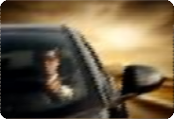

car.

The man is in front of the car. The man is in the front of the

##### careful ['keəfl] : 小心的，仔细的

1. **vase [vɑːz] [veɪs] : 花 瓶**

vases 复 数

##### flower ['flaʊə(r)] : 花

flowers 复 数

1. **drop [drɒp] : v. 掉 下**throw[θrəʊ] 扔Don’t drop it! Don’t throw it!

##### Lesson 39 语法讲解

**说不**

1. **is not/ am not/ are not**

It is my name. - It is not my name. She is pretty. - She is not pretty.

You are busy. - You are not busy.

I am listening. - I am not listening.

##### Don’t（Do not） + v. （动词）

Do it! Don’t do it! Come in!

Don’t come in!



##### Don’t smoke!

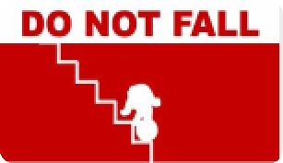



**Don’t litter! Don’t fall! Don’t enter!**

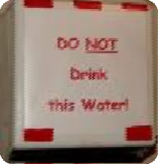

Don’t drop it！别摔了！ Don’t do that! 别这么做！

Don’t put it there! 别放那儿！ 不要工作啦！

Don’t work!

不要开车啦！ Don’t drive!

不要在这游泳！

Don’t swim here! 不要做饭啦！

Don’t cook! 我不在那儿！

I am not there!

我不会这么做！

I am not doing that! 不要开窗！

Don’t open the window!

##### Lesson 39 课文讲解

1. **What are you going to do with…? 你打算怎么处理…?**

What are you going to do with the old books?

##### Give it to me.

**祈使句：**

* 1. 没有主语
  2. 动词打头

①Come in.

Shut the door. Open the window. Air the room…

②Be careful!

##### be+ 非动词（adj./ prep./n./ …）

Be happy! Be good! Be early! Be here!

Be a good boy!

##### Give it to me.

You give the vase to me.

主 谓 宾 宾双宾语:

give \ show \ take \teach… You give the vase to me.

主 谓 宾 宾You give me the vase.

主 谓 宾 宾

the vase: sth.

me: sb.

##### give sth. to sb.= give sb. sth.

I give some money to him. = I give him some money.

I give a flower to my mother. = I give my mother a flower. 我给了他们一些新书。

I give some new books to them =.I give them some new books.

我给了她一个糖果。

I give her a candy. =I give a candy to her.

##### 双宾语:

**give \ show \ take \teach… 给予 展示 带给 教 授** 我向他展示了我的新车。

I show my new car to her=I show her my new car.

我带给了他生日礼物。

I take the birthday present to him. = I take him the birthday present. 我教她英语。

I teach English to her. =I teach her English.

##### There we are.

**= We are there.** 就这么着吧！ 就到这儿吧！

##### Lesson 40 单词句型讲解

1. **show [ʃəʊ] : v. 给…看**
2. **send [send] : v. 寄送，派遣**
3. **take [teɪk] : v. 带 给接双宾语**

**show sb. sth.= show sth. to sb. send sb. sth.= send sth. to sb. take sb. sth.= take sth. to sb.**

**What are you going to do with…? I’m going to give/show/send/take…**

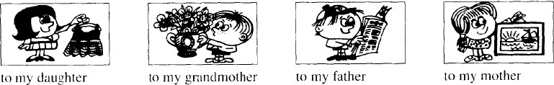

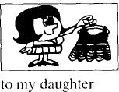**What are you going to do with the dress? 你打算怎么着这件裙子？**

**我打算把它送给我女儿。**

**I’m going give the dress to my daughter. I’m going to give my daughter the dress.**

**What are you going to do with the flowers?**

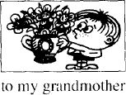**你打算怎么着这些花？**

我打算把花送给我奶奶。

I’m going give the flowers to my grandmother.

I’m going to give my grandmother the flowers.

##### What are you going to do with the newspaper? 你打算怎么着这报纸？

我打算把它带给我爸。

I’m going to take the newspaper to my father. I’m going to take my father the newspaper.

##### What are you going to do with the picture? 你打算怎么着这图片？

我打算把它寄给我妈。

I’m going to send the picture to my mother. I’m going to send my mother the picture.

##### Lesson 39&40 知识拓展不要：Don’t+ v. No+ n. ：

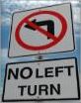Don’t smoke！ No smoking！

##### 不许左转

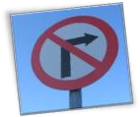

**不许右转**

**No right turn. Don’t turn left.**



**不准调头No U turn**

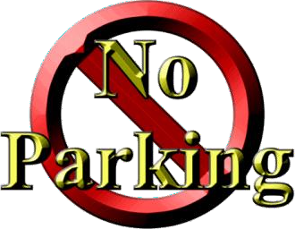

**不准停车**

**No parking! Don’t park!**

**Lesson 41&42 预习**

1. **课文：量词；**
2. **语法：不可数名词；**
3. **知识拓展：认识货币。**

**Lesson 41 单词讲解**

1. **cheese [tʃiːz] : 奶 酪**

笑 音 \ i:\ Say cheese!

##### bread [bred] : 面 包

1. **soap [səʊp] : 肥 皂** soup [suːp] 汤

##### chocolate ['tʃɒklət] : 巧克力

1. **sugar ['ʃʊɡə(r)] : 糖（白砂糖）**

candy，糖果sugar coat？

Can you sugar coat a little? 你可以稍微委婉一点吗？

##### coffee ['kɒfi] : 咖 啡

1. **tea [tiː] : 茶**
2. **tobacco [tə'bækəʊ] : 烟 草**

cigarette 香 烟

##### Lesson 41 课文讲解

1. **Not very. 不是非常…**

It is not very heavy.

Are you busy? Is it expensive?

##### What’s in it? 里面是什么？

What’s on it？ 上 面 是 什 么 ？ What’s under it？下面是什么？ What’s over it？上方是什么？ What’s behind it？后面是什么？

##### 量词:

**a piece of… 一片、一块的… a loaf of… 一个、一条的…**

**a bar of… 一条、一块的…**

**a bottle of… 一瓶的… a pound of… 一磅的…**

**a tin of… 一罐的… a cup of…**

**a box of…**

**a spoon of…**

1. **pound:**
   1. ￡英镑

one pound \ two pounds

penny: 便士,one penny \ two pence 五 角 ≈ fifty pence

dollar: ＄美元

one dollar \ two dollars

cent: 美分,one cent\ two cents

##### pound: 一 磅

**one pound ≈ 0.454 kilogram（千克 \ 公斤）**

a pound of apples: 一磅苹果

Her weight is under ninety pounds.

她的体重不足 90 磅。（90 磅 ≈ 40.86 公斤） 半磅：half a pound of..

四分之一磅：a quarter of a pound of…

##### Lesson 41 语法讲解

**名词**

* + 1. 冠词+名词
    2. 名词所有格:‘s \ of
    3. 单&复数
    4. 可数&不可数

##### 不可数名词

1. **概念：不可以数的、不可以计算的名词；**
2. **包括：**
   1. 液体状的东西：

water\ tea\ coffee\ milk\ beer…

* 1. 物质名词：

soap\ gold\ chocolate\ tobacco…

* 1. 抽象名词： love\ friendship\ anger…
  2. 无法计算：

work\homework\rice\rain…

##### 用法：

* 1. 前面不可以加 one, two, three…
  2. 前面不可以加 a\an;
  3. 后面不可以加 s，永远是单数**。**

a water\two tea\some milks\breads  the beer\the cheese\some rice

##### 与量词的搭配：

a piece of bread 一片面包 a loaf of bread 一个面包

a bar of soap 一条肥皂

a bottle of cola 一瓶可乐

a pound of… 一磅的…

a tin of cola 一罐可乐a cup of coffee 一杯咖啡

a spoon of sugar 一勺糖

1. There some bread on the table.

√A. is B. are

1. I am thirsty. Would you bring me , please?

A. some waters √B. some tea

C. some soups D. some eggs 3). There two bars of soap in the bathroom.

A. is √B. are

two bars of chocolate

four cups of tea

two tins of cola

##### Lesson 42 单词句型讲解

1. **bird [bɜːd] : 鸟**

birds

##### any ['eni] : 一 些

1. **some [səm] : 一 些**
2. **some \ any+ 复数或不可数名词时表 “一些”, some 用在肯定句中, any 用在否定、疑问句中；** 一些学生：

some students \ any students 一些水：

some water \ any water

165

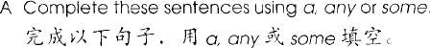

1. Is there _ bread in the kitchen? (any)
2. There’s loaf on the table. (a)
3. There’s coffee on the table too. (some)
4. There isn’t chocolate on the table. (any)
5. There is spoon on that dish. (a)
6. Is there soap on the dressing table? (any)

##### 但在表请求、建议的疑问句中用 some；

Can you lend me some money? 你可以借我点钱吗？

Would you like to drink some tea? 你想喝点茶吗？

##### some +单数名词，“某一” Any ＋单数名词，“任一”

Some day, he can be some one. 某一天,他可能成为个人物。

You can buy it in any supermarket.

你可以在任何一个超市买到。

##### Lesson 41&42 知识拓展

**有关货币：**

1. 常用币种:
   1. Euro: € 欧 元
   2. dollar: ＄美元
   3. pound: ￡英镑

##### 读法:

￡3: three pounds

＄5: five dollars

€ 7: seven euro

￡0.9: ninety pence

＄0.3: thirty cents

€ 0.6: sixty euro cents

￡10.5: ten pounds fifty pence

€ 24.60: twenty four euro sixty euro cents twenty-four sixty euro

￡120: one hundred and twenty pounds one twenty pounds

##### Lesson 43&44 预习

1. 课文：there, here 开头的口语表达；
2. 语法：can；
3. 知识拓展：数词 1-20；

##### Lesson 43 单词讲解

* 1. of course: 当然certainly 更加正式

Of course not. 当然没有。

* 1. kettle ['ketl] : n. 水壶
  2. behind [bɪ'haɪnd] : prep. 在…后面The boy is standing behind the tree.
  3. teapot ['ti: pɒt] ['ti: pɑ: t] : n. 茶 壶hot pot, 火 锅

"double flavor Pot" "Yuanyang Pot"

* 1. now [naʊ] : 现在，此刻
     + What are you doing now?
     + I am learning English.
     + What are you going to do now?
     + I am going to swim.
  2. find [faɪnd] : v. 找到look for： 寻 找

Look! Can you see it? Listen! Can you hear it? Look for it! Can you find it?

* 1. boil [bɔɪl]: v. 沸腾，开The water is boiling. Let’s boil an egg.

boiled [bɔɪld] 烧开的，煮熟的boiled water 开 水

boiled egg 煮鸡蛋

##### Lesson 43 语法讲解

1. 可以吗?

Can you…? Are you…？

Can she…? Is she…？

Can he…? Is he…？

Can we…? Are we…？

Can they…? Are they…？

1. can + 动词,且原形！

你可以帮我吗？ Can you help me? 他可以做这事吗？ Can he do it?

我们可以一起游泳吗？ Can we swim together?

Can you make the tea?

Can you see it?

Can you find them?

你能拍手吗？ Can you clap your hands?

你能伸得很高吗？ Can you stretch up high ? 你能跺跺脚吗？ Can you stamp your feet？

##### Lesson 43 课文讲解

1. Hurry up! 快 点

Be quick!

1. Can you make the tea? 你可以沏点茶吗？ Make the tea, Sam! 沏茶去!

make

make the tea 沏茶 make the coffee 冲咖啡make the bed 整理床铺 make a bookcase 做个书架What make is it? 这个什么牌子的？

1. It’s over there. 就在那儿。

It’s right here 就在这儿。

1. Can you see it? 你能看得见吗？

Can you look at it? 你能看一下吗？ look- see

listen- hear

look for- find

1. There it is.

Here they are. It is there.

They are here.

我到了。 Here I am. 他在那呢。 There he is.

##### Lesson 44 单词句型讲解

1. I can see spoons, but I can’t see any knives.
2. I can see some hammers, but I can’t see any boxes.
3. I can see some coffee, but I can’t see any loaves of bread.
4. I can see some cupboards, but I can’t see any shelves.
5. I can see Mr. Jones and Mr.Brown, but I can’t see their wives.
6. I can see some cups, but I can’t see any dishes.
7. I can see some cars, but I can’t see any buses.

Are there any…? Is there any…?

Are there any +复数？

Is there any +不可数？

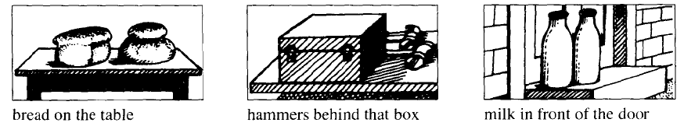

##### Lesson 43&44 知识拓展

one[wʌn] two [tu：] three[θri：] four[fɔ：(r)] five[faɪv] six [sɪks]

seven ['sevn] eight [eɪt] nine [naɪn] ten[ten] eleven [ɪ'levn] twelve [twelv]

thirteen [ˌθɜ：'ti:n] fourteen [ˌfɔ：'ti:n] fifteen [ˌfɪf'ti:n] sixteen [ˌsɪks'ti:n]

seventeen [ˌsevn'ti:n] eighteen [ˌeɪ'ti:n] nineteen [ˌnaɪn'ti:n] twenty ['twenti]

##### Lesson 45&46 预习

1. 语法：情态动词；
2. 课文：can 的疑问句；
3. 知识拓展：数词及常用的 can 的口语句型。

##### Lesson 45 单词讲解

1. can[kæn] : 能够、可以
2. boss[bɒs] : 老 板manager, 经 理
3. minute ['mɪnɪt] : 分钟\ 一会儿

hour['aʊə(r)] 小时second['sekənd] 秒

稍等片刻：Wait a minute. / Wait a second.

1. ask [ɑ: sk] [æsk] : v. 请 求 \ 问Can I ask you a question? ask the way 问 路
2. handwriting ['hændraɪtɪŋ] : n. 书 写他的字写的很好。

His handwriting is very nice.

1. terrible ['terəbl] : adj. 糟糕的

It’s terrible today. 天气很糟糕。

He is terrible. 他很讨厌。

##### Lesson 45 语法讲解

连系动词、情态动词、实义动词、助动词情态动词：

1. 概念：表示情感、态度

You must go out!

Can you please stand up?

1. 包括：can, must, may…
2. 用法：+ 动词，且原形He can do/read it.
3. 没有人称和数的变化

She is… She can…

He is… He can…

It is… It can…

I am… I can…

They are… They can…

1. 疑问句：情态动词提前He can read it.

Can he read it?

He can do it. Can he do it?

1. 否定句：

can—can’t, cannot must— mustn’t (禁止) may— may not

①. Tom can swim well. (变为一般疑问句) Can Tom swim well?

②. The students must finish their homework tonight. (变为否定句) The students don’t need to finish their homework tonight.

③. I can stay with you. (变为否定句) I can’t/cannot stay with you.

④. She can drive to school. (变为疑问句)

Can she drive to school?

##### Lesson 45 课文讲解

1. The boss’s letter 老板的信[bɒsɪz]
2. Can you come here a minute please? 请你过来一下好吗？

a minute:一下、一会儿

1. She is next door. 她在隔壁。next door 在隔壁＼与…相邻

She is next door to us. 她与我们相邻。

There is a school next door to the park. 公园的隔壁有所学校。next-door adj. 隔壁的

The next-door girl is very beautiful. 隔壁的女孩很漂亮。

The old man next-door is going to leave. 隔壁的老人就要离开人世了。

1. The boss’s handwriting is terrible. 老板的字迹真糟糕了。/老板写的字真难看。我妈写的字很好看。

My mother’s handwriting is beautiful.

##### Lesson 46 单词句型讲解

1. lift [lɪft] : v. 举 起

Can you lift this heavy case?

电梯（英式直梯，美式：elevator）

There are thirteen people in this lift, it’s overweight. 电梯里有 13 人，超重啦！

1. cake [keɪk] : 蛋糕，可数名词
2. biscuit ['bɪskɪt] : 饼干，可数名词
3. They are typing these letters. They can type these letters.
4. She is making the bed. She can make the bed.
5. You are swimming across the river..

You can swim across the river.

1. We are coming now. We can come now.
2. We are running across the park.

We can run across the park.

##### Lesson 45&46 知识拓展

can 在口语中

* 1. Can I help you?
  2. Can’t wait!
  3. I can’t help! 没法子！
  4. Can you give me a hand? 可以搭把手帮个忙吗？

数 字 ： twenty thirty forty fifty sixty seventy eighty ninety

thirteen thirty

fourteen forty

fifteen fifty

sixteen sixty

seventeen seventy

eighteen eighty

nineteen ninety twenty-one

thirty- six

forty- five fifty- seven sixty- nine seventy- two eighty-six ninety-three

23: twenty - three 36: thirty - six

42: forty - two 57: fifty - seven 64: sixty - four

78: seventy - eight 85: eighty - five 91: ninety - one

##### Lesson 47&48 预习

* + 1. 语法：实义动词的疑问和否定；
    2. 课文：

简单实用口语； 复习介词；

* + 1. 数词及 apple 相关俚语。

##### Lesson 47 单词讲解

1. like[laɪk] : v. 喜欢，想要我喜欢足球。

I like football.

我非常喜欢足球。

I very like football.

I like football very much.

我喜欢踢足球。(play football) I like playing football.

我喜欢开车。(drive) I like driving.

我喜欢游泳。(swim) I like swimming.

1. want [wɒnt] : v. 想

think 考虑，认为

我想要一辆新车。I want a new car.

我特别想要一辆新车。I very want a new car.

I want a new car very much.

我想买一辆新车。 (buy) I want to buy a new car.

我想开车。(drive)

I want to drive.

我想游泳去。(swim) I want to swim.

##### Lesson 47 语法讲解

他们幸福吗？

they happy?

Are Do



他们是学生吗？

they students?

Are Do



他们在地铁上吗？

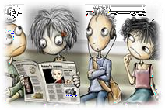 they on the subway? Are Do

* Are they happy?
* Are they students?
* Are they on the subway?

Are they + 形容词/名词/介词… 一般疑问句：

… +动词？

be+ 形容词/名词/介词…

Do you like coffee?

Do you want any sugar?

你说英语吗？

Do +动词？

Do you speak English?

你经常吃早饭吗？

Do you often eat breakfast?

你正在吃早饭。

You are eating breakfast. Are you eating breakfast? 现在进行时态：

主语+ is/am/are + doing

他们不幸福。

They happy. are not do not

他们不是学生。

They students.

are not do not

他们不在地铁上。

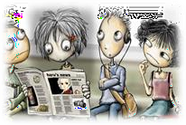They on the subway. are not do not

* They are not happy.
* They are not students.

… +动词

* They are not on the subway.

They are not+ 形容词/名词/介词… 否定句：

be not+形容词/名词/介词…

I don’t like milk in my coffee. 我不说英语。

I don’t speak English.

do not +动词

你不经常吃早饭。

You don’t often eat breakfast.

疑问句：

Do + 动词？

否定句：

do not/don’t + 动 词

我不开车。

I don’t drive.

我不游泳。

I don’t swim.

我不做家务。

I don’t do the housework.

你 开 车 吗 ？ Do you drive?

你游泳吗？

Do you swim?

你做家务吗？

Do you do the housework?

##### Lesson 47 课文讲解

1. Do you like coffee?

the

Do you like a book? Do you like the book? Do you like book?

Do you like books?

1. - Do you want any sugar?

* Yes, please.
* Do you want any milk?
* No, thank you.

Yes, please. No, thank you.

1. I don’t like milk in my coffee. 我不喜欢咖啡里面加牛奶。

I don’t like English in Chinese. 我不喜欢中文里夹杂英文。

##### Lesson 48 单词句型讲解

1. fresh [freʃ] adj. 新鲜的the fresh air
2. egg [eɡ] n. 鸡 蛋
3. butter ['bʌtə(r)] n. 黄 油
4. pure [pjʊə(r)] adj. 纯净的the pure water
5. honey ['hʌni] n. 蜂蜜
6. ripe [raɪp] adj. 成 熟 的
7. banana [bə'nɑːnə] [bə'nænə] n. 香蕉
8. jam [dʒæm] n. 果 酱traffic jam 交通堵塞
9. sweet [swiːt] adj. 甜 的her sweet voice
10. orange ['ɒrɪndʒ] n. 橙 子
11. Scotch Whisky 苏格兰威士忌
12. choice [tʃɔɪs] adj. 上等的，精选的some choice apples

n. 选 择

He can make a wise choice. 你可以做出个明智的选择。

1. apple ['æpl] n. 苹 果
2. wine [waɪn] n. 果 酒
3. beer [bɪə(r)] n. 啤 酒
4. blackboard ['blækbɔːd] n. 黑 板

whiteboard 白 板

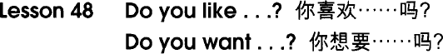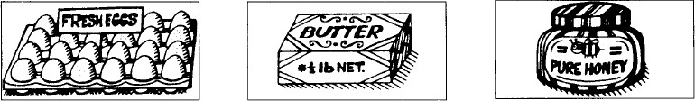

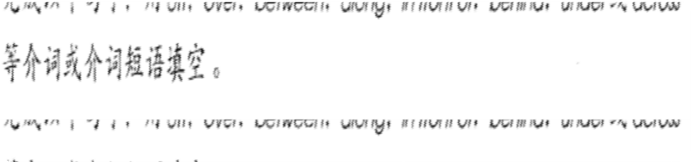

off: 离开

over: 跨越，上方between: 两者之间along: 沿着

in front of: 前 面behind: 后 面under: 下 面across:穿过

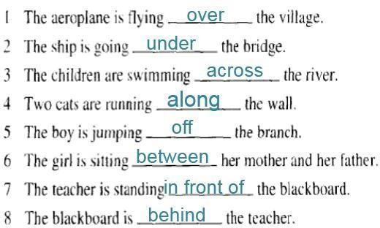

##### Lesson 47&48 知识拓展

* 1. the apple of one’s eyes 掌上明珠
  2. the big apple 纽约市
  3. Adam’s apple 男性的喉结

一百：one hundred

* + - 236

two hundred and thirty-six

* + - 542

five hundred and forty-two

* + - 807

eight hundred and seven

* + - 978

nine hundred and seventy-eight

* + - 685

six hundred and eighty-five

* + - 491

four hundred and ninety-one

##### Lesson 49&50 预习

1. 语法：一般现在时态；
2. 课文：

实用口语拓展；

1. 知识拓展：数词

##### Lesson 49 单词讲解

1. butcher ['bʊtʃə(r)] : 卖肉的at the butcher’s: 在肉店at the doctor’s: 在诊所

at the hairdresser’s: 在理发店at the baker’s: 在面包店……

1. meat [miːt] : 肉,不可数名词
2. beef [biːf] : 牛 肉
3. lamb [læm] : 羔羊肉mutton ['mʌtn] : 羊 肉涮羊肉：

instant-boiled mutton mutton hotpot

1. steak [steɪk] : 牛 排a piece of steak
2. mince [mɪns] : 肉 馅
3. chicken ['tʃɪkɪn] : 鸡肉
4. pork [pɔːk] : 猪 肉
5. husband ['hʌzbənd] : 丈夫
6. tell [tel] : 告 诉

tell sb. 告诉某人…

Tell me/him/her/us/them…

1. truth [truːθ] : 实情、事实true: adj. 真实的
2. either ['aɪðə(r)] ['iðər] : 也，

too: 也，肯定句，疑问句

我也不知道。I don’t know either. 你也喜欢英语吗？

Do you love English, too?

##### Lesson 49 语法讲解

一般现在时态：

1. 何时用？
   1. 经常的状态；
   2. 习惯的动作；
   3. 真理。
2. 结构？
   1. 经常的状态； 主语+ is \am\ are+非动词
   2. 习惯的动作； 主语+ v. （动词）
   3. 真理。

主语+ is \am\ are, 主语+ v.（动词） The earth is round.

The sun rises in the east.

1. 动 词 ?

主语+ v.（动词）

主语为非三单 + 动词原形主语为三单 + 动词 s\es

非三单：第一，第二，第三人称复数

I, we, you, they 三单：第三人称单数，she，he，it Lucy, Sam, Mr. Lee, his sister, This book, that student, Beijing, my uncle, her dog,

President Trump,

the teacher, her husband

He loves his girlfriend very much.

Jim and Lily walk to school every day.

They drink beer every night.

My dog watches TV at night.

The student goes to school on foot.

Sam and I eat together.

1. She up(起床) at six in the morning.

**√**

A. get B. gets C. getting

1. Tom is a worker. He in a factory.

His sisters in a hospital.

A. work/ work B. works/ works

C. works/work D. work/works

**√**

#### 

1. 疑问？

They drink beer every night.

they drink beer every night?

Do

He loves his girlfriend very much.

he love his girlfriend very much?

Does

1. 否定？

They drink beer every night.

They drink beer every night.

don’t

He loves his girlfriend very much.

He love his girlfriend very much.

doesn’t

1. - How you go to school?

- I go to school by bus.

But my brother school on foot.

A. do, go to B. are, go to

C. do, goes to D. are, goes to

**√**

1. Lucy want to go shopping with her. But she must.

A. don’t B. aren’t

**√**

##### C. isn’t D. doesn’t

**Lesson 49 课文讲解**

1. Do you want any meat today? Are you…? Do you…? Are you+ 非动词?

Do you + 动词?

Are you…? Do you…?

busy?

a teacher?

at home?

sleep well?

make the bed?

have breakfast?

Are you…? Do you…?

Is she\he\it…？ Does she\ he\ it…?

tall?

a boss?

in Beijing?

swim well?

wash your hands?

walk to school?

先看词性:

再看人称:

Are you…?

Do you…?

Is she\he\it…？

Does she\ he\ it…?

她是你的女朋友吗？

Is she your girlfriend?

你经常睡得很晚吗？

Do you go to bed late?

他在北京学习吗？

Does he study in Beijing?

你经常在家吃饭吗？ Do you eat at home?

先看词性: 动词 or 非动词

再看人称: 三单 or 非三单

（三单: 第三人称单数）

she\ he\ it

Lily, Sam, Mr. Lee, his mother, her uncle, this lady, that man, Beijing, the moon

1. I like lamb. But my husband doesn’t.

isn’t, aren’t, don’t, doesn’t? isn’t+ 非动词

aren’t+ 非动词don’t+ 动 词doesn’t+ 动 词

先看词性: 动词 or 非动词再看人称: 三单 or 非三单

练习：

他个子不高。He isn’t tall.

他不经常游泳。

He doesn’t usually swim.

我们不经常见面。

We don’t usually meet.

他们不在北京。

They aren’t in Beijing.

她不喜欢肉。

She doesn’t like meat.

我不忙。

I am not busy.

1. To tell you the truth,… 说 句 老 实 话 吧 … Well…

Yeah…

To be honest,… That is to say…

4.

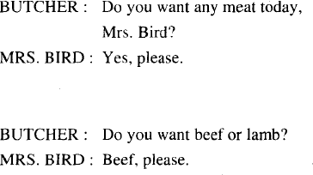

##### Lesson 50 单词句型讲解

* 1. tomato [tə'mɑːtəʊ] [tə'meɪtoʊ] : 西红柿
  2. potato [pə'teɪtəʊ] : 土 豆
  3. cabbage ['kæbɪdʒ] : 卷心菜
  4. lettuce ['letɪs] : 莴苣；生菜
  5. pea[piː] : 豌 豆
  6. bean [biːn] : 豆角
  7. pear [peə(r)] : 梨
  8. grape [ɡreɪp] : 葡 萄
  9. 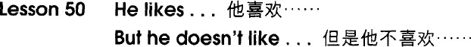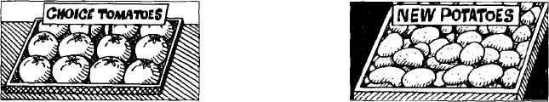peach [piːtʃ] : 桃 子草 莓 ：strawberry 西瓜：watermelon

am not, aren’t, isn’t, can’t, don’t, doesn’t

非动词 情态动词 实义动词

先看词性，再看人称

1. He likes coffee, but I don’t.
2. She likes tea, but he doesn’t.
3. He is eating some bread, but she isn’t.
4. She can type very well, but he can’t.
5. They are working hard, but we aren’t.
6. He is reading a magazine, but I am not.

##### Lesson 49&50 知识拓展

The kid is so strong. He can lifts this table. The kid is so strong. He can lift this table. 1). - Time !

- Yeah. And you miss your family?

A. fly, do B. flies, are

C. fly, does D. flies, do

√

#### 

1. The picture very nice.

she want to buy it?

# √

A. is, Do B. is, Does

#### 

C. are, Do D. are, Does

一千：one thousand

* 1423

one thousand

four hundred and twenty-three

* + 5736

five thousand

seven hundred and thrity-six

* + 4042

four thousand and forty-two

* + 7009

seven thousand nine

5416

3200

4833

9006

1832

##### Lesson 51&52 预习

1. 语法：一般现在时态描述天气；
2. 词汇：季节、月份、时间前的介词；
3. 知识拓展：

数词、sometimes 相关的词汇对比。

##### Lesson 51 单词讲解

1. Greece [ɡriːs] : 希腊Greek, 希腊人Athens, 雅 典
2. climate ['klaɪmət] : n.气候

weather n.天气

How is the climate in Beijing?

1. country ['kʌntri] : n.国家in my/your country
2. pleasant ['pleznt] : adj.宜人的

The weather is very pleasant. 令人开心、愉快的，

a pleasant dream 美 梦

a pleasant manner 随和的态度

1. weather['weðə(r)] : n. 天 气How is the weather today?

The weather is fine/ pleasant/ terrible.

1. spring[sprɪŋ]: n.春季summer['sʌmə(r)] 夏天

autumn ['ɔːtəm] / fall [fɔːl] 秋天winter ['wɪntə(r)] 冬天

1. windy['wɪndi]: adj.有风的

It’s windy today.

1. warm[wɔːm] : adj.温暖的It’s warm today.

炎热的, hot — 寒冷的, cold 温暖和, warm—凉爽的, cool

1. rain[reɪn]: v. 下 雨这里经常下雨。

It is often rain here. It often rain here.

It often rains here.

1. 经常的状态: 主语+ is\am\are
2. 习惯的动作: 主语+ v.
3. snow [snəʊ] : v.下雪这里经常下雪。

It often snows here.

1. 经常的状态: 主语+ is\am\are
2. 习惯的动作: 主语+ v.
3. sometimes ['sʌmtaɪmz] :

adv.有时

1. Jan. ['dʒænjuəri] 1 月13.Feb. ['februəri] : 2 月14.Mar. [mɑːtʃ] : 3 月15.Apr. ['eɪprəl]: 4 月16.May[meɪ]: 5 月17.June[dʒuːn] : 6 月18.July[dʒu'laɪ] : 7 月19.Aug. ['ɔːɡəst] : 8 月20.Sept. [sep'tembə(r)] :9 月21.Oct. [ɒk'təʊbə(r)] : 10 月
2. Nov. [nəʊ'vembə(r)] : 11 月
3. Dec. [dɪ'sembə(r)]: 12 月
   1. 首字母大写
   2. 可只记缩写

##### Lesson 51 语法讲解

1. 一般现在时态
   1. 经常的状态：主语+ is \am\ are+非动词
   2. 习惯的动作：主语+ v.
   3. 真理。
   4. 这里冬天经常是雪天。
   5. It’s often snowy in winter here. 这里冬天经常下雪。

It’s often snows in winter here.

It often snows in winter here. 这工作很简单。

The work is easy. 他在北京工作。

He is works in Beijing.

He works in Beijing.

1. 介词
   1. 可翻译的介词

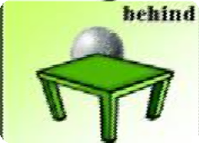

* 1. 无需翻译, 介词+时间/地点冬天非常冷。

It’s cold in winter.

in+ 时间/地点

in+月、季、年in April.

in summer

in 2019

in+地点（相对较大） in Beijing

In China

三月很暖和。

It’s very warm in March.

夏天经常是雨天。

It is often rainy in summer.

我打算 2026 年去南极旅行。

I am going to travel in the South Pole in 2026.

北京冬天很冷。

It is cold in Beijing in winter.

##### Lesson 51 课文讲解

1. 你来自哪里？

Where do you come from?

are?

do- 提问动词, are- 提问非动词come v.

from perp.

Where are you from?

* Where do you come from?
* I come from…
* Where are you from?
* I am from…

1. What’s the climate like? like, prep.像…一样

What’s the weather like?

What’s sth./ sb. like? What’s her boyfriend like?

What’s your boss like?

How’s sth./ sb.? How’s the climate? How’s the weather? How’s her boyfriend? How’s your boss?

What’s the climate like in…+国家/城市/季节/月份?

1. 三月经常是风天。March often windy.

It’s often windy in March. 注意：主语，介词！

It’s + 天气形容词 + in +时间/地点

四月很暖和。

It’s warm in April.

六七八月很炎热。

It’s hot in June, July and August.

这里夏天很凉快。

It’s cool here in summer.

这里冬天很暖和。

It’s warm here in winter.

四月和五月会下雨。

It’s rain in April and May.

rain- rainy snow- snowy

v.- adj. v.- adj.

It + 天气动词+ in+时间/地点

It’s + 天气形容词+ in +时间/地点

##### Lesson 52 单词句型讲解

1. the U.S. : 美国

the United States of America American 美国人

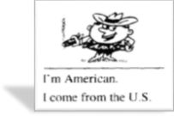

1. Brazil[brə'zɪl] :巴西Brazilian 巴 西 人

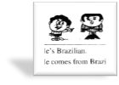

1. Holland:['hɔlənd] 荷兰Dutch 荷兰人

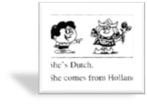

1. England: n. 英 国English 英国人

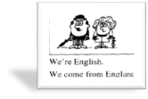

1. France [frɑːns] : 法 国French 法国人

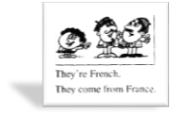

1. Germany['dʒɜːməni] : 德 国German 德国人

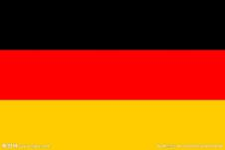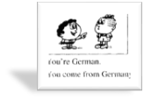

1. Italy['ɪtəli] :意大利Italian 意大利人

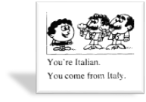

1. Norway['nɔːweɪ]:挪威Norwegian 挪威人

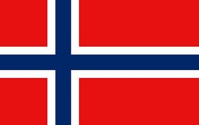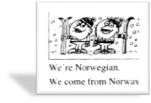

1. Russia['rʌʃə] :俄罗斯Russian 俄罗斯人

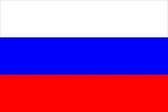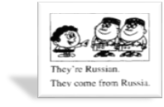

1. Spain: n.西班牙Spanish 西班牙人

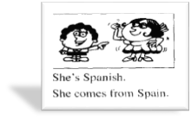

1. Sweden['swiːdn]: 瑞 典Swedish 瑞典人

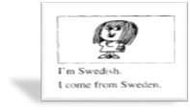

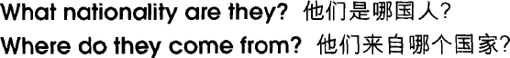

##### Lesson 51&52 知识拓展

1. sometimes: 有时，频率副词He is sometimes late.
2. sometime: 某时，副词

I hope to see you again sometime.

1. some time: 一段时间

It takes me some time to get there.

一万：ten thousand

* 20000

twenty thousand

* 50000

fifty thousand

* 80000

Eight thousand

* 21’423

twenty-one thousand

four hundred and twenty-three

* + 54’216

fifty-four thousand

two hundred and sixteen

* 82’691

eighty-two thousand

six hundred and ninety-one

* + 69’130

sixty-nine thousand one hundred and thirty

##### Lesson 53&54 预习

* 1. **话题：气候天气；**
  2. **词汇：频率副词；**
  3. **知识拓展：各种天气表达，数词**

**Lesson 53 单词讲解**

1. **mild [maɪld] : adj. 温和的，温暖的It is mild in fall. 秋天天气很温和。mild food 清淡的食物**

**spicy food 辛辣的食物**

1. **always ['ɔːlweɪz] : adv. 总是，一直，永远**
2. **north [nɔːθ] : 北 方**
3. **east [iːst] : 东 方**
4. **west [west] : 西 方**
5. **south [saʊθ] : 南 方**

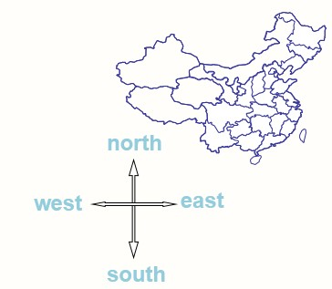

* 1. **in the north…**
  2. **in the north of…**

**Beijing is in the north of China.**

* 1. **news: 消息、新闻**
  2. **East, west ,home is best. 金窝银窝，不如自己的草窝。**

1. **wet [wet] : 潮湿的**

**water- wash- wine- wave- well- weep-woman…**

1. **season ['siːzn] : 季 节**

**一年有四季。**

**There are four seasons in a year.**

**They are spring, summer, fall and winter.**

1. **best [best] : 最 adv、最好的 adj. Green is my favorite color.**

**I like green best. （形前动后）**

**Beijing is my favorite city. I like Beijing best.**

**Spring is his favorite season.**

**He likes spring best.**

**Chinese is her favorite language. She likes Chinese best.**

***Little Prince* is my favorite book.**

***I like Little Prince* best.**

##### night [naɪt] : 夜晚、深夜evening: 傍 晚

1. **rise [raɪz] : 升 起**
2. **set [set] : 落 下**

**太阳每天上午 6 点升起，7 点落下。**

**The sun rises at 6:00 in the morning and sets at 7:00 in the evening.**

1. **early ['ɜːli] : 早 的 adj.\ adv.**
2. **late [leɪt] : 晚的 adj.\adv.**

**I am late today. adj. 我今天很晚。**

**I come late today. adv.**

**我今天来得很晚。**

1. **interesting ['ɪntrəstɪŋ] : 有趣的**
2. **subject ['sʌbdʒɪkt] : 话题、科目What’s the subject we are going to talk about today?**

**We have nine subjects this term.**

1. **conversation [ˌkɒnvə'seɪʃn] : 谈 话**

**Lesson 53 语法讲解**

1. **频率副词:**

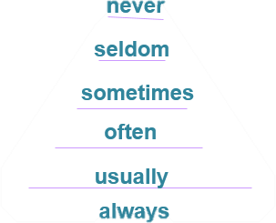

1. **频率副词的位置:**

**通常情、系后，实义前He can never sleep.**

**She is seldom ill.**

**He always loves her.**



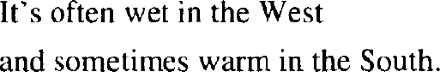

**位置移动语法上不错！ 我永远也记不住。**

**I can never remember.**

**I never can remember.**

**他老是迟到。**

**He is always late.**

**他经常吃肉。**

**He often eats meat.**

**Lesson 53 课文讲解**

1. **An interesting climate**
2. **What’s the climate\weather like in…+ (月份、季节、年、地点)?**
3. **描述天气的句型结构:**

**It is+ 形容词+ in+地点+时间**

**It + 动词+ in+ 地点+时间**

**春天天气很糟糕。It is terrible in spring. 西部气候很干燥。It is dry in the west.**

**厦门天气很宜人。It is pleasant in Xiamen.**

1. **Which seasons do you like best? Which are your favorite seasons? Which is your favorite season?**

|  |  |  |
| --- | --- | --- |
| **which+** | **单数名词：** | **哪一个** |
| **which+** | **复数名词：** | **哪一些** |

**Lesson 54 单词句型讲解**

**1.Australia- Australian: 澳大利亚，澳大利亚人2.Austria- Austrian: 奥地利，奥地利人3.Canada-Canadian: 加拿大，加拿大人4.China- Chinese: 中国，中国人**

1. **Finland- Finnish: 芬兰，芬兰人**
2. **India-Indian: 印度，印度人7.Japan-Japanese: 日本，日本人**
3. **Nigeria- Nigerian: 尼日利亚，尼日利亚人**
4. 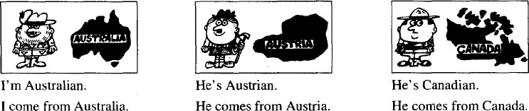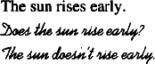**Turkey- Turkish: 土耳其，土耳其人10.Korea- Korean: 韩国，韩国人11.Poland-Polish: 波兰，波兰人12.Thailand-Thai : 泰国，泰国人**
5. **The sun sets late.**

***Does the sun set late?***

***The sun doesn’t set late.***

1. **He likes ice cream.**

***Does he like ice cream?***

***He does not like ice cream.***

1. **Mrs. Jones wants a biscuit.**

***Does Mrs. Jones want a biscuit?***

***Mrs. Jones does not want a biscuit.***

**Lesson 53&54 知识拓展**

1. **常见天气**
   1. **晴朗: sunny\ clear**
   2. **阵雨: rain showers**
   3. **小雪: light snow**
   4. **冰冻: freeze**
   5. **大部多云: mostly cloudy**
   6. **局部有风: partly windy**
   7. **飓风: hurricane**
   8. **雾霾: smoggy/haze**
   9. **暴雨洪灾: rain and flood**
   10. **沙尘暴: sandstorm**
2. **抱怨天气:**

**The weather is bad\ terrible.**

**I’m feeling a bit under the weather.**

1. **喜欢某种天气:**

**I like…\ I love… I’m crazy about…**

**点 钟 的 表 达**

* **5:00**

**five**

* **11:00**

**eleven**

* **9:00**

**Nine**

* **7:06**

**seven o six**

* **12:08**

**twelve o eight**

* **7:05**

**seven o five**

* **3:10**

**three ten**

* **10:20**

**ten twenty**

* **6:15**

**six fifteen**

* **5:42**

**five forty-two**

* **11:25**

**eleven twenty-five**

* **12:55**

**twelve fifty-five**

**年 份 的 表 达**

* **1983**

**nineteen eighty- three**

* **1912**

**nineteen twelve**

* **1995**

**nineteen ninety- five**

* **2000**

**two thousand**

* **2003**

**two thousand three**

* **2008**

**two thousand eight**

* **2012**

**two thousand twelve**

* **2015**

**two thousand fifteen**

* **2023**

**two thousand twenty- three**

**Lesson 55&56 预习**

1. 词汇：动词词组；
2. 课文：一般现在时态描述日常行为习惯；
3. 语法：三单后动词的变化。

##### Lesson 55 单词讲解

1. **live[lɪv]: v.住，生活（长期居住）**

live + at live + in

She lives at 23 Haidian Street. I live in Beijing.

##### stay[steɪ]: v.呆在，停留（短暂停留）

stay + at stay + in stay at home

stay at the hotel

stay in New York

##### arrive[ə'raɪv]: v. 到 达

arrive + at arrive + in

He arrives at the classroom early.

I arrive in Shanghai late.

##### home[həʊm] :

n.家 adv.在家，到家

1. **housework ['haʊswɜːk] n. 家 务**homework ['həʊmwɜːk] n. 家庭作业不可数

do some housework/ homework

做家务/做家庭作业

She never does the housework. 她从不做家务。

##### lunch [lʌntʃ] : n.午饭

breakfast n. 早 饭dinner n. 晚 饭

eat\ have breakfast\ lunch\ dinner

##### 7. afternoon [ˌɑːftə'nuːn] : n.下午

after 之后noon 正午

morning n. 早 晨

evening n. 傍 晚

night n. 夜 晚

in the morning\ afternoon\ evening at night

an evening dress

Good evening!

Good night!

##### usually['juːʒuəli] : adv.通常

usual: adj. 平常的unusual: adj. 不同寻常的

##### together[tə'ɡeðə(r)] : adv.一起

他们通常一起喝咖啡。

They usually drink coffee together. 咱一块干吧！

Let’s do it together.

##### Lesson 55 语法讲解

1. **home**

去学校：go to school 去上班：go to work 去睡觉：go to bed

去上海：go to Shanghai 回家：go to home

go home arrive home come home

home n. 家 adv. 在家，到家这是我的家。

This is my home.

欢迎来我家做客。Welcome to my home.

##### 表示地点的副词：

home/ there/ here/ upstairs/downstairs… stay here

go there come upstairs go downstairs

##### Lesson 55 课文讲解

1. **the Sawyer family**

the Sawyers：姓…一家人

the + 姓氏+ family \ the + 姓氏+s the Lee family/ the Lees

the Smith family/ the Smiths

##### The Sawyer family live at 87 King Street.

**…住在国王街 87 号。**

地址：大-小

海淀路 9 号： 9 Haidian Road

海淀区海淀路 9 号：

9 Haidian Road, Haidian District 朝阳区：Chaoyang District

北京市海淀区海淀路 9 号：

9 Haidian Road, Haidian District, Beijing 北京市朝阳区幸福街 4 号

4 Xingfu Street, Chaoyang District, Beijing

##### 动词短语：

go to work 去上班go to school 去学校take sb. to … 送 … 去

stay at home 呆在家里see her friends 见朋友

come home from work 下 班 回 家come home from school 放学回家go to bed 去睡觉

read a newspaper 看 报 纸watch television 看电视

谁？- 干什么？

我 7 点上学。(go to school…去上学) I go to school at 7：00.

他每天都去上班。(go to work 去上班)

He goes to work every day.

我送妹妹去火车站。(take sb. to … 送…去) I take my sister to the train station.

他每天都看报。(read newspapers 看报) He reads newspapers every day.

她经常下班回家很早。(come home from work 下班回家)

She often comes home from work early.

我通常晚上 11 点睡觉。(go to bed 去睡觉) I usually go to bed at 11:00 at night.

##### Lesson 56 单词句型讲解

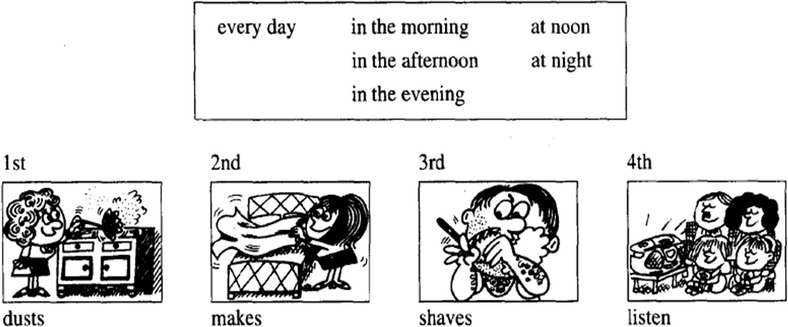

|  |  |
| --- | --- |
| **名词的复数** | **动词的第三人称** |
| A. +s | A. +s |

|  |  |
| --- | --- |
| a book- books | come-comes |
| a cat- cats | dust- dusts |
| a bottle-bottles | make-makes |
| My mother dusts the table every day. | |
| B. 辅音+y-ies | B. 辅音+y-ies |
| a lady- ladies | study-studies |
| a baby-babies | try- tries |
| My sister studies hard every day. | |
| C. s/sh/ch/x+es | C. s/sh/ch/x+es |
| a watch- watches | watch-watches |
| a bus- buses | pass-passes |
| a dish- dishes | wish- wishes |
| My dog watches TV every night. | |
| D. o+es | D. o+es |
| a potato- potatoes | go-goes |
| a hero- heroes | do-does |
| My father does the housework every day. | |

1. **The children go to school in the morning.**
2. **Their father takes them to school.**
3. **Mrs.Sawyer stays at home.**
4. **She does the housework.**
5. **She always eats her lunch at noon.**

**Lesson 55&56 知识拓展**

**She always eats her lunch.**

**The children always do their homework.**

**Mr.Sawyer usually reads his newspaper.**

**强调主语！**

**Lesson 57&58 预习**

* 1. 语法：一般现在, 现在进行的对比；
  2. 时间的表达；
  3. 英式美式英语的区别

##### Lesson 57 单词讲解

* 1. **o’ clock: 点钟，整点**3 点整：three o’ clock 5 点整：five o’ clock

12 点整：twelve o’ clock

##### shop[ʃɒp] : 商 店

书店：a book shop

免税店：a duty-free shop 服装店：a dress shop

玩具店：a toy shop

百货商店：department store（美）

##### 3. moment ['məʊmənt] : 片刻、瞬间

at the moment: 此 刻

She is learning English at the moment. 稍等片刻：

Wait a moment. = Wait a minute.

##### Lesson 57 语法讲解

**一般现在时 & 现在进行时**

1. 功能不同
   1. 一般现在：

习惯的状态、经常的动作、真理；

* 1. 现在进行：

此时此刻正在做、一段时间内做。

1. 结构不同：
   1. 一般现在：主语+is\am\are, 主语+v.
   2. 现在进行：主语+ is\am\are + doing
2. 时间状语不同
   1. 一般现在：every…always, usually, often, sometimes…
   2. 现在进行：now, at the moment…

我通常 12 点吃饭，但今天都这会了，2 点才吃呢！ I usually have lunch at 12:00.

But I am having lunch now at 2:00.

他通常 7 点画画，但今天现在在画。He usually draws at 7:00.

But he is drawing now today.

##### Lesson 57 课文讲解

1. **It is…**
   1. **天气；**
   2. **点钟；**
   3. **电话。**

春天天气很糟糕：It is terrible in spring. 现在是 8 点整： It is eight now.

是我，Venus：It’s me, Venus.

1. **The children go to school by car every day.** on foot-by bike-by bus-by car-by train-by air… 你是怎么去学校的？

How do you go to school?

我坐公交车去。

I go to school by bus.

##### But today, they are going to school on foot.

现在进行时态：主语+ is/am/are+ doing

一般将来时态：主语+is/am/are going to do/地点They are going to school.

他们正在去学校。

他们打算去学校。

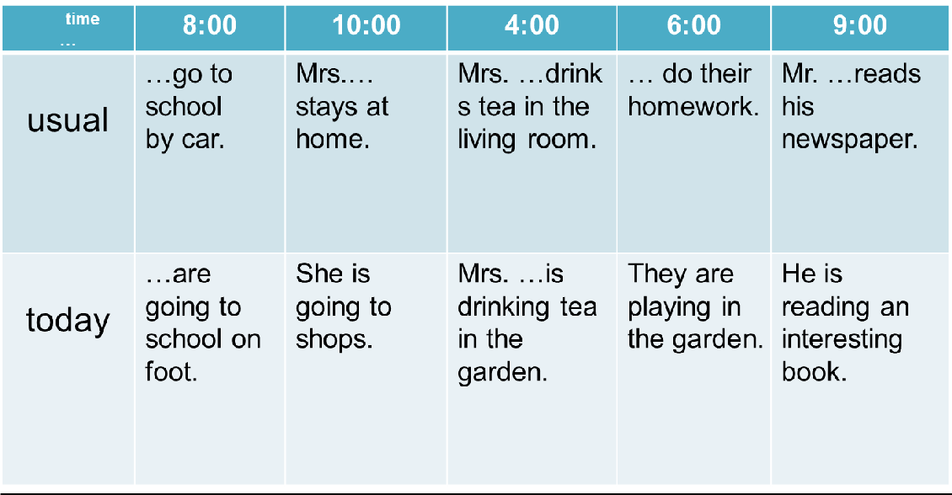

##### Lesson 58 单词句型讲解

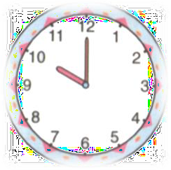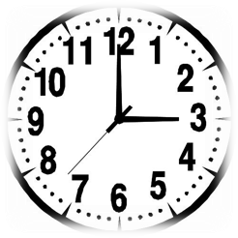**1. What’s the time? What time is it?**

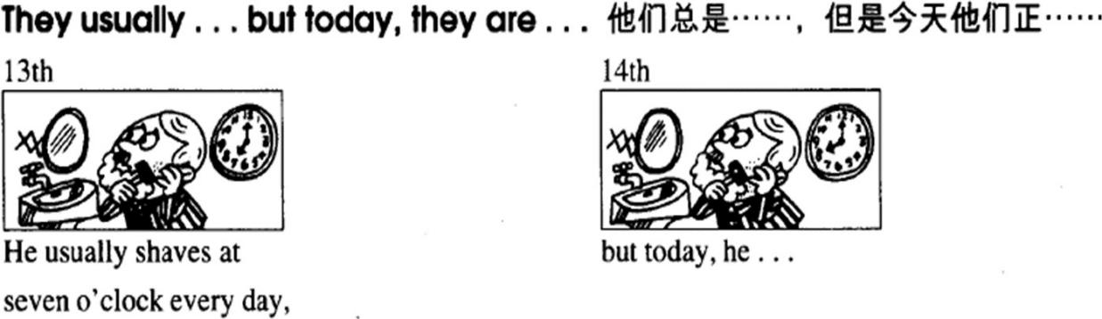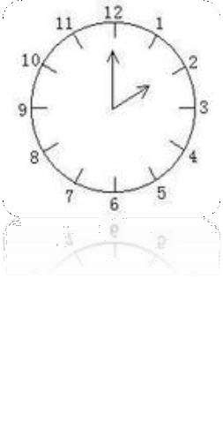

**two o’ clock**

**ten o’ clock**

**three o’ clock**

He usually shaves at 7:00 every day, but today, he shaves at 8:00.

##### Lesson 57&58 知识拓展

**American English**



**British English**

**British English**



1. **发音**
2. **书写**
3. **表达**
4. 发音

daughter, city, four, shirt，autumn…

1. 书写

color，favorite，chili，traveling…



coulor, favourite, chilli, travelling



1. 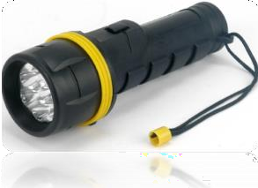表达

##### 美式：garbage flashlight mail

**英式：rubbish torch post**

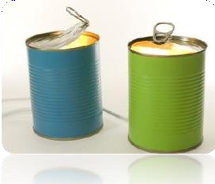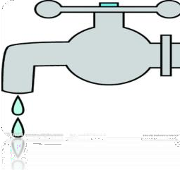

|  |  |  |
| --- | --- | --- |
| **美式：can** | **fall** | **faucet** |
| **英式：tin** | **autumn** | **tap** |

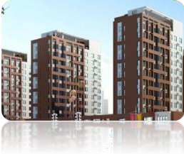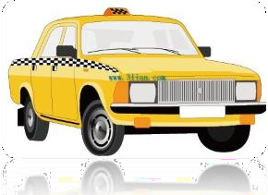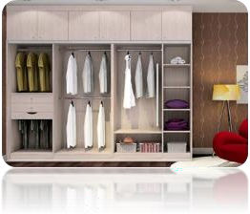

|  |  |  |
| --- | --- | --- |
| **美式：apartment** | **cab** | **closet** |
| **英式：flat** | **taxi** | **wardrobe** |

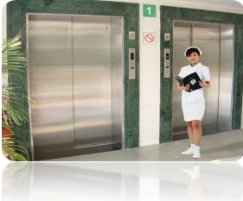

**美式：elevator cookie**

**英式：lift biscuit**

**Lesson 59&60 预习**

语法：have；

课文：购物场景；

知识拓展：序数词，购物口语表达。

##### Lesson 59 单词讲解

1. **envelope['envələʊp]: n.信封**
2. **writing paper :**

a piece of writing paper two pieces of writing paper

##### shop assistant : n. 售 货 员

1. **size[saɪz] : n.尺寸，尺码，大小**

S\M\L

S – small

M - medium ['miːdiəm] L - large

XS- extra small

small\ medium\ large size size 6\ size 7…

##### pad[pæd]: n.信笺簿

1. **glue[ɡluː]: n.胶水**

a bottle of glue

##### chalk[tʃɔːk] : n.粉笔

1. **change[tʃeɪndʒ]: n.零钱，找给的钱**

零钱：small change

不用找了：keep the change

##### Lesson 59 语法讲解

* 1. **Have 用法**

① 词性：实义动词；

② 人称变化：

I/You/We have… He/She/It has…

③ 疑问句：

Do you have…?

Does she/he/it have…?

④ 否定句：

don’t… doesn’t…

你有女朋友吗？

Do you have a girlfriend?

没有。

I don’t have a girlfriend.

她有男朋友吗？

Does she have a boyfriend?

没有。

She doesn’t have a boyfriend.

##### Lesson 59 课文讲解

1. **买东西时用来询问的句型：**

I want some…

Do you have any…? n.+ please

##### 一盒粉笔：a box of chalk

**一大盒粉笔：a large box of chalk**

**一瓶可乐：a bottle of cola**

**一大瓶可乐：a large bottle of cola**

**一杯水：a glass of water**

**一大杯水：a large glass of water**

1. **only adv. 仅仅，只有**

I have two watches.

I only have two watches.

I have only two watches.

##### I only have large ones.

ones- large pads

##### That’s all, thank you. 就这些了, 谢谢！

That’s all, thank you for your listening.

* 1. 发言完毕时；
  2. 讲课结束时；
  3. 购物时…

##### What else?

Who else? Which else? Where else?

What else do you want? Who else do you like? Which else is your favorite?

Where else do you want to go?

##### Lesson 60 单词句型讲解

**Do you have any…?**

**A. + 可数名词复数**

**friends\ envelopes\ bananas…**

**B. + 不可数名词**

**coffee\ tea\ time…**

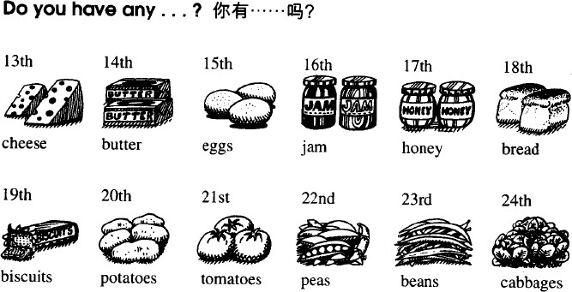

**Lesson 59&60 知识拓展**

**购物用语：**

1. 请问您这卖短裤吗？

Do you have any shorts?

I want some shorts, please.

1. 有的，您要什么尺码的？

Yes. What size do you want?

1. 我要中码。

I want medium size.

1. 我可以试穿吗？ Can I have a try?
2. 当然了。

Yes, of course.

1. 没问题，我要了。OK，this pair please.

##### 序数词：

第一：first 1st

第二：second 2nd

第三：third 3rd

第四：forth 4th

第五：fifth 5th

第六：sixth 6th

第七：seventh 7th

第八：eighth 8th

第九：ninth 9th

第十：tenth 10th

第十一：eleventh 11th

第十二：twelfth 12th

第十三：thirteenth 13th

第十四：fourteenth 14th

第十五：fifteenth 15th

第十六：sixteenth 16th

第十七：seventeenth 17th

第十八：eighteenth 18th

第十九：nineteenth 19th

第二十： twentieth 29th

第二十一： twenty- first 21st

第二十二： twenty- second 22nd

第二十三： twenty- third 23rd

第二十四： twenty- forth 24th

第二十五 ：twenty- fifth 25th

第二十六： twenty- sixth 26th

第二十七： twenty- seventh 27th

第二十八： twenty- eighth 28th

第二十九： twenty- ninth 29th

第三十： thirtieth 30th

第三十一： thirty- first 31st

第三十二： thirty- second 32nd

第三十三： thirty- third 33rd

##### Lesson 61&62 预习

* 1. **语法：感官动词；**
  2. **课文：感冒的话题；**
  3. **知识拓展：生病的口语。**

**Lesson 61 单词讲解**

**2. feel [fiːl] : v.感觉**

I feel cold.

She feels hot.

##### look [lʊk] : v. 看(起来)

She looks pretty.

##### must [mʌst] : 必 须

1. **call [kɔːl] : v. 叫、请**Please call the teacher. 请叫一下老师

##### doctor ['dɒktə(r)] : n. 医 生

1. **telephone ['telɪfəʊn] : n. 电话**

call sb. phone sb. give sb. a call

give sb. a phone

明天我来看你，万一我来不了，我会打电话的。

I’m going to see you tomorrow, but in any event ,I'll phone/I’ll call/give you a call.

##### remember [rɪ'membə(r)] : v.记得、记住

Do you remember? Oh, yeah, I remember. 哦，对， 我想起来了！

##### mouth [maʊθ] : n. 嘴 巴

Open your mouth. 张开嘴巴。

##### tongue[tʌŋ] :n. 舌 头

tongue twister 绕口令

A big black bear sat on a big black bug. Sixth sick Sheik’s Sixth Sheep’s sick .

##### bad [bæd] : adj. 严重的

a bad cold: 严重的感冒

##### cold [kəʊld] : n. 感 冒

a cold day(寒冷的一天)

a cold handshake (冷淡的,不热情) the cold color (冷色调)

a bad cold(感冒)

##### news [njuːz] : n. 消 息

a piece of news

We have nine subjects this term.

##### Lesson 61 语法讲解

**感官动词:**

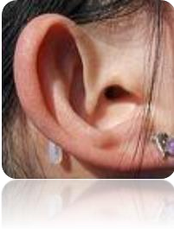

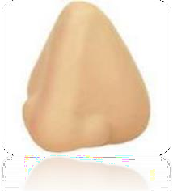

**2.**

look

feel

sound

**感官动词**

smell

taste

**Ａ. 感官动词－半系动词**

1. **一半实义动词**

① 人称&时态变化： do- does

look-looks, sound-sounds, feel-feels, smell-smells, taste-tastes

他看起来很忙。He looks very busy.

面包闻起来很香。The bread smells yummy.

② 疑问句**：** do/does

你做饭吗？Do you cook?

你感觉热吗？Do you feel hot?

音乐听起来美吗？

Does the music sound beautiful?

③ 否定句：

don’t/doesn’t

我不做饭。I don’t cook.

我感觉不热。I don’t feel hot.

音乐听起来不美。

The music doesn’t sound beautiful.

面包闻起来不香。

The bread doesn’t smell yummy.

##### 一半系动词

* 1. **实义动词- 副词**

She is listening to music carefully.

I eat my breakfast quickly.

##### 感官动词- 形容词

You look young.

It tastes good.

你像是很热。

You look very hot.

我觉得不舒服。I feel ill\sick.

这道菜尝起来不错。The dish tastes good.

这歌听起来很熟悉。

The song sounds familiar.

1. The girl looks , but she doesn’t do her homework **(c)**
   1. gentle; careful B. gently; carefully C. gentle; carefully
2. The music very nice. I enjoy listening to it again. **(B)**
   1. sound B. sounds C. hears
3. The food smells

and sells

.**(A)**

* 1. good; well B. good; good C. well; good

##### Lesson 61 课文讲解

1. **in bed（生病卧床）**

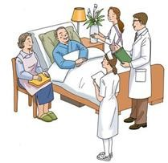

He is in bed. She is in the bed.



The man is in hospital.

The nurse is in the hospital.

1. **What’s the matter with him?** What’s the matter with sb. ? What’s wrong with sb.? What’s up?

##### 所以他必须在床上呆一周。

So he must in bed stay a week.

So he must stay in bed for a week.

**for+ 段时间，表示长达**

我今天上了 8 小时的课。

I have classes for eight hours today. 他必须在北京呆 10 年。

He must stay in Beijing for ten years.

##### That’s good news for Jimmy. 对于某人来说…

英语对他来说很简单。English is very easy for him.

北京的气候对她来说太干燥了。

It is too dry for her to stay in Beijing.

##### Lesson 62 单词句型讲解

1. **headache ['hedeɪk] : 头 疼**
2. **earache ['ɪəreɪk] : 耳朵疼**
3. **toothache ['tuːθeɪk] : 牙 疼**
4. **stomach ache ['stʌmək eɪk] : 胃 疼ache- 表示疼痛**

n. backache 背疼

v. My head aches.我头疼。

 **I have a headache.**

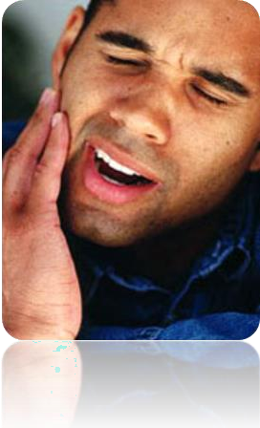 

##### have a toothache have a stomach ache

1. **flu [fluː] : 流 感禽流感: bird flu 猪流感: swine flu**

**have flu\ have bird flu…**

1. **measles ['miːzlz] : 麻 疹have measles**
2. **mumps [mʌmps] : 腮腺炎have mumps**
3. **dentist ['dentɪst] : 牙 医scientist: 科学家tourist: 旅行的人**

**typist: 打字员**

1. **medicine ['medsn] : 药 （不可数）**
2. **temperature['temprətʃə(r)] : 温 度发烧：**

**have a temperature**

**have a fever**

1. **aspirin ['æsprɪn] 阿斯匹林**

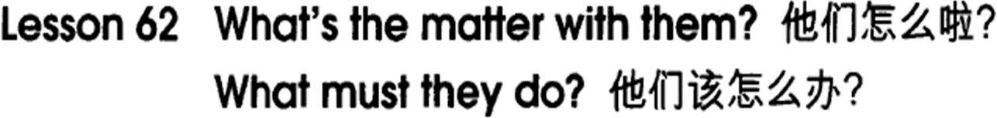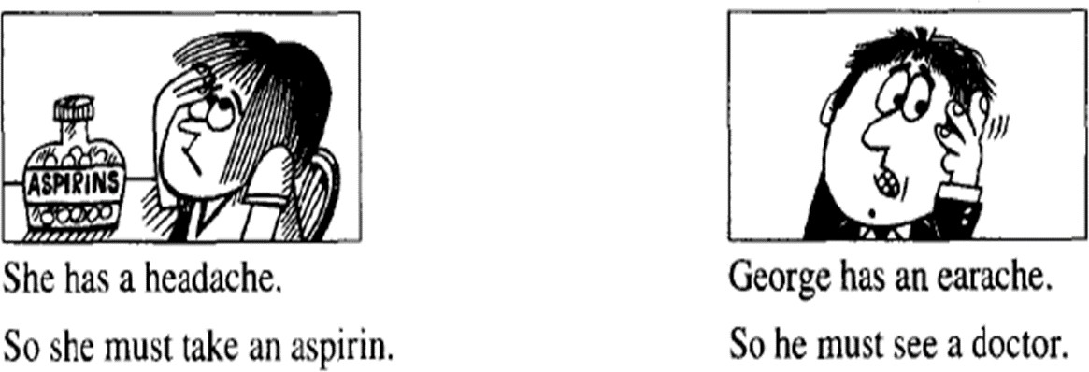

**重要短语：**

1. **take an aspirin**
2. **see a doctor**
3. **take some medicine**
4. **have a temperature**
5. **have flu**
6. **stay in bed 生病&解决办法**

 

He has a headache. The baby has a temperature.

What must he do? What must we do?

He must take an aspirin. He must see the doctor.

##### Lesson 61&62 知识拓展

1. **常见病症的表达:**

He is under the weather.

He has a runny nose.他流鼻涕。He sneezes. 他打喷嚏。

He has a scratchy throat. 他喉咙沙哑。

He has an allergy. 他过敏了。

##### 感冒如何解决？

* 1. stay in bed
  2. eat mild food
  3. drink more boiled water
  4. keep warm
  5. have some medicine
  6. see a doctor

##### 常用患病的词:

* 1. have\ has…
  2. take\ catch

Mary takes cold easily.

* 1. get…

I think she gets flu.

* 1. suffer from...

They suffer from flu.

##### Lesson 63&64 预习

* + 1. **语法：must 的否定；**
    2. **课文：生病话题，组织句子的注意事项；**
    3. **知识拓展：break 组成的口语表达。**

**Lesson 63 单词讲解**

**3. better['betə(r)]: adj.形容词 well 的比较级**

good-better well-better

I’m well.— I’m better.

##### certainly['sɜːtnli] : adv.当然

* + Can you help me?
  + Certainly!

1. **get up[ɡet ʌp] : 起 床**go to bed\ go to sleep 三单形式：

gets up\ goes to bed\ goes to sleep

##### yet[jet] : adv. 还，仍

否定、疑问句末

你还不能去上班呢。

You can’t go to work yet. 他还不会开车呢。

He can't drive yet.

##### rich [rɪtʃ] : adj.油腻的

rich food

A. 富 有的 B. 华丽的

a rich man rich silk

C. 肥沃的rich land

##### food [fuːd] : n. 食 物

rich food, 油腻的食物mild food, 清淡的食物spicy food,辛辣的食物green food, 绿色食品fast food, 快 餐

sea food, 海鲜 season ['siːzn] : 季节

##### remain [rɪ'meɪn] : v.保持，继续stay

I am going to remain/stay a long time in the city. 我打算在这个城市呆很长一段时间**。**

##### Lesson 63 语法讲解

**must**

1. **疑问：**

我 必 须 清 扫 屋 子 吗 ？ Must I clean the room？

##### 否定：

我不必清扫屋子。

I mustn’t clean the room. **mustn’t: 绝对不可以，禁止**你绝对不可以在这大吵。

You mustn’t make noise here. 你绝对不可以在这吸烟。

You mustn’t smoke here. 我不必清扫屋子。

I mustn’t clean the room.

I don’t need to clean the room. don’t need to… 不必，不需要你不必谢我。

You don’t need to say thanks to me.

##### Lesson 63 课文讲解

1. **You look very well.**

感官动词- adj.

你看起来很开心啊。You look very happy.

他看起来很忙啊。He looks very busy.

##### 你现在好多了，但还不能去上学呢。

**You are better now，**

**but you mustn’t go to school yet.**

mustn’t, 绝对不可以yet, 否定疑问句末

##### 你必须再卧床两天。

卧床：stay in bed，再：again

You must stay in bed two days again.

* 1. again, 再一次地Try again.

Say it again.

another two days another two weeks

* 1. **for**+ two days

翻译汉语时不需要，介词+时间

**for+ 时间段，长达**

for a week

for two months for three years

你必须再卧床两天。

You must stay in bed for another two days. 我必须在北京再呆三个月。

I must stay in BJ for another three months.

我必须再学两年英语。

I must study English for another two years. 我必须再休息 10 分钟。

I must take a rest for another ten minutes.

##### have a temperature

have a fever 三单：has

He has a fever.

Do you have a fever? Does he have a fever? I don’t have a fever.

He doesn’t have a fever.

##### 卧床:

stay in bed remain in bed

##### 他每天可以起床大约 2 小时。

He every day can get up about two hours.

① 谁 ？- 干 什 么 ？ He can get up …

② for+ 时间段，长达

He can get up for about two hours.

③ 时 间 every day .

Every day, he can get up for about …

##### 每天：every day & each day every 整 体

**each 个 体**

Hi, every one! 大 家 好 ！ Each man has his own name 每个人都有自己的名字**。**

1. **You must keep the room warm.**

**主 谓 宾 宾补The room is warm.**

**主 系 表**

**I’m going to paint it pink.**

**主 谓 宾 宾 补**

**Lesson 64 单词句型讲解**

1. **play[pleɪ]: v. 玩**
   1. play games 玩游戏
   2. play the violin 弹奏，拉琴
   3. play football\ basketball 踢球/打球

##### match [mætʃ] : n.火柴

matches

##### talk [tɔːk] : v.谈话

talk to sb. 与…谈话

Don't talk to me like that!

Don’t talk to strangers.4.China- Chinese: 中国，中国人

##### library ['laɪbrəri] : n.图书馆

in the library

##### drive [draɪv] : v. 开 车

drive a car

##### so [səʊ] : adv.如此地

so beautiful \ so much

##### quickly ['kwɪkli] : adv.快地

He drives so quickly.

##### lean out of : 身体探出

lean [liːn], 倾斜，偏向，弯斜

lean out of the window 把身子探出窗户 10.Korea- Korean: 韩国，韩国人

##### break[breɪk]: v.打破

Don’t break it!

##### noise[nɔɪz]: n. 喧闹声

发出噪音

make the noise

##### Lesson 63&64 知识拓展

1. **give me a break**

Give me a break! I am nervous enough. 行行好吧,我已经够紧张的了。

Give me a break! Is she blind or what? 拜托，她眼睛瞎了吗?

**拜托/ 放过我吧/ 行行好吧/ 不要强求我**

1. **break up**

**They break up the partnership. 他们终止了合作关系。**

**She breaks up with her boyfriend.**

**她和男朋友分手了。终止/ 结束/ 分手**

**Lesson 65&66 预习**

* 1. **词汇：反身代词；**
  2. **课文：各种时间的读法；**
  3. **知识拓展：时间前的介词。**

**Lesson 65 单词讲解**

* 1. **Dad: 爸爸（口语）**
  2. **key [kiː] : 钥 匙**

门的钥匙：the key to the door 车的钥匙：the key to the car

书的颜色：the color of the book

张艺谋的电影：ZhangYimou’s movie

1. **baby ['beɪbi] : 婴儿、宝贝**baby- kid(child)-teenager baby, honey, sweetheart…

##### hear [hɪə(r)] : 听 见

Listen! Can you hear it? Look! Can you see it?

Look for it! Can you find it?

##### enjoy [ɪn'dʒɔɪ] : 玩的开心en- 使 得

enlarge, endanger, enslave, enjoy…

* 1. 过的愉快、玩的开心I enjoy my holiday.
  2. 喜欢

I enjoy the song every day.

##### mum [mʌm] : 妈 妈

mom

##### Lesson 65 法讲解

**反身代词：**

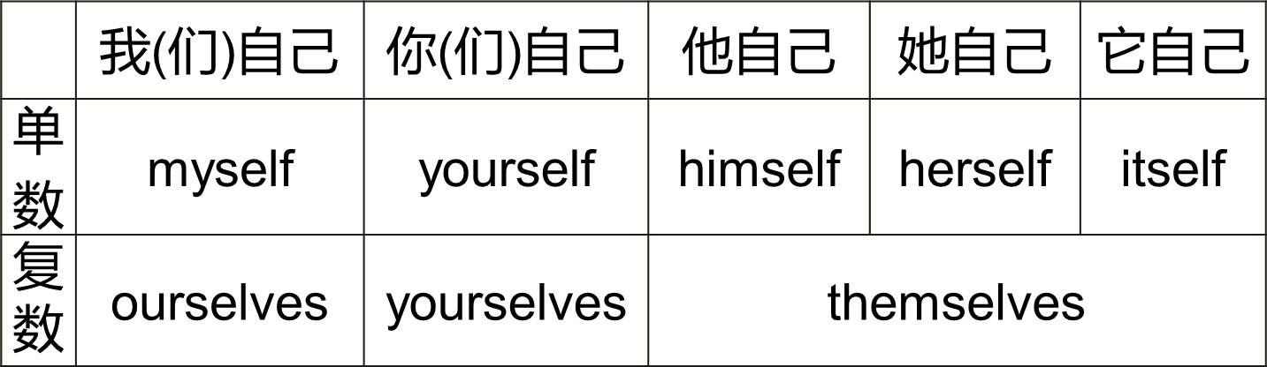

1. 英语中为什么有反身代词？
2. 何时用？

##### 强调主语&宾语

He himself sent me a gift.

他亲自送我一件礼物。I see Obama himself.

我见了奥巴马本人。

##### 不言而喻的宾语

Take good care of yourself.

Enjoy yourself.

1. 用法？

##### 介词+ 反身代词

**by oneself 独自、依靠自己**

I’m going to swim by myself.

He’s going to learn English by himself.

##### between oneself 私 下

It’s just between ourselves.

##### 动词+ 反身代词

**enjoy oneself 玩的开心、过的愉快**They always enjoy themselves. **help oneself 随 意**

Help yourselves, please.

##### Lesson 65 课文讲解

1. **You must be home at half past ten. must\can+ be+ 非动词**

他能够在这呆很久。

He can be here for a long time. 他们必须 9 点到这。

They must be here at 9:00.

##### 回家：

be home\ get home\ come home\ arrive home…

##### …the key to the front door.

**前门的钥匙**

the front door& the back door the key to …

the answer to the question the exit to the building the ticket to the movie

##### 年龄的表达：

**…years old**

**…year - old**

19 岁：nineteen years old nineteen year-old

##### Enjoy yourself. 玩的开心啊

Enjoy your holiday. Enjoy your class.

Enjoy your dinner party. Have a nice day.

##### Lesson 66 单词句型讲解

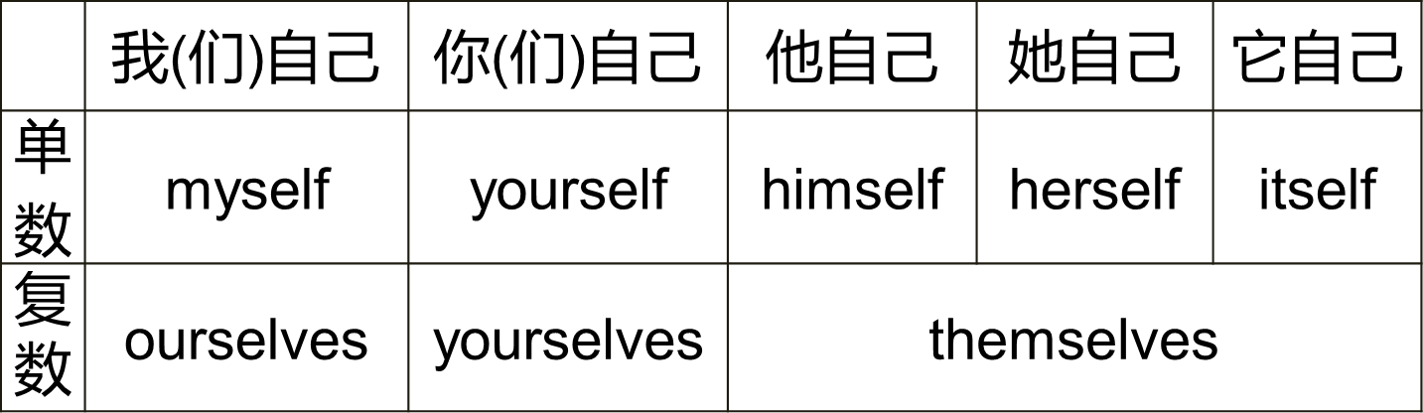

What’s the time? 时间的读法：

3:00 three o’clock

**past- 过 to- 差7:30** seven thirty

half past seven

half to eight

**4:20** four twenty

twenty past four forty to five

**11:40** eleven forty

forty past eleven twenty to twelve

**a quarter- 15 分钟10:15** ten fifteen

fifteen past ten

a quarter past ten

**2:45** two forty-five

forty-five past two three quarters past two fifteen to three

a quarter to three

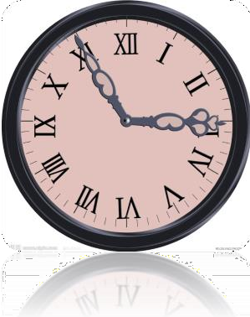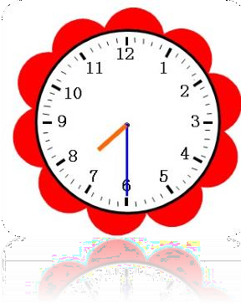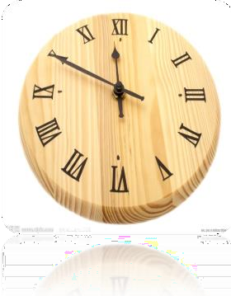

two fifty-five five to three

fifty-five past two

seven thirty thirty past seven half past seven half to eight

two quarters past seven

eleven fifty ten to twelve

fifty past eleven

##### Lesson 65&66 知识拓展

**时间前是否加介词？**

**1. 需加介词的情况：**

at + 点on+ 天

in + 月、季、年

1). I often meet him **at** ten o’clock . 2). They come back _**in** May.

1. It’s clod _**in** winter and hot_**in** summer.
2. His birthday is _**on** May 1st.
3. She must get up early **on** Monday.
4. I’m going to arrive **at** 10:00 **on** Friday.
5. I am going to see him **at** ten o’clock .
6. It often rains in **November**.
7. Where do you come **from**? I come from **France**.
8. I always go to work **in** the morning.
9. What is the climate like **in** your country?
10. It’s cold **in** winter and hot **in** summer.

##### 不需用介词的情况：

today\ tomorrow\ yesterday\ this…\that…\next…\last…

* 1. It’s sunny today.
  2. I’m going to meet some friends tomorrow. 3). He is going to go abroad next year.

4). He is free this month.

##### Lesson 67&68 预习

1. **语法：一般过去时态；**
2. **词汇：星期的表达；**
3. **知识拓展：“我也是”。**

**Lesson 67 单词讲解**

**6. greengrocer ['ɡriːnɡrəʊsə(r)] :**

n.蔬菜水果零售商grocer: 零售商

at the greengrocer’s: 在蔬菜水果零售店at the butcher’s: 在肉店

at the doctor’s: 在诊所

at the grocer’s: 在零售店

##### absent ['æbsənt] : adj.缺席的

He is absent today.

He is absent from school today.

**be absent from…**

meeting \ school \ work \ class… She is not absent from the meeting.

她没有缺席会议。

##### keep [kiːp] : v.(身体健康)处于(状况)

keep healthy 保持健康 4. hear [hɪə(r)] : 听 见

##### spend [spend] : v. 度 过

* 1. **spend + 时间+ 地点**

He spends two days in Beijing. He stays in Beijing for two days.

* 1. **spend + 时间+ with sb.**

He spends two weeks with his girlfriend.

##### weekend [ˌwiːk'end] : n.周末

1. **country['kʌntri] : n.乡村i**n the country 在乡下

in the city 在城里in the village 在 村 里 国家, in my country

##### lucky['lʌki] : adj.幸运的

You are so lucky! You are a lucky dog.

##### 首字母大写 B. on + 天

1. **Sunday: n. 星期日**
2. **Monday: n. 星期一**
3. **Tuesday: n. 星期二**
4. **Wednesday: n.星期三**
5. **Thursday: n.星期四**
6. **Friday: n.星期五**
7. **Saturday: n.星期六**

**Lesson 67 语法讲解**

**一般过去时态L31：现在进行L37：一般将来L49：一般现在**

**一般现在时态**

**一般过去时态**

1. 经常的状态： 过去经常的状态： 主语+ is \am\ are 主语+ was\wer
2. 习惯的动作： 过去习惯的动作： 主语+ v. （动词） 主语+ v.（did）
3. 真理：

主语+ is \am\ are 主语+ v.（动词）

##### 主语+was\ were

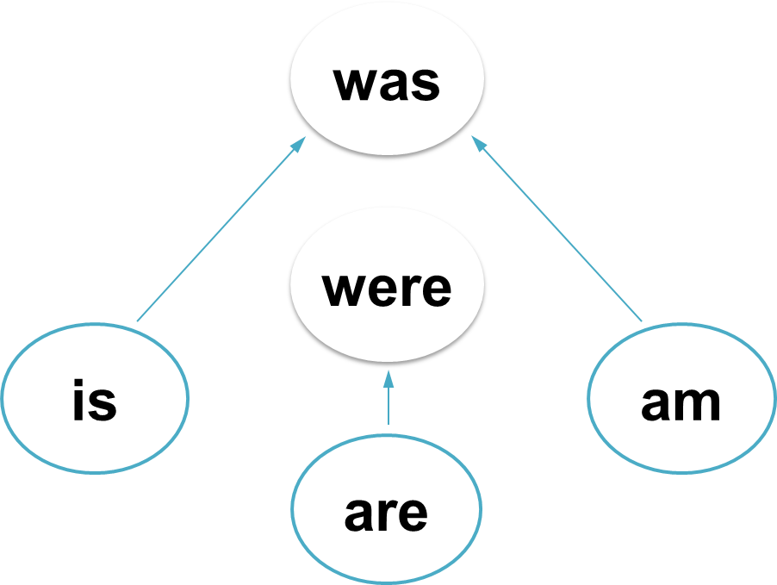

They were young.

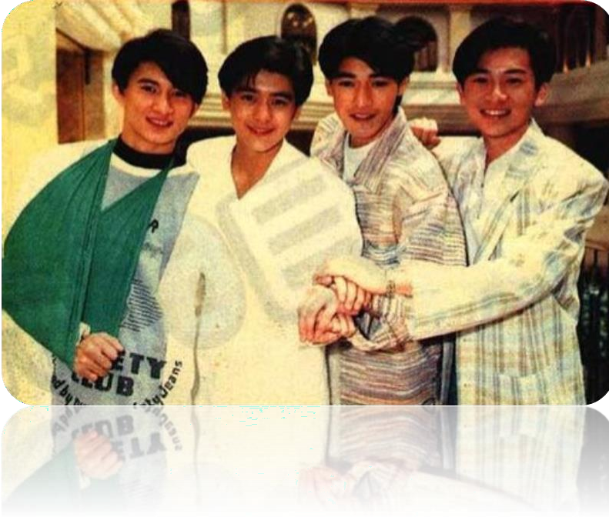

She is beautiful.

She was beautiful.

He is a boy.

He was a boy.

You are at home.

You were at home.

##### 一般过去时态

A. 过去（经常）的状态： 主语+ was\were+非动词

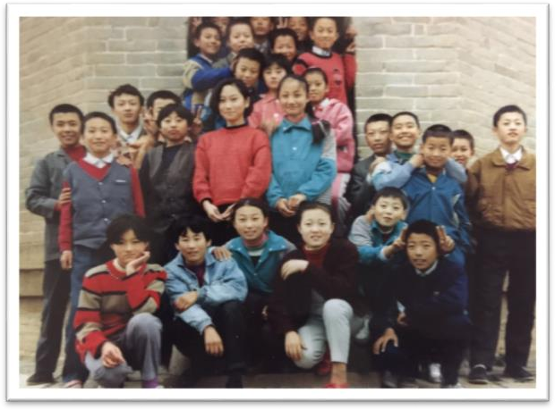

当时我上小学。

I was in the primary school. 当时我穿着红色衣服。

I was in red.

当时我在最前面。I was in front.

当时我左手托着腮帮。

My chin was in my left hand. I was a rich man.

##### 一般过去时态

过去（经常）的状态： 主语+ was\were+非动词

##### 一般疑问句：was/were 提前

Were you a rich man? Were you a poor man? **否定句：was/were+ not** You were not a rich man.

You were not a poor man.

##### Lesson 67 课文讲解

1. **回家：at the butcher’s: 在肉店**

Were you at the butcher’s? 你刚在肉店吗？

**were- 过去式**

Are you at the butcher’s? 你现在在肉店吗？

##### How’s Jimmy today?

**How is…?**

**’s(is was has)**

**Lesson 68 单词句型讲解**

1. **church[tʃɜːtʃ]: n. 教 堂**

at church 在教堂

##### dairy ['deəri] : n.乳品店

at the dairy

##### baker['beɪkə(r)] : n.面包师傅

at the baker’s 在面包店

##### grocer ['ɡrəʊsə(r)] : n.食品杂货商

at the grocer’s 在杂货铺

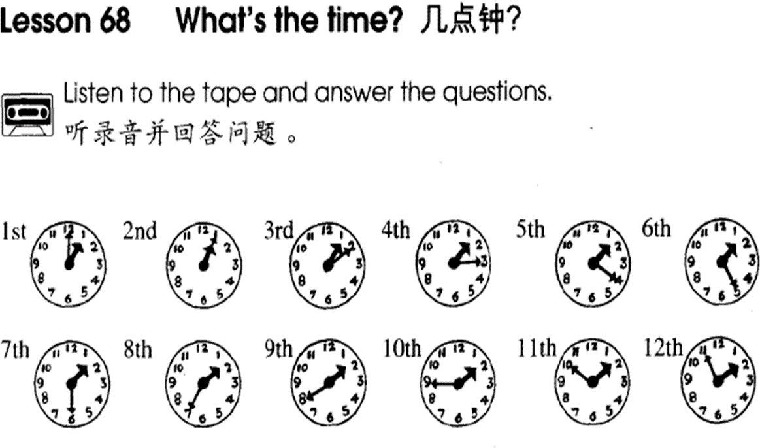

##### Where were you on Sunday, Jan. 1st?

**I was at church.**

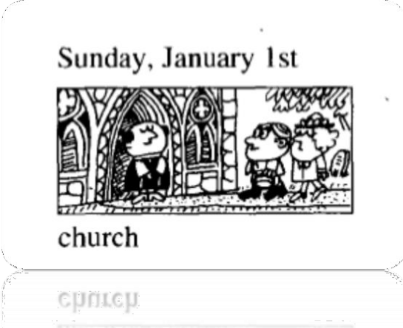

**When were you at the butcher’s?**

**I was at the butcher’s on Wed, Apr. 4th.**

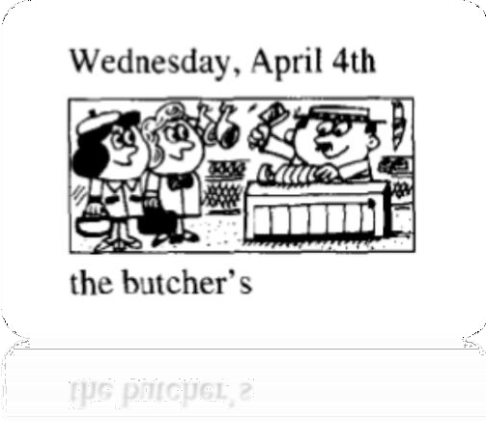

书面练习

完成下列句子，必要时填上定冠词 the

1. I was at ~ church on Sunday.
2. I was at the office on Monday.
3. My son was at ~ school on Tuesday.
4. My wife was at the butcher’s on Wednesday.
5. She was at the grocer’s on Thursday.
6. My daughter was in the country on Friday.
7. I was at ~ home on Saturday.

##### Lesson 67&68 知识拓展

我也是。Me too.

* I love Beijing. What about you?
* Me too.

-I don’t love Beijing. What about you?

-Me either.

-My keys are in the car. What about your keys?

-Mine too.

-My favorite sport is swimming. What about you?

-Mine too.

##### Lesson 69&70 预习1.语法：There be 句型的一般过去；

* 1. **词汇：时间前的介词；**
  2. **知识拓展：There be 句型。**

**Lesson 69 单词讲解**

1. **year [jɪə(r)] : 年**1998 年 ：in 1998 2019 年 ：in 2019

蛇年：the year of the snake 猪年：the year of the pig

猴年：the year of the monkey

今年：this year 去年：last year

今年是猪年，去年是狗年。It is the year of the pig

and it was the year of the dog.

##### race [reɪs] : 比 赛

比速度- 汽车比赛、划船比赛、赛跑

a car race, a boat race, a running race 球类比赛：match

a football match

a basketball match…

##### town [taʊn] : 城 镇

village- town- city

##### crowd [kraʊd] : 人 群

in the crowd

a crowd of people

##### stand [stænd] : 站 立

1. **exciting [ɪk'saɪtɪŋ] : 令人激动的**

The football match is exciting.

##### just[dʒʌst] adv. 正好，恰好

1. **finish: 完成、结尾v.**

I must finish it on time.

##### n.= ending

It is a good finish(ending) of the movie.

##### winner ['wɪnə(r)] : n. 获胜者

win- winner the first

##### behind [bɪ'haɪnd] : prep. 后 面

in front : 前 面

##### way [weɪ] : 路 途

* 1. on the way…

在去学校的路上：

on the way to school 在回家的路上：

on the way home

* 1. No way!
  2. By the way,…顺便

##### Lesson 69 语法讲解

**There be 句型的过去式**

1. 构成： There be (was, were)+地点
2. 用法： 拥有---have

存在---There be

1. 分类：

There was…+ 单数名词There were…+复数名词

1. 使用：

酒店昨天有很多客人。

There were hundreds of guests in the hotel yesterday. 奥运会时北京的老外特别的多。

There were many foreigners in Beijing during the Olympic Games.

1. 疑 问 句 ： was/were 提 前

从前这里有一条河。

There was a river here before. 从前这里有一条河吗？

Was there a river here before? 以往北京也有这么多地铁线吗？

Were there so many subway lines in Beijing?

人行道上昨天有垃圾吗？

Was there litter on the pavement yesterday？

1. 否定句：

was/were+not

从前这里有一条河。

There was a river here before. 从前这里没有河。

There was not a river here before.

##### Lesson 69 课文讲解

1. **There were hundreds of people there.**

hundred: 百

one hundred, two hundred… hundreds of… : 成百上千的thousands of…:上千上万的millions of…:不计其数的

##### My wife and I were at the race.

You and I… She\ he and I… Lucy, you and I

at the race: 在比赛现场

##### You can see us in the crowd.

1. **There were twenty cars in the race.**

in the race: 参加比赛

##### He was in car number 15.

他在 15 号车里。

15 号 车 : car number 15 (car 15)

10 号 线 : Line 10

601 室 : Room 601

19 站 台 : Platform 19…

1. **其他 5 辆车？** other five cars five other cars 其他两位老师:

two other teachers

##### On the way home…

1. **My wife said to me, “…”.**

is-was

am-was are-were say-said

##### Lesson 70 单词句型讲解

1. **stationer ['steɪʃənə(r)] : 文具商**

在文具店：at the stationer’s 在肉店：at the butcher’s

在蔬菜水果店：at the greengrocer’s

##### Denmark ['denmɑːk] : 丹 麦

Danish: 丹麦人

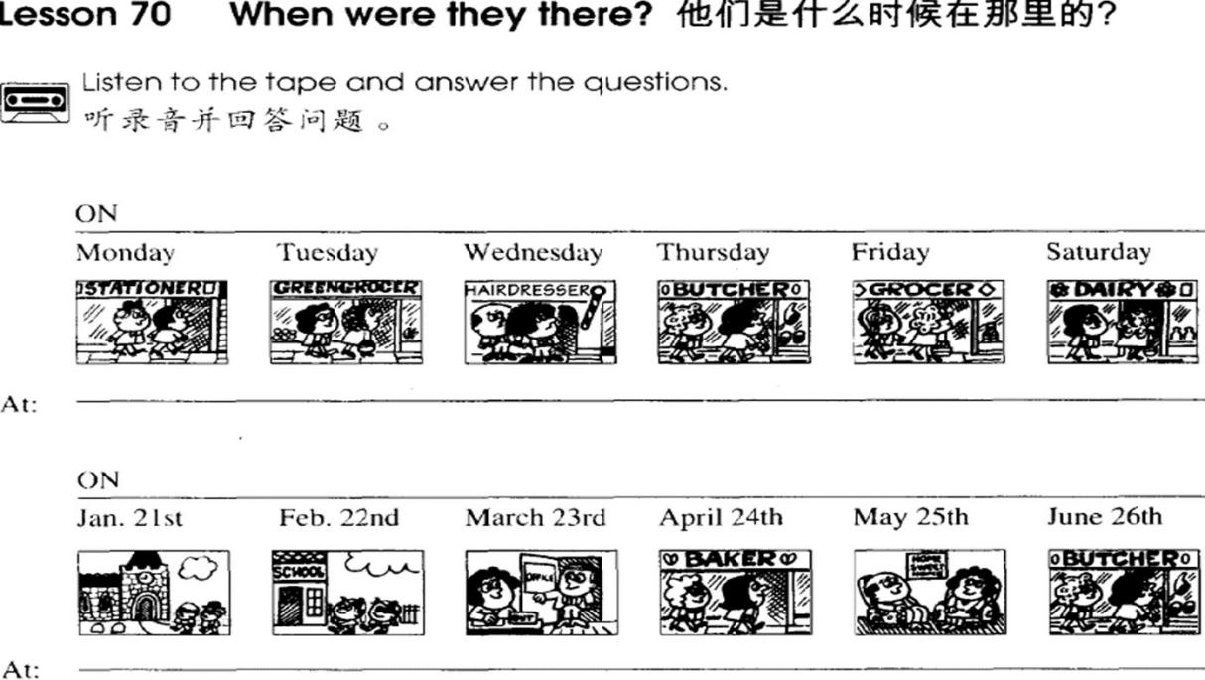

##### at+ 点on+ 天

**in+ 月、季、年**

完成以下句子，用适当的介词填空。

We were at the stationer’s on Monday.

We were there at four o’clock .

They were in Australia in September.

They were there in spring.

On November 25th, they were in Canada.

They were there in 1990.

##### Lesson 69&70 知识拓展

Where there is a will, there is a way. 有志者, 事竟成。

Where there is great love, there are always miracles.

哪里有真爱存在，哪里就有奇迹。

Without ideal, there is no secure direction; without direction, there is no life.

没有理想，就没有坚定的方向; 没有方向，就没有生活。

##### Lesson 71&72 预习

1. **语法：一般过去时态；**
2. **课文：过去式的应用；**
3. **知识拓展：电话用语。**

**Lesson 71 单词讲解**

1. **awful ['ɔːfl] : adj.让人讨厌的，坏的**

He is awful. 他真讨厌。

##### telephone ['telɪfəʊn] : v .& n.打电话

1. **time [taɪm] : n.次(数)**

one time = once two times = twice three times

##### answer ['ɑːnsə(r)] ['ænsər ]: v.接(电话)

answer the phone 接电话answer the question 回答问题

##### last [lɑːst] : a.最后的，前一次的

last time, 上 次last week, 上 周

last month, 上个月last year, 去 年

##### phone [fəʊn] : n.电话(=telephone)

1. **again [ə'ɡen] : adv.又一次地**

Try again. 再试一次。Do it again. 重做。

See you again. 再次见面

##### say [seɪ] : v.说

过去式—said

say hello to sb. 问 好

say good-bye to sb. 道 别

He said good-bye to me yesterday. 他昨天向我道别了。

##### Lesson 71 语法讲解

**一般过去时态**

* 1. 过去(经常的)状态：

主语+ was\were+ 非动词

* 1. 过去(习惯的)动作： 主语+ v.（did）

Michelle visited China in 2014.

I watched “Toy story 3” last month.

 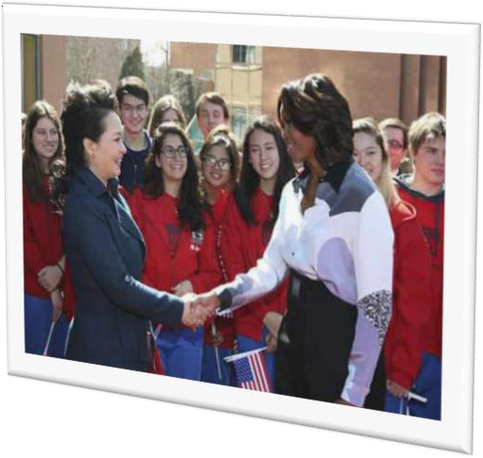

I cleaned my room this morning.

She helped me yesterday.

They enjoyed themselves last weekend.

##### “ 时 态 - 动 词 ” do-did



动词

**动词过去时的变化:**

1. **一般情况+ ed, call—called; air— aired；**
2. **以字母 e 结尾+ d, live—lived; love—loved；**
3. **以辅音字母+ y 结尾,变 y 为 i +ed, try—tried; study—studied；**
4. **辅+元+辅（汉堡包结构),将辅音字母双写+ed, stop—stopped.**

我 2010 年在美国学习。**（study-studied）** I studied in the US in 2010.

公车刚刚停下来了。**（stop-stopped）**

The bus stopped just now.

他们两年前居住在纽约。**（live-lived）** They lived in New York two years ago.

我上午给房间通风了。**（air-aired）** I aired the room this morning.

##### 一般现在时态:

**疑问句：**

**Do\does + 动词？ 否定句：**

**Don’t \Doesn’t+ 动 词**

**一般过去时态: 疑问句：**

**Did + 动词？**

**否 定 句 ： Didn’t + 动 词**

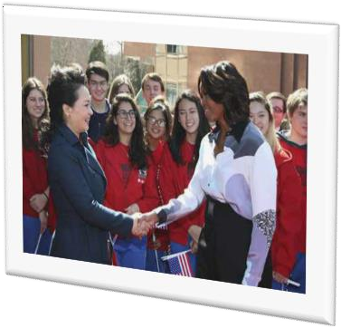Michelle visited China in 2014.

Did Michelle visit China in 2014?



I watched “Toy story 3” last month.

I didn’t watch “Toy story 3” last month.

I cleaned my room this morning.

I didn’t clean my room this morning.

She helped me yesterday.

She didn’t help me yesterday.

They enjoyed themselves last weekend.

They didn’t enjoy themselves last weekend.

I went to Hollywood nine years ago.

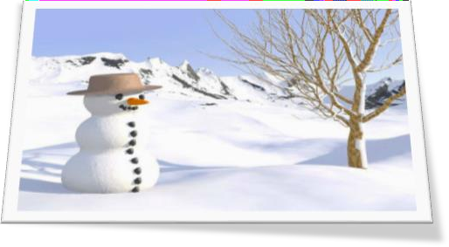 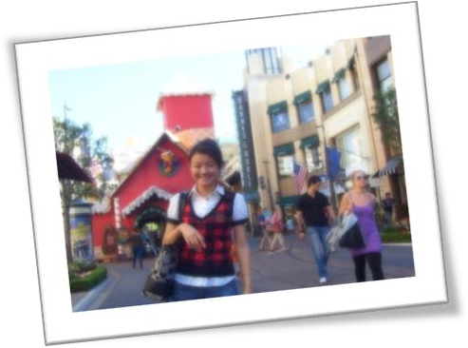

I made a snow man last winter.

##### Lesson 71 课文讲解

1. **What’s Ron Marston like?**

What’s the weather like?

##### 他昨天给我打了四个电话。

He phoned me four telephones yesterday. He phoned me four times yesterday.

我昨天接了 6 个电话。

I answered the six phones yesterday.

I answered the phone six times yesterday.

##### 昨天：yesterday

前天：the day before yesterday 昨天早晨： yesterday morning

前天早晨： the day before yesterday in the morning 昨天下午： yesterday afternoon

前天下午： the day before yesterday in the afternoon

昨天傍晚： yesterday evening

前天傍晚： the day before yesterday in the evening 昨天夜里：last night

前天夜里：the night before last(night)

1. **动 词 的 过 去 式 ：** telephone- telephoned answer-answered

say- said

arrive- arrived

##### Lesson 72 单词句型讲

**When did you…?**

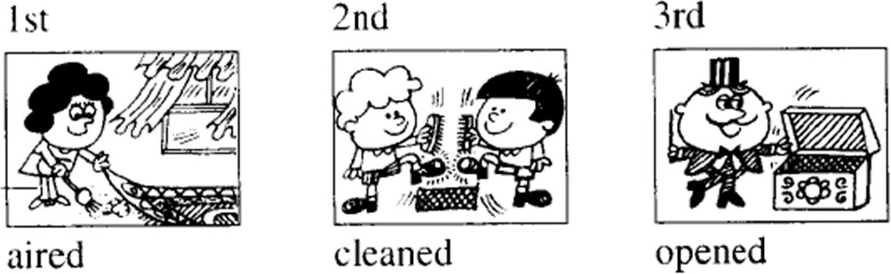

When did you air the room?

I aired the room in the morning. 1.It rained yesterday.

1. It snowed yesterday.
2. He boiled some eggs yesterday.
3. We enjoyed it yesterday, too.

##### Lesson 71&72 知识拓展

**电话用语**

* 你好！我是 Venus。

Hello. It’s Venus.\ This is Venus.

* 请问李先生在吗？ Is Mr. Lee in?

-请问您是哪位？

Who is calling please?

-我是他的朋友，Venus. It’s his friend, Venus.

-请稍等。

Please hold on.

-对不起他去开会了。 Sorry, he is in a meeting.

Where there is a will, there is a way.

-那好吧，请让他一会给我打过来好吗？ OK，tell him to call me latter.

-好的。

Ok. Bye.

##### Lesson 73&74 预习

1. **课文：问路场景；**
2. **词汇：副词；**
3. **语法：句子的组织步骤。**

**Lesson 73 单词讲解**

1. **week [wiːk] n. 周**这 周 ：this week 上 周 ：last week 下周：next week

##### London ['lʌndən] : n. 伦 敦

London is the capital city of Britain.

##### suddenly ['sʌdənli] : adv. 突然地

1. **bus stop: n. 公共汽车停靠站**

bus station: 公共汽车总站

##### smile [smaɪl] : 微 笑laugh [lɑːf] [læf] : 大 笑v./ n.

He said and smiled.

She is telling me a story with a smile. They are talking and laughing.

##### pleasantly ['plezntli] : adv. 愉快地

1. **understand [ˌʌndə'stænd] : v. 懂得、明白**

understood

##### speak [spiːk] : v. 讲话、说话

spoke say -said

speak: A. 说话的能力；B. 语言。

say: 说话的内容。

对某人说: say to sb. \ speak to sb 这孩子很小，还不会说话。

The baby is too young, he can’t speak.

他说这是对的。

He said, “It’s right.”

我会说法语。

I can speak French.

1. It's very cloudy now. But the radio

it’s going to be sunny this afternoon.

* 1. speaks B. tells

C. talks **D. says**

1. He is super. He can English, French and Chinese.
   1. say **B. speak**

C. talk D. tell

##### hand [hænd] : n. 手

a green hand: 新 手

##### pocket ['pɒkɪt] : n. 衣 袋

pocket money: 零用钱

He put his hands into his pockets.

##### phrase [freɪz] : n. 短 语

phrasebook: 短语手册

##### slowly ['sləʊli] : adv. 缓慢地

**Lesson 73 语法讲解**

* 1. **副词**
     1. **功能**
     2. **位置**
     3. **种类**

地点副词：here,there,home

频率副词：always,often,sometimes 时间副词：today,yesterday…

方式副词：slowly, suddenly, quickly…

##### 演变

**adj.- adv. （…的—…地） 形容词-副词之规则**

1. 一般直接+ly,如 quickly;
2. 辅+y 结尾,变 y 为 i +ly, 如 lazy-lazily, happy-happily; 3). 以 ll-结尾,直接+y,如 fully;

4). 辅音+le ,e 变 y, 如 able-ably, single-singly; 5). 元音+e 结尾,去 e+ly, true –truly .

1. He is not the winner, but he runs very .
   1. quick **B. quickly** C. slow D. slowly
2. She is a very girl.
   1. **lovely** B. love C. loves lovely: 可爱的

deadly：致命的

friendly: 友好的

##### 句子组织的 5 步骤：

谁？

干了什么？ 如何干的？ 在哪干的？ 何时干的？

1. 他每天开心地在家等她。谁 ？ He

干什么？waits for her

如何干的？ happily

在哪干的？ at home 何时干的？ every day.

1. 我昨天忙碌地在商场买了很多鞋。

谁 ？ I

干什么？bought many shoes 如何干的？ busily

在哪干的？ in the mall 何时干的？ Yesterday

1. 我今上午突然在教室里发现一个不认识的人。谁 ？ I

干什么？found a stranger

如何干的？ suddenly

在哪干的？ in the classroom. 何时干的？ this morning

1. 他上周匆忙地离开了。谁 ？ He

干什么？left

如何干的？ hurriedly 在哪干的？...

何时干的？ last week

##### 谁？ —— 主语

**干什么？——谓语+宾语**

**如何干的？ ——方式状语在哪干的？——地点状语何时干的？ ——时间状语**

**Lesson 73 课文讲解**

1. **课文中出现的过去时态：**

went to - lost her way- saw- said- smiled- did not- spoke- was- put- took- opened- found- read

go to- went to

lose her way- lost her way see- saw

say-said

smile- smiled do not- did not speak-spoke

is-was put-put take-took

open-opened find- found read-read

##### She does not know London very well. 她对…不是很了解。

仿写：

他对北京不是很了解。

He does not know Beijing very well. 我对上海非常了解。

I know Shanghai very well.

##### She lost her way. lose one’s way 迷 路

one’s- 某人的，如： my, his, her, our, their…

They don’t know New York , so they lost their way.

##### She said to herself.

她对自己说—— 她想。

##### Then he put his hand into …and took out a phrasebook.

put- put take- took

**put ... into: 放 入**

**take out: 拿 出**

她把书放进了包。

She put the book into the bag. Sam 从钱包里拿出了一些钱。

Sam took out some money from his wallet.

##### I do not speak English.

I cannot speak English.

##### 上个月我去了上海。我对上海不是很熟悉,所以迷路了。突然,我在地铁站附近看见一位老太太. “我可以向她问路”,我想。“打扰一下,您能告诉我到南京路怎么走么？” 老太太友好地笑了笑。她不懂普通话。她讲的是上海话。然后她把手伸进了衣袋,陶出了一张地图。她翻开地图找到了南京路。

**Lesson 74 单词句型讲解**

1. **hurriedly ['hʌridli] : adv. 匆忙地**
2. **cut [kʌt] : v. 切，割**

cut-cut

##### thirstily ['θɜːstɪli] : adv. 口渴地

1. **go [ɡəʊ] : v. 去**

go-went

##### greet [ɡriːt] : v. 问候、打招呼

greet-greeted

greet sb. 向某人打招呼

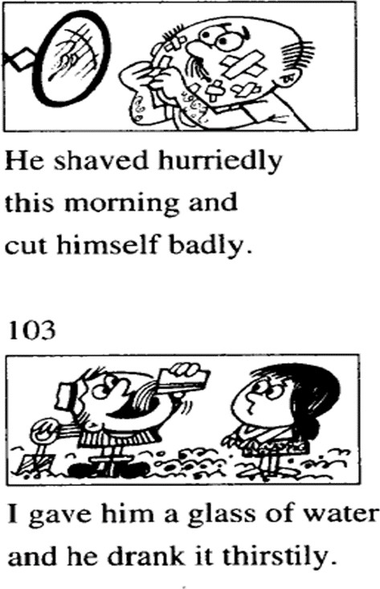 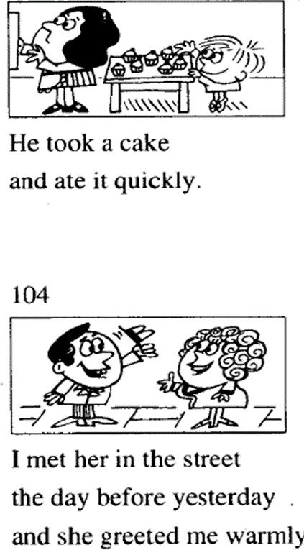

1. He read the phrase **slowly** .
2. He worked **lazily**.
3. He cut himself **badly**.
4. He worked **carefully**.
5. The door opened **suddenly**.

##### Lesson 73&74 知识拓展

**有关问路:**

1. Excuse me. Can you tell me the way to…?
2. Excuse me. Do you know the way to…?
3. Excuse me. How can I get to…?
4. Excuse me. Where is…please?

##### 2. 指路:

1. 左转—turn left
2. 右转—turn right
3. 直行—go straight, go down
4. 交叉路口—crossing，intersection

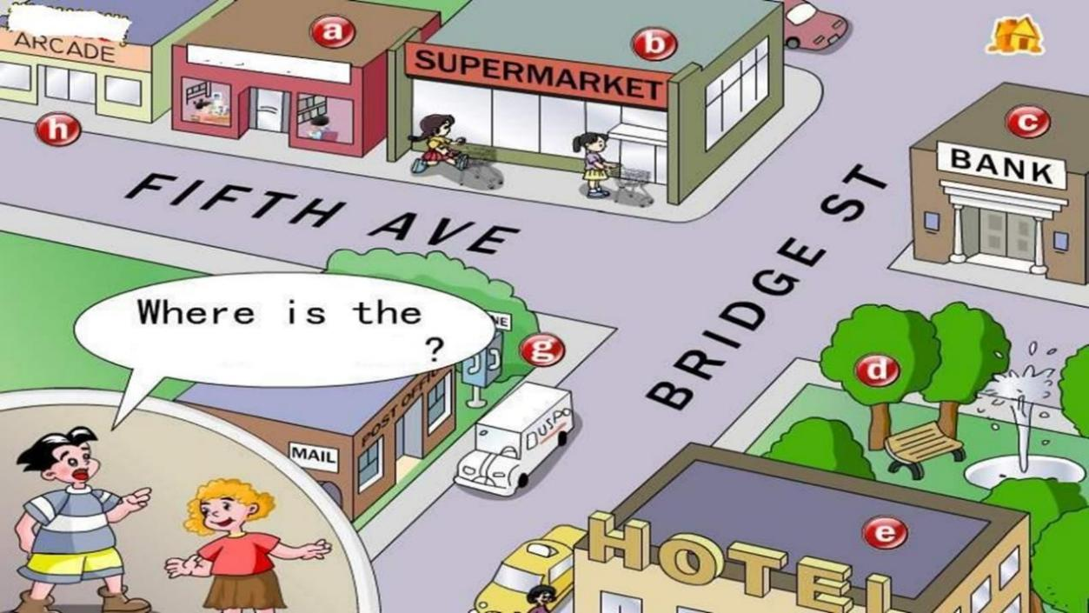

##### Lesson 75&76 预习

* 1. **课文：买鞋的场景，句子仿写；**
  2. **词汇：un-否定前缀；**
  3. **语法：不规则动词的过去式。**

**Lesson 75 单词讲解**

1. **ago[ə'ɡəʊ]: adv. 以 前**

a week\ a month\ a year … ago 她以前很苗条。

She was slim ago. She was slim before.

只能放在一般过去时态中！

##### buy [baɪ] : v. 买

过去式：bought

我昨天买了一件新外套。

I bought a new coat yesterday. 他去年买了一辆新车。

He bought a new car last year.

##### pair [peə(r)] : n.双，对

a pair of+复数名词a pair of shoes

a pair of socks

a pair of chopsticks

a pair of glasses 一副眼镜a pair of jeans 一条牛仔裤六双鞋

six pairs of shoes

两双袜子

two pairs of socks

两条牛仔裤

two pairs of jeans

地板上有一双鞋。

There **is** a pair of shoes on the floor.

床上有两双袜子。

There **are** two pairs of socks.

##### 就近原则~

1. **fashion ['fæʃn] : n.(服装的)流行式样**

in fashion 流行中

out of fashion 过时的

Short skirts are in fashion now.

These shoes are out of fashion.

##### uncomfortable [ʌn'kʌmftəbl] : adj.不舒服的

un+ comfortable

The shoes are very uncomfortable.

这鞋非常不舒服。

I have an uncomfortable feeling in my throat. 我喉咙有不舒服的感觉。

##### wear [weə(r)] : v.穿着，戴着

She wears a dress. 她穿着一件裙子。

He wears a black tie. 他戴着一条黑色的领带。He wears a cool hat.

他戴着一顶很酷的帽子He wears a watch. put on v. 穿上,戴上Put on your dress.

Put on your watch.

##### Lesson 75 语法讲解

**动词过去式的不规则变化：**

1) cut- cut 切,割

let- let 让

put- put 放cost- cost 花费,值

hurt- hurt 使…伤痛

read- read 读

2） fly- flew 飞

blow- blew 吹

draw- drew 画

grow- grew 生长

know- knew 知道

1. begin- began 开始drink- drank 喝

sing- sang 唱

swim- swam 游泳

1. feel- felt 感到keep- kept 保持

leave- left 离开

sleep- slept 睡sweep- swept 扫

1. catch- caught 抓

teach- taught 教

1. meet- met 遇见get- got 得到

sit- sat 坐

win- won 赢

1. build- built 建造

send- sent 送,寄spend- spent 花 费make- made 制造hear- heard 听见

##### 情态动词的过去式：

can- could 能may- might 也许must- must 必须will- would 会

##### Lesson 75 课文讲解

1. **Do you have any shoes like these? like, 像 … prep.**

any shoes [like these] 像这样的一些鞋the ones [on the shelf] 架 子 上 的 那 些 the book [on the desk] 书桌上的那本书the cup [on the table] 桌上的那个杯子the knife [in the box] 盒子里的那把刀桌上的那本书

the book on the desk

桌上那个杯子

the cup on the table

盒子里的那把刀

the knife in the box

你有像这样的书吗？

Do you have any books like this?

你喜欢像她这样的女孩吗？ Do you like girls like her?

你相信像这样的事吗？

Do you believe things like it?

##### Can you get a pair for me?

get, v. 得到， 调货

##### I’m afraid that I can’t.

that, 无意义I’m afraid… I’m sorry…

##### They are very uncomfortable. 他们确实不舒服。

今天确实是晴天。It ***is*** sunny today. 你确实挺漂亮的。You ***are*** pretty.

昨天确实是 10 号。

It ***was*** 10th yesterday.

我爱你。

I love you. 我确实爱你。

I **do** love you.

他昨天告诉了我这事。

He told me that yesterday. 他昨天确实告诉了我这事。

He **did** tell me that yesterday.

##### Women always wear uncomfortable shoes. 女人总是喜欢穿不舒服的鞋。

Men always like beautiful girls. Children always like toys.

Students never like homework.

##### Lesson 76 单词句型讲解

**When did you…?**

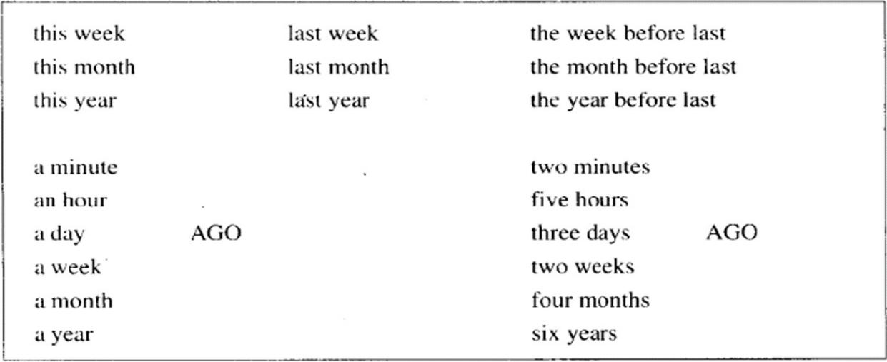

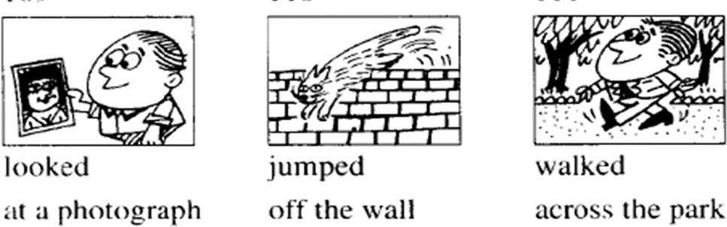

When did you look at a photograph?

I looked at a photograph this morning.

When did you jump off the wall?

I jumped off the wall two minutes ago.

1. She met her friends yesterday.
2. They drank some milk yesterday.
3. He swam in the river yesterday.
4. She took him to school yesterday.
5. He cut himself yesterday morning.

##### Lesson 75&76 知识拓展

**un-**

1. **形容词前**

happy- unhappy certain- uncertain

clean- unclean comfortable- uncomfortable easy- uneasy

tidy- untidy

##### 名词前

truth- untruth n.

##### 动词前

cut- uncut adj. lock- unlock v. dress- undress v.

##### Lesson 77&78 预习

1. **课文：看牙医；**
2. **语法：否定疑问句;**
3. **知识拓展：英式美式在用词上的对比。**

**Lesson 77 单词讲解**

1. **appointment [ə'pɔɪntmənt] : n. 约会、预约date: 男女之间的约会**

have an appointment have a date

和…有约: have an appointment with…

I have an appointment with the doctor at 10:30.

##### urgent ['ɜːdʒənt] : adj. 紧急的、紧迫的urgency ['ɜːdʒənsi]: n. 急 事

In case of urgency, call the police. 一旦发生紧急情况，打电话给警察。

##### till [tɪl] prep. 直到…为止

I waited for you till 11:00 last night.

##### Lesson 77 语法讲解

**否定疑问句：**

1. **构成：**

**一般疑问句的疑问词+not 的缩略式**

Are you ok? Aren’t you ok?

Do you know that? Don’t you know that? Can you wait? Can’t you wait?

##### 何时用？

* 1. **表达强调**

Aren’t you lucky！

##### 表达情绪

Don’t you love me?

##### 翻译：“难道，难道不…”

1. **组织步骤：**

**① 变：一般疑问句+ not 缩略式**

难道她不漂亮吗？ Is she beautiful?

Isn’t she beautiful?

难道她没有男朋友吗？

Does she have a boyfriend? Doesn’t she have a boyfriend?

难道你昨天没去约会？

Did you have a date yesterday? Didn’t you have a date yesterday?

难道你就不能温柔一点吗？ Can you be tender?

Can’t you be tender?

##### ② 直接说：（先看词性，再看人称）

难道你不懂吗？

Don’t you understand?

难道她没做饭？ Didn’t she cook?

难道他不帅？

Isn’t he cool?

难道他没迟到？ Wasn’t he late?

难 道 你 没 睡 着 ？ Didn’t you sleep?

难 道 你 不 幸 运 ？ Aren’t you lucky!

##### Lesson 77 课文讲解

1. **a terrible\bad toothache**
2. **I want to see the dentist, please.**

want + n. want + to do

I want a new car.

I want to buy a new car.

##### Do you have an appointment?

have a headache：头疼

Do you have a headache?

have a cold：感冒Did you have a cold?

have a blind date：相亲Did you have a blind date?

##### Can you come at 10 a.m. on Monday, April 24th?

* 1. a.m.: in the morning p.m.: in the afternoon

凌晨 5 点：5 a.m. 深夜 11 点：11p.m.

* 1. 4 月 24 日，星期一，上午 10 点10 a.m. Monday, Apr. 24th

at 10 a.m., on Monday, on Apr. 24th

##### I’m afraid that . I’m sorry .

1. **Can’t you wait till this afternoon?**

**否定疑问句：**

**难道你就不能等到今天下午吗？**

**Lesson 78 单词句型讲解**

1. She buys a new car every year. She bought a new car last year.
2. She airs the room every day. She aired it this morning.
3. He often loses his pen. He lost his pen this morning.
4. She always listen to the news. She listened to the news yesterday.
5. She empties this basket every day. She emptied it yesterday.

##### Lesson 77&78 知识拓展

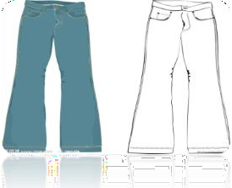

美式：movie pants soccer

英式：film trousers football

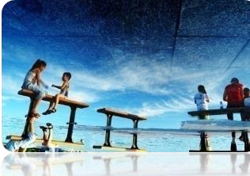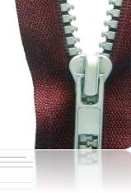

|  |  |  |
| --- | --- | --- |
| 美式：vacation | subway | zipper |
| 英式：holiday | underground | zip |

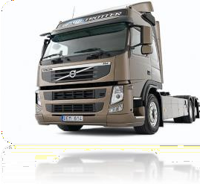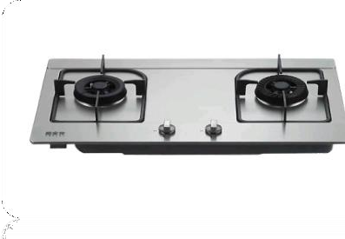

|  |  |  |
| --- | --- | --- |
| 美式：truck | stove | sneakers |
| 英式：lorry | cooker | trainers |

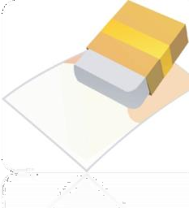 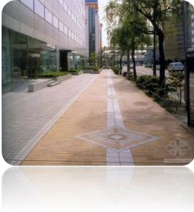 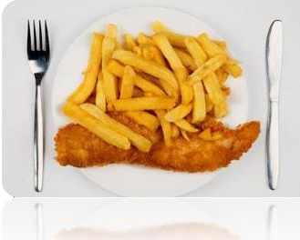

|  |  |  |
| --- | --- | --- |
| 美式：eraser | sidewalk | fries |
| 英式：rubber | pavement | chips |

##### Lesson 79&80 预习

* 1. 语法：have；
  2. 课文：“很多”；
  3. 知识拓展：各种蔬菜。

##### Lesson 79 单词讲解

1. **shopping['ʃɒpɪŋ] : n.购物**

去购物：go shopping

购物商场：a shopping mall 看橱窗：window shopping

I really enjoy window shopping.

##### list [lɪst] : n.单子

名单：a name list

购物清单：a shopping list

##### vegetable ['vedʒtəbl] : n.蔬菜

veget-

vegetarian, 素食主义者I love vegetables.

##### need [niːd] : v.需要

need + n.

I need some money. need + to + v.

I need to borrow some money.

##### hope [həʊp] : v.希望

I hope so. 希望如此

##### thing [θɪŋ] : n. 事情，东西

1. **money ['mʌni] : n.钱**

不可数

很多钱：a lot of money 挣钱：make money

##### Lesson 79 语法讲解

**have: 拥 有**

**① have = have got**

I have two sisters.

I have got two sisters.

##### ② has = has got

She has a new boyfriend.

She has got a new boyfriend.

##### ③ don’t have = haven’t got

I don’t have any time.

I haven’t got any time.

##### ④ doesn’t have = hasn’t got

She doesn’t have a good friend.

She hasn’t got a good friend.

##### ⑤ Do you have…? = Have you got…?

Do you have any money?

Have you got any money?

##### ⑥ Does she have…? = Has she got…?

Does she have a boyfriend?

Has she got a boyfriend?

##### Lesson 79 课文讲解

1. **I’m making a shopping list.**

make

* 1. What make is it? n. 品 牌
  2. make the bed 整理床铺
  3. make a bookcase 制作一个书架
  4. make some tea 沏茶
  5. make some coffee 冲咖啡

1. **We need a lot of things this week.** a lot of， 很 多many， 很 多 （ 可 数 ） much，很多（不可数）

a lot of— 肯定句

1. **have** = have got 拥 有We have a new house. =

We have got a new house.

We haven’t got much tea or coffee. =

We don’t have much tea or coffee.

We haven’t got many tomatoes. =

We don’t have many tomatoes.

We’ve got a lot of potatoes. =

We have a lot of potatoes.

We haven’t got any meat at all. =

We don’t have any meat at all.

Have we got any beer and wine? =

Do we have any beer and wine?

I haven’t got much. =

I don’t have much.

I haven’t got much either! =

I don’t have much either!

##### We haven’t got any meat at all. 我们一点肉都没了。

**at all, 一点也不，根本，否定句**

I don’t love you at all. 这根本没什么关系。

It doesn't matter at all.

我跟本不认识他。

I didn't know him at all.

我根本不确定。

I'm not sure at all.

##### I hope that you’ve got some money. 我希望你还有钱。

I hope . that,无意义

##### Lesson 80 单词句型讲解

1. **groceries ['ɡrəʊsəri] : n.食品杂货**

a grocery store n. 杂货店It’s a small grocery store.

And there are many groceries.

##### fruit [fruːt] : n.水果

不可数

##### stationery ['steɪʃənri] : n.文具

不可数

##### newsagent ['njuːzeɪdʒənt] : n.报刊零售人

news, 新 闻

agent,代理人，中介，经纪人

##### chemist ['kemɪst] :

**n. 药剂师，化学家**

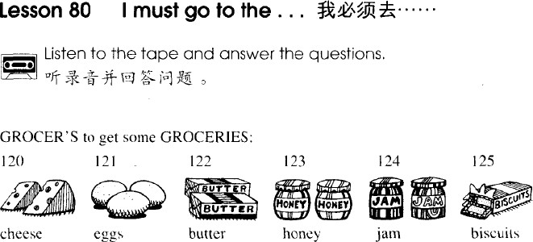

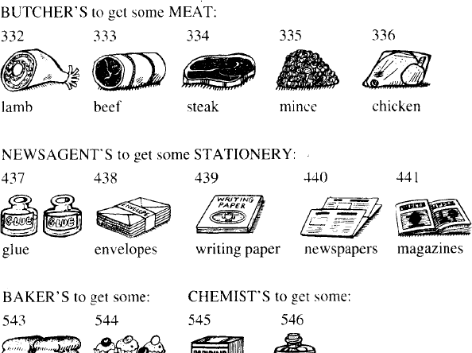

**Lesson 79&80 知识拓展**

**vegetables**

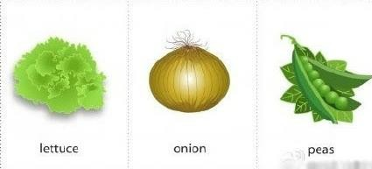

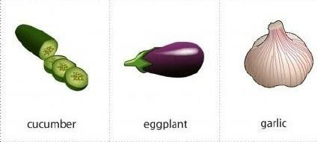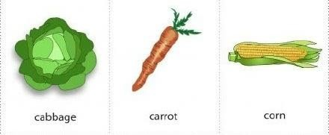

**Lesson 81&82 预习**

1. 语法：have；
2. 课文：日常串门儿；
3. 知识拓展：厨师学校的内容。

##### Lesson 81 单词讲解

1. **bath [bɑːθ] : n. 洗 澡**

have a bath

He had a bath at 11:00 p.m. last night. shower， 淋 浴

##### nearly ['nɪəli] : adv. 几乎、将近

I’m nearly ready. I nearly die.

##### ready ['redi] : adj. 准备好的

Dinner is ready. 饭好了

##### dinner: n. 正餐、晚餐

breakfast、 lunch 、dinner

##### restaurant ['restrɒnt] : n. 餐 馆

at the restaurant

##### roast[rəʊst] : adj. 烤的

a roast duck 烤 鸭

##### Lesson 81 语法讲解

**实义动词 has had**

**have**

？

##### 拥有

I have a close friend in Beijing. 我在北京有一个亲密的朋友。

##### have 与生病

have a cold、have a headache、have a toothache

##### 吃、喝、玩、乐、做……

洗 澡 have a bath 游 泳 have a swim 理 发 have a haircut 聚会 have a party

度 假 have a holiday

玩的开心 have a good time 上 课 have a lesson

##### 实义动词

**Have**

**主语+ have (has) + done 助动词**

**Lesson 81 课文讲解**

* + 1. **老张来了！**

Lao Zhang comes.

Lao Zhang is here. Sam is here.

我回来了。

I’m home.

##### Have a cigarette. 抽支烟吧。

have a rest: 休息一下吧have a drink: 喝一杯吧have a seat: 坐 吧

##### Have a glass of …then.

then: A. 然后； B. 那么。 Then no. 那就算了吧。

##### Lesson 82 单词句型讲解

1. **breakfast ['brekfəst] : 早 餐**
2. **haircut ['heəkʌt] : 理发** have a haircut
3. **party ['pɑːti] : 聚会** a birthday party 生日派对 a dinner party: 宴 会
4. **holiday['hɒlədeɪ]: 假 日vacation[və'keɪʃn]** have a holiday

have a vacation



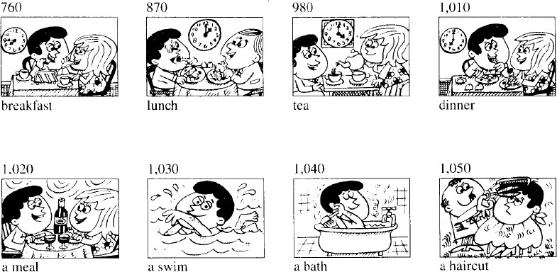

drink-drank, enjoy-enjoyed yourself, are eating, go for-went for, eat-ate, take

1. They had a meal at a restaurant. They a meal at a restaurant.
2. We had a holiday last month.

We a holiday last month.

1. Have a biscuit. a biscuit.
2. You had a good time. You .
3. They are having their lunch. They their lunch.
4. I had a glass of milk.

I a glass of milk.

##### Lesson 81&82 知识拓展

【**各种烹饪大法】**

☻ fry 油炸 ☻ roast 烘 烤

☻ bake 烘焙 ☻ grill 用（烤架）烤

☻ simmer 炖 ☻ steam 蒸

☻ mash 捣碎 ☻ boil 煮 熟

☻ mince 绞碎 ☻ shell 剥 皮

##### 【中国特色食品】

a boiled egg a fried egg a tea egg fried sticks

sliced noodles steamed bread sweet ball soup fish ball soup

eight treasures porridge sweet potato porridge soybean milk

hot pot

##### Lesson 83&84 预习

* 1. 语法：现在完成；
  2. 课文：日常串门儿；
  3. 知识拓展：各种节假日。

##### Lesson 83 单词讲解

1. **mess[mes]: n.杂乱，凌乱**

It’s very untidy. Excuse the mess.

##### pack[pæk] : v.包装，打包，装箱

pack the books into the case

##### suitcase ['suːtkeɪs] : n.手提箱

1. **leave [liːv] : v.离开**

left- left

He left yesterday.

##### already[ɔːl'redi] : adv.已经

**Lesson 83 语法讲解**

**现在完成时态：**

**时间**

*



**过去 现在**

**截止现在已经完成**

**现在完成时态:**

**主 语 + has\have + done**

**“ 时 态 - 动 词 ”**

动词原形- do

**动词**

现在分词- doing 三单形式- does 过去式- did

过去分词- done

##### 动词过去分词的变化规则:

1. 一般情况+ ed, call-called; air-aired；
2. 以字母 e 结尾+ d, live-lived; love-loved；
3. 以辅音字母+ y 结尾,变 y 为 i +ed, try-tried; study-studied；
4. 辅+元+辅（汉堡包结构),

将辅音字母双写+ed,stop-stopped

我已经给房间通过风了。I have aired the room. 他已经看完这部电影了。

He has watched the movie.

我们已经到达北京了。

We have arrived in Beijing. 我已经吃过早饭了。

I have had breakfast.

他已经度过假了。

He has had his holiday. 她已经理过发了。

She has had a haircut.

##### 现在完成时态:

**主 语 + has\have + done 疑问句：have\ has 提前否定句：have\ has + not** 你已经给房间通过风了吗？ Have you aired the room? 他已经看完这部电影了吗？

Has he watched the movie? 我们已经到达北京了吗？ Have we arrived in Beijing? 你已经吃过早饭了吗？

Have you had breakfast? 他已经度过假了吗？

Has he had his holiday?

她已经理过发了吗？ Has she had a haircut? 你没有给房间通过风。

You have not aired the room. 他没有看完这部电影。

He has not watched the movie.

我们没有到达北京。

We have not arrived in Beijing.

##### Lesson 83 课文讲解

1. **I’ve already had lunch.**

**I had lunch at half past twelve.**

**时间**



**\***

**12：30 现在**

**already: 已经，放在肯定句、疑问句中**

位置：通常在 done 前他已经洗完澡了。

He has already had a bath.

我已经上完课了。

I have already had my lesson.

你已经完成作业了吗？

Have you already done your homework?

他已经游完泳了吗？

Has he already had a swim?

##### Have a cup of coffee then.

then

* 1. 然后
  2. 那么Then no. 那就算了。

##### I’ve just had a cup.

**I had one after my lunch.**

**时间**

*

**after lunch 现在just: 刚刚，放在肯定句中**

位置: 通常在 have\has 后他刚刚洗完澡。

He has just had a bath.

我刚刚上完课。

I have just had my lesson.

##### Aren’t you lucky! 否定疑问句：

Are you lucky? Aren’t you lucky? You are so lucky！

##### Lesson 84 单词句型讲解

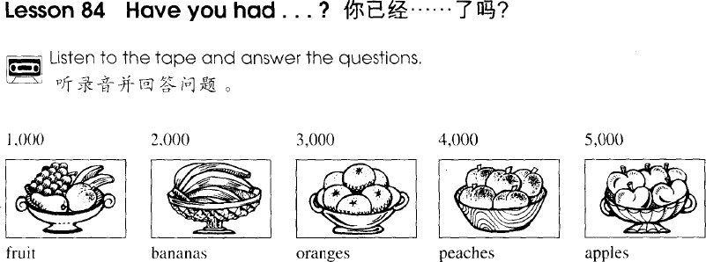

* + 1. 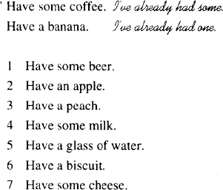I’ve already had some.
    2. I’ve already had one.
    3. I’ve already had one.
    4. I’ve already had some.
    5. I’ve already had some.
    6. I’ve already had one.
    7. I’ve already had some.

##### Lesson 83&84 知识拓展

【**西方的节假日】**

New Year’s Day 新 年

Valentine’s Day 情人节（Feb.14th ）

Easter Day 复 活 节 (the first Sunday after the full moon following the spring equinox )

April Fool’s Day 愚人节（Apr.1st ） Halloween 万 圣 节 (Nov. 1st )

Thanksgiving Day 感恩节（the last Thursday of Nov.）

##### Lesson 85&86 预习

1. 语法：现在完成和一般过去的对比；
2. 课文：现在完成时态的第二种结构；
3. 知识拓展：电影话题拓展。

##### Lesson 85 单词讲解

* 1. **Paris ['pærɪs] : 巴 黎**
  2. **cinema ['sɪnəmə] : 电影院**
  3. **film [fɪlm] : 电 影**

美式 movie 英 式 film go to the cinema watch\see a film\movie

##### beautiful['bjuːtɪfl] : 漂亮的

nice smart lovely

good-looking

gorgeous['ɡɔːdʒəs] beauty: 美 女

* 1. **city ['sɪti] : 城 市**New York city Beijing city

##### never ['nevə(r)] : 从来没有

* + 1. 一般现在：

He never gets up early. She is never late.

* + 1. 现在完成：

I have never left. 我从未离开。现在完成的否定形式：

I have never…

* + 1. 一些短语中Never give up! Never fear! Never mind! ...

##### ever: 在任何时候

* + 1. always

Honesty ever pays. 诚实永远有回报。

* + 1. 一般过去(疑问句中)：

Did you ever see such a man?

* + 1. 现在完成(疑问句中)： Have you ever …?
    2. 口语中：

Don’t ever do it!= Never do it!

##### Lesson 85 语法讲解

**现在完成&一般过去：**

1. **结构：**

现在完成：主语 + have(has)+done 一般过去：主语 + was\were\did

##### 用法：

现在完成：过去发生，影响现在 一般过去：过去发生，与现在无关

**时间**



*

##### 过去 现在

1. **时间状语：**

**现在完成： 含糊**

just, already, before, never, ever, yet…

##### 一般过去： 具体

yesterday, last…,

…ago, just now…

##### 语用功能：

**现在完成：引起话题一般过去：具体谈论**

Have you ever had a girlfriend? Yes.

When did you…?

Where did you …? How did you…?

- Have you ever…?

made a foreign friend\ cheated on exams...

- No, I have never. Yes , I have.

* When did you…?
* Where did you…?
* What did you …?
* How did you…?

我去年去了英国。

I went to Britain last year.

我已经去过英国啦！

I have been to Britain.

他上个月写了一本书。

He wrote a book last month.

他到现在为止写了五本书了！ He has written five books.

1. I the film TV at home

last night.

√

A. saw\from B. saw\on

C. have seen\ on D. have seen\from

1. It dry for a long time.

A. is B. was

C. has been D. have been 3). — Where did you go last weekend?

√

— Nowhere. I at home.

A. am √B. was

C. stay D. have been

##### Lesson 85 课文讲解

1. **巴黎之春**

the spring of Paris? Paris’s spring?

Paris in the spring 春天里的巴黎北京的冬：Beijing in the winter

纽约的夏天 ：New York in the summer

##### Have you just been to the cinema?

* 1. just: 刚刚（现在完成）

just now: 刚刚（一般过去）

* 1. been:

**is**

**am**

**are**

**be**

**was**

**were**

**been**

他已经在那了。

He has **been** there.

他在那。

He is there. **is been**

**主语+ have/has+ been+ 非动词**

他一直以来都是个好学生。

He has always been a good student. 我一直都很忙。

I have been busy.

* 1. Have you just been to the cinema? 你刚刚去电影院了吗？

go-went- gone been to: 去 过gone to: 去 了

1. —Where is Jim？

— He has gone to England.

1. —Have you ever been to Japan?

— Yes, I have been to Japan twice.

1. I heard the Great Wall is a very exciting place. But I have never been there.
2. —Where have you been?

—I the cinema.

A. have been to B. have gone to

√

C. have went to D. went to

##### What’s on? 上映了什么？

What’s on the cinema？ What’s on the radio？ What’s on the television？

##### Have you ever been there?

Have you just been to the cinema?

there : 地点副词口语句型：

Have you ever been to ?

##### It rained all the time.

all the time: 一直。

##### Lesson 86 单词句型讲解

现在完成&一般过去

1. She has just boiled an egg.
2. She / boiled it a minute ago.
3. She has never been to China, but he was there in…
4. He has already painted that bookcase.
5. He / painted it a week ago.
6. She / emptied the basket this morning.
7. He has just dusted the cupboard.

##### Lesson 85&86 知识拓展

**box office\ticket box**

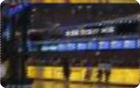

**cinema**



**movie\film**



**screen**

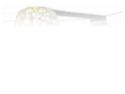

**popcorn**



**background music**

**Audrey Hepburn Anne Hathaway**

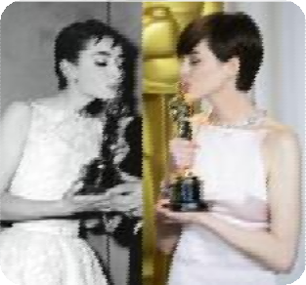

**Best Actress in Best Actress in a**

**the year of 1953 Supporting Role**

**in the year of 2013**

**Lesson 87&88 预习**

1. 语法：现在完成和一般过去的区别；
2. 词汇：不规则动词的过去分词；
3. 知识拓展：have gone & have been

##### Lesson 87 单词讲解

1. **attendant [ə'tendənt] : n.接待员**
2. **bring [brɪŋ] : v.带来，送来take [teɪk] : v. 带 走**

bring sth.\sb. to… take sth.\sb. to…

把你的新女朋友带来。

Bring your new girlfriend to me. 他把这个戒指带给了他老婆。

He took this ring to his wife.

* 1. May I my boyfriend here next time?
     1. bring B. take

C .more D. carry

* 1. The young man flowers to the girl every day.
     1. fetches B. brings

C. takes D. carries fetch, 取；carry，随身携带

##### garage ['ɡærɑːʒ] [ɡə'rɑːʒ] : n.车库，汽车修理厂

1. **crash [kræʃ] : n.碰撞**

a car crash an air crash

##### lamp-post [læmp pəʊst] : 灯杆

1. **repair [rɪ'peə(r)] : v.修理**

repair my car

##### try [traɪ] : v.努力，设法try to … 努力去做…

I try to finish it.

I try not to miss him.

**try one’s best to…尽某人最大的努力…**

one’s- my\ his\ her\ our\ their He tried his best to study English. I tried my best to forget him.

##### Lesson 87 语法讲解

**现在完成时态：**

**时间**

*



**过去 现在**

**现在完成：过去发生，影响现在**

**一般过去：过去发生，无关现在**

He has got married. 他已经结婚了。

He got married in 2010. 他 2010 年结的婚。

I have graduated. 我已经毕业了。

I graduated in 2006. 我 2006 年毕业的。

I have finished Book1. 我已经学完一册了。

I finished Book1 last week. 我上周学完一册的。

I have been to New York . 我去过纽约。

I went to New York in 2010. 我 2010 年去了纽约。

**立足现在**

1.- you the text yet ?

- Yes, we it two hours ago.

1. Did…copy…did
2. Have…copied…have
3. Did…copied…did
4. Have… copied…did

**√**

#### 

1. My mother me a new coat yesterday.

I it on. It fits me well.

* 1. had made…have tried

**√**

* 1. made…have tried

#### 

* 1. has made…tried
  2. made…tried

##### Lesson 87 课文讲解

1. **Is my car ready yet?**

yet:

到现在为止 否定和疑问句

一般现在 & 现在完成

Have your mechanics finished yet?

yet:

还，仍

否定和疑问句

一般现在 & 现在完成He is not ready yet.

I haven't really got into my new job yet.

Not yet. 还没呢!

##### What’s the number of your car? What’s your car number?

1. **I remember now. 我想起来了。**
2. **They are still working on it. 还在修着呢 。**
   * Have you finished Book 1?
     + Not yet. I’m still working on it. 没，正学着呢~
     + Have you had a girlfriend?
     + Not yet. I’m still working on it. 没，正努力着呢~

##### 看一看: have a look 试 一 试 : have a try 尝一尝: have a taste

我想看一看你的新车。

I want to have a look at your new car.

我可以尝一尝你的奶酪吗？

Can I have a taste of your cheese?

##### I drove it into a lamp-post. into, 进 入

1. **To tell you the truth,… 说句老实话吧，…**

**Lesson 88 单词句型讲解**

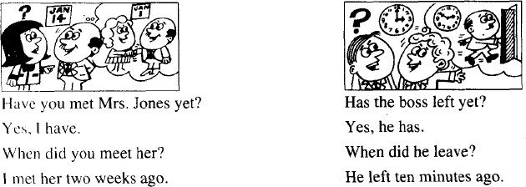**现在完成：引起话题一般过去：具体谈论**

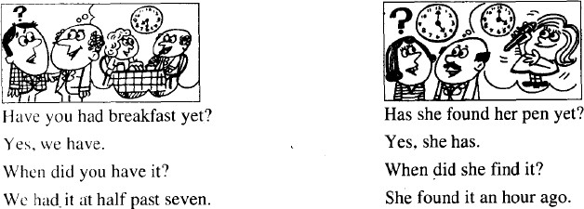

**do did done**

**① read- read- read 读cut- cut- cut 切,割**

**let- let- let 让put- put- put 放**

**cost- cost- cost 花费,值**

**set-set- set 落下、安置hurt- hurt- hurt 使…伤痛**

**② fly- flew- flown 飞draw- drew- drawn 画grow- grew- grown 生 长know- knew- known 知 道**

**③ begin- began- begun 开 始**

**drink- drank- drunk 喝sing- sang- sung 唱swim- swam- swum 游 泳ring- rang- rung 打电话**

**④ feel- felt- felt 感 觉**

**keep- kept- kept 保 持leave- left- left 离 开sleep- slept- slept 睡 觉**

**sweep- swept- swept 打 扫**

**⑤ catch- caught- caught 抓teach- taught- taught 教**

**⑥ meet- met- met 遇 见**

**get- got- got 得 到hold- held- held 举 行sit- sat- sat 坐**

**win- won- won 赢**

**⑦ build- built- built 建 造send- sent- sent 送,寄spend- spent- spent 花 费make- made- made 制 造hear- heard- heard 听 见**

**Lesson 87&88 知识拓展填 入 has / have been 或 has / have gone.**

1. Sam： Sally and Tim are on holiday, aren't they?

Where **have** they **gone**?

Sue：To Florida, again.

Sam： How many times **have** they **been** there?

Sue： This is their third visit.

1. Harry: I saw you in Annabel's

Restaurant last night.

Diana: No, it wasn't me.

I **have** never **been** there.

1. Alan: Where's Tony?

Mary: He's got a headache so he has gone to bed.

1. Steve: Can I speak to Jill, please? Lynn: She's out, I'm afraid.

She has gone to the cinema this evening.

##### Lesson 89&90 预习

* 1. 语法：现在完成时态第二种用法；
  2. 词汇：花费的不同表达；
  3. 知识拓展：购物口语。

##### Lesson 89 单词讲解

1. **believe [bɪ'liːv] : 相信、认为think**

**feel: 感觉、认为hold: 握住、坚持认为**

**consider: 考虑、认为**

**I think…**

**I also think…**

**I still think…**

**Do you think so?**

1. **may [meɪ] : （用于请求许可）可以**

May I …? Can I …?

##### How long: 多 久

How long have you lived in Beijing? How long are you going to stay here? How long does this train stop here?

##### since [sɪns] : 自 从

* 1. since + 时间点

She has been in Beijing since 2004.

* 1. since + n.

She hasn't been out since the accident.

##### why [waɪ] : 为什么

what/when/which/where/who/whose…

1. **sell [sel] : v. 卖**sell- sold- sold sale: n.

a big sale: 大甩卖for sale: 出 售

##### because [bɪ'kɒz] : conj.因为

* 1. **because of + n.\ pron.**

Because of you, I try my hardest just to forget everything.

Because of the smog, everyone wears mask.

* 1. **because+ 句 子**

I bought the house because it faced to the south.

I said sorry because I hurt him.

##### retire [rɪ'taɪə(r)] : v. 退休、息影、退役

My grandpa has retired.

##### cost [kɒst] : 花 费

**spend**

**cost 花费 take 时间和金钱**

**这件 T 恤衫花了我 300 元。我花 300 元买了这件 T 恤衫。**This shirt costs me￥300.

I spend ￥300 on this shirt.

##### 结论 1： 主语是人+ spend



**主语是物+ cost \ take**

**结论 2： sth. costs (sb.) ＋金钱**



**sth. takes (sb.)＋时间**

这段旅程得用两小时。

This journey takes two hours. 这双鞋 30 镑。

This pair of shoes costs me 30 pounds.

他在纽约度过了两周的时间。

谁— 干了什么 —如何干的 — 在哪干的 —何时干的

**He spent two weeks in New York 结论 3：spend +时间 + 地点**

他在北京度过了 20 年的时光。

He spent twenty years in Beijing.

他和他的女朋友一起度假。

##### 谁— 干了什么 — 如何干的 — 在哪干的 — 何时干的

**He spent her weekend with her boyfriend. 结论 4：spend +时间 + with sb.**

她和男朋友一起度过了周末。

She spent her weekend with her boyfriend.

##### 她把所有的钱都花在买化妆品上了。

**谁— 干了什么 — 如何干的 —在哪干的 — 何时干的She spent all her money on cosmetics.**

**结论 5：spend +钱 + on sth.\sb.**

他把所有的钱都用来买书了。

He spent all his money on books.

1. Digital cameras are popular, but some still too much.
   1. pay B. spend C. cost D. takes

√

#### 

1. Michael often spends his weekends his grandparents.
   1. with B. in C. on **spend+时间+with sb.**

√

#### 

1. It you 15 minutes to go there by bus.
   1. takes B. spends C. costs D. pay

√

#### 

1. She all her money on clothing.
   1. pays B. s pent C. costs D. takes

√

#### 

1. We a pleasant hour with our friends.
   1. cost B. spend C. worth D. take

√

#### 

1. —Your MP3 is so nice. How much is it?

—It’s ￥500.

# √

A. cost B. pay C. worth D. take

**结论 6：be + worth**

这套房子现在值 300 万。

The apartment is worth three million now. 你的车值多少钱啊？

How much is your car worth?

就值这个钱。

It’s worth the money.

spend

cost

花费

take

**结论 1： 主语是人+ spend**



**主语是物+ cost \ take**

**结论 2： sth. costs (sb.) ＋金钱**



**sth. takes (sb.)＋时间**

**结论 3：spend +时间 + 地点**

**结论 4：spend +时间 + with sb. 结论 5：spend +钱 + on sth.\sb. 结论 6：be+ worth**

cost- cost-cost take- took- taken

spend- spent- spent

##### pound [paʊnd] : 英 镑

pound- pounds

##### penny ['peni] : 便 士

复数：pence

##### Lesson 89 语法讲解

**现在完成：**

1. **用法 1：**

到目前为止已经完成（过去发生,影响现在）

##### 用法 2：

**表持续（未完成）**

I have finished Book 1.

完成c

She has lived in Beijing for ten years.

持续:未完成

**时间**

*



##### 过去 现在



**\* 时间**



##### 过去 现在

1. **时间状语：**

**完成：**just, already, before, never, ever, yet…

**持续：**since, for…

##### since+ 时间点：自从for+ 时间段：长达

自从 2014 年以来：since 2014 长达 5 年：for five years

自从 2010 年他就住这了。

He has lived here since 2010.

她学英语已经长达十年之久了。

She has studied English for ten years.

他们在一起已经两年了。

They have been together for two years.

* How long have you been married? 你们结婚多久了?
* 一个月了。For a month.

Since a month ago.

##### Lesson 89 课文讲解

* 1. **I believe that this house is for sale.**

for sale

##### May I have a look at it, please?

Can I …? Could I …?

##### I’ve lived here for twenty years.

I’ve= I have for+ 段时间：长达

##### I have been here since 1976.

since+ 点时间：自从…

##### How much does this house cost?

cost- spend- worth

How much do you spend on this house?

How much does the house cost? How much is the house worth? How much is the house?

##### 6. £ 68,500

百 : hundred 千: thousand

万: ten thousand

十万: one hundred thousand 百万: million

##### It’s worth every penny of it.

**一分价钱一分货。**

1. **Women always have the last word. 女人总是最后说了算。**

have the last word: 说了算，最后拍板。

我们家我妈说了算。

My mom has the last word in my family. 现在我说了算。

I have the last word now.

##### Lesson 90 单词句型讲解

**现在完成&一般过去**

语用功能：

现在完成：引起话题一般过去：具体谈论

Have you ever…? Have you …yet? When/Where/How did you …?

##### Where did you read it? I read it at home.

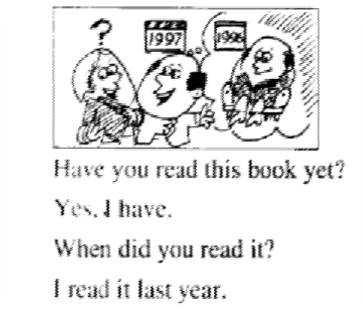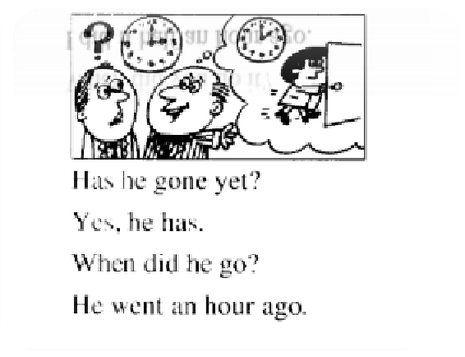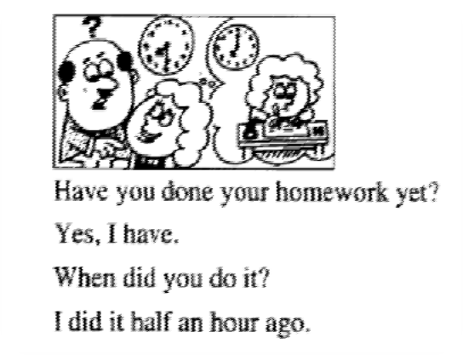

**Where did you do it? I did it at home.**

**How did he go? He went by car.**

**How did she speak to him? She spoke to him pleasantly.**

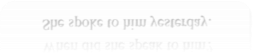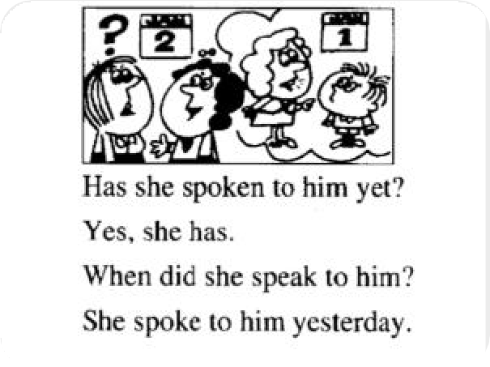

**Lesson 89&90 知识拓展**

1. **必备词汇：**

去 购 物 ： go shopping 逛街：window shopping 网 购 ：online shopping 商场：department store 购物中心：shopping mall 打折：discount

刷卡：use my card

##### 问与答：

问 ： Can I help you? 答 ： I want a…please.

A…please.

问：May I have a try? Can I have a try?

答：Sure.

问 ： Is that ok?

答 ： Do you have a small\large size?

It’s too large\small for me. 问：How much is it?

答：It’s...

问：Is there any discount? 答：Yes.\ No.

问 ： Can I use my credit card?

答 ： Sure.

Cash only please.

##### Lesson 91&92 预习

1. 语法：一般将来时态；
2. 课文：各种时态的混合使用；
3. 词汇：“人”。

##### Lesson 91 单词讲解

* 1. **still[stɪl]: adv. 还，仍旧**

情系后，实义前He is still there.

I still stay in Beijing.

She still loves you.

##### move [muːv] : v. 搬 家

move to…

She moved to Mars last year. move into…

He has moved into the new house.

##### miss [mɪs] : v.想念，思念, 错过

* 1. **neighbour ['neɪbə(r)] : n.邻居neighbor (美式)**
  2. **person ['pɜːsn] : n. 人**

one person two persons

We have two persons with that name.

我们这里有两位叫这个名儿的。VIP- a very important person

##### people['piːpl]: n. 人 们

* + 1. 谓语动词用复数

We are one people, with one will. 我们是一个民族,拥有一个意志。

* + 1. 泛指人们

People do not know the value of health till they lose it.

直到失去健康，人们才知道健康的可贵。

* + 1. the+ people, 人 民

My duty is to serve the people.

##### poor [pʊə(r)] : adj. 可怜的

**Lesson 91 语法讲解**

**一般将来时态**

**主 语 +is\am\are going to 一般将来时态**

**主语 + will + v.(原形)**

* He will come on time. 他会准时来的。
* The woman will talk for hours about nothing. 那个女人将会哇啦哇啦一连胡说上几个小时。
* He will show his true colors someday.

他总有一天会现出原形的。

* 演讲者将是我们的老朋友约翰。

The speaker will be our old friend, John.

* 她理想化的未来丈夫将是身材高大，皮肤浅黑，相貌英俊。

Her sublimate future husband will be tall, dark, and handsome.

##### 一般将来时态

**主语 + will + be.+ 非动词**

疑问句： will 提前否定句： will+ not

* He will come on time. Will he come on time?
* The woman will talk for hours about nothing.

Will the woman talk for….?

* He will show his true colors someday. Will he show…?
* The speaker will be our old friend, John. The speaker will not be our old friend, John.
* Her sublimate future husband will not be tall, dark, and handsome.

##### 一般将来时态

**主 语 + is\am\are going to 主语 + will + v. (原形)**

**主语 + will + be+ 非动词**

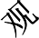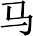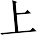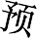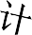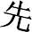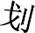

* Look at the black clouds! It’s going to rain.
* Look! Jim is going to fall into the river!
* They are going to get married next month.

##### Lesson 91 课文讲解

1. **Has he sold his house yet?**

他的房子卖掉没？

##### Yes, he has.

已经卖了。

**立足现在**

##### He sold it last week.

他上周卖的。

**叙述过去**

##### Not yet. 还没呢。

* + Have you got married?
  + Not yet.
  + Have you finished your work?
  + Not yet.

##### He is going to move tomorrow. 他打算明天搬家。

明天早晨：tomorrow morning 明天下午：tomorrow afternoon 明天晚上：tomorrow evening 明天夜里：tomorrow night

后天：the day after tomorrow

后天早晨：the day after tomorrow in the morning 后天下午：the day after tomorrow in the afternoon 后天晚上：the day after tomorrow in the evening

后天夜里：the night after next

##### I’ll miss him.

I’ll= I will…

##### He has always been a good neighbor.

**主语+ have/has+ been+ 非动词**

她一直以来都很漂亮。

She has always been pretty. 他一直以来都很丑。

He has always been ugly.

他们一直是一对儿。

They have always been a couple.

##### Will you see… today?

1. **Please give him my regards. regards: 问候、致意**

give sb.sth. send sb.sth.

Please send him my regards.

Please give your mother my regards.

##### He didn’t want to leave this house.

**No, he didn’t want to leave, but his wife did.**

**可不是嘛！**

**是啊!**

**Yes, he didn’t want to leave. 中文：主观、表意**

**英文：客观、形式**

* Jim didn’t love Sara, did he?
* No, he didn’t. 是的，不爱。
* Yes, he did.

不是，很爱的。

##### Lesson 92 单词句型讲解

**When will…?**

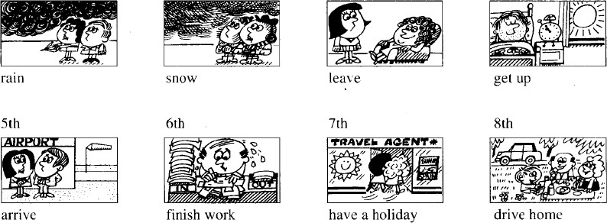

* 你们何时去度假呢？

When will you have a holiday？

* 你们去哪度假呢？

Where will you have a holiday?

* 你们如何去呢？ How will you go?

##### Lesson 91&92 知识拓展

**表将来的其他结构:**

1. **be about to 即 将**We are about to leave. 我们要走了。

He is about to finish his study. 他即将完成学业。

1. **be＋to do**

**指按计划或安排将要发生某事。**We are to meet at the zoo. 我们约定在动物园见面。

The football match is to play at 8:00 today.

今天足球比赛将在 8 点举行。

##### Lesson 93&94 预 习

* 1. 语法：并列句；
  2. 课文：各种时态的混合使用；
  3. 词汇：“return”。

##### Lesson 93 单词讲解

1. **pilot ['paɪlət] : n. 飞行员**
2. **return [rɪ'tɜːn] : 返 回**

**re-**

do sth. again

redo: 重做 rewrite: 重 写remarry: 再婚 review: 复 习

##### go back

**return from\to 从…返回, 返回到…**

He will go back from New York next month.

He will return from New York next week.

She will go back to China next week.

She will return to China next week.

##### send back 还 , 退 货

I am going to return the books.

I am going to send back the books.

He will return the coat.

He will send back the coat.

##### give in exchange

She is only one, but she is clever to return goodbye.

她才一岁，但已经聪明到懂得给人回应打招呼了。They are going to return the visit next week.

他们准备下周去回访。

##### New York [njuː jɔːk] : n. 纽 约

1. **Tokyo ['təukjəu] : n. 东 京**
2. **Madrid [məˈdrɪd] : n. 马德里**
3. **fly [flaɪ] : 飞 行**
   1. **fly- flew-flown**
   2. **fly from\to ,从…飞回, 飞到…**

下周他将从纽约飞回来。

He will fly from New York next week.

下个月她将飞回中国。

She will fly to China next month.

##### Lesson 93 语法讲解

**句子的种类(结构)：**

1. 简单句
2. 并列句
3. 复合句

##### 并列句：

* 1. 结构：

简单句+ and\but\so+ 简单句He loves me and I am happy.

He loves me but I am not happy.

He loves me so I am happy.

* 1. and, but, so, or…

not only … but also… 不仅…而且…

He’s only forty-one years old, **and** he has already been to nearly every

country in the world.

* 1. 主次？
  2. 时态？

##### Lesson 93 课文讲解

1. **He is… He was… He will…**

**He flew to…**

**He has already been to….**

1. **He’s only forty-one years old, and he has already been to nearly every country in the world.**
   1. 年龄的表达：

41 岁：

forty-one years old forty-one year- old

* 1. 全世界几乎每个国家 全国几乎每个城市：

nearly every city in China

全 北 京 几 乎 每 个 的 地 方 nearly every place in Beijing

##### Lesson 94 单词句型讲解

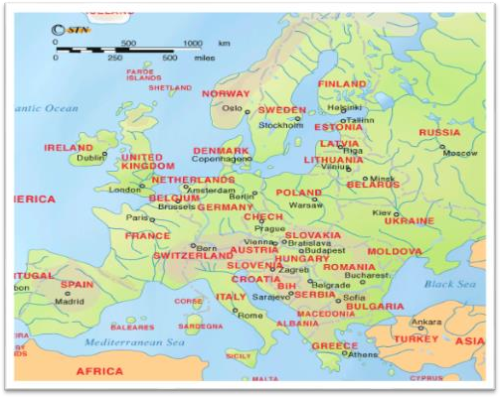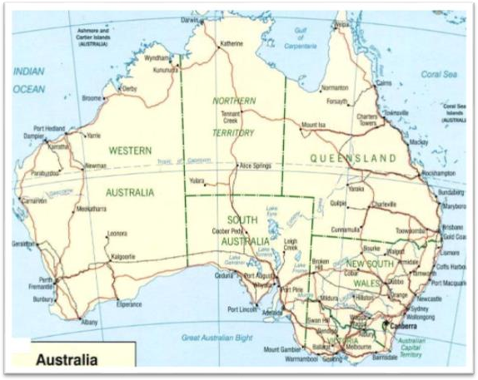

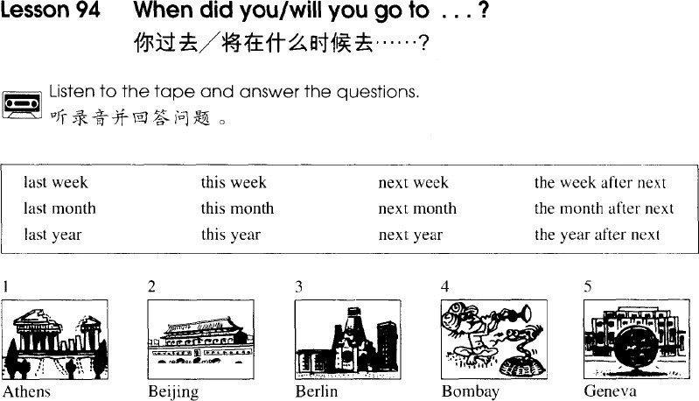

* 你去过雅典吗？
* 没有。
* Have you ever been to Athens?
* No, I have never.
* 打算去吗？
* 打算去。
* 打算什么时候去？
* 打算明年去。
* Will you go there?
* Yes.
* When will you go there?
* I will go there next year.
* 你去过柏林吗？
* 去过。
* Have you ever been to Berlin?
* Yes, I have.
* 什么时候去的？
* 去年去的。
* 和谁一块去的？
* 和我男朋友一起去的。
* When did you go there？
* I went there last year.
* Who went there with you?
* I went there with my boyfriend.

##### Lesson 93&94 知识拓展

1. **综合应用各种时态；**
2. **搞定考试中的时态题。**

张一山是我们新搬来的隔壁邻居。他是个演员。

##### Zhang Yishan is our new next-door neighbor. He is an actor.

他曾在北京五十五中学读书。他曾在北京五十五中学读书。

##### He was in No.55 middle school in Beijing.

下个月他将飞往山东。下个月他将飞往山东。现在他在上海。

##### He will fly to Shandong. The month after next he will fly to Hong Kong. At the moment, he is in Shanghai.

他是一星期以前飞到上海的。再下个星期他将返回北京。

##### He flew to Shanghai a week ago. He will return to Beijing the week after next.

他只有 21 岁，但他几乎去过中国的每一个地方了。

##### He is only twenty-one years old, and he has been to nearly every place in China.

张一山是个很幸运的人。但他的爸爸运气不是很好。他总是呆在北京。

##### He is a lucky person. But his father is not very lucky. He usually stays in Beijing.

1. **The pilot to Shanghai last Tuesday.**

√

* 1. **will fly B. flies C. flew D. has flown**

1. **— When did Sam go to Seoul?**

**— He there the year before last.**

√

* 1. **went B. went to C. will go D. goes**

1. **— Who is Jerry Cooper?**

**— ? I saw you talking with him at the meeting.**

* 1. **Don’t you meet him yet**
  2. **Hadn’t you met him yet**
  3. **Didn’t you meet him yet**

√

* 1. **Haven’t you met him yet**

1. **Turn on the television or open a magazine and you advertisements showing happy families.**

√

* 1. **will often see B. often see**

**C. are often seeing D. have often seen**

1. **—I hear Jane has gone to the Holy Island for her holiday.**

**—Oh, how nice! Do you know when she ?**

* 1. **was leaving B. had left**

√

**C. has left D. left**

**Lesson 95&96 预习**

1. 语法：had better；
2. 课文：in；
3. 知识拓展：提建议的方式。

##### Lesson 95 单词讲解

1. **return [rɪ'tɜːn] : n.往返**

往返票 return tickets

单程票 single ( journey) ticket return label：退货标签

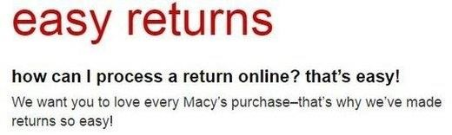

##### train [treɪn] : n.火车

1. **platform ['plætfɔːm] : n.站台**

Platform 4

Line 16

Room 438

##### plenty ['plenti] : n.大量plenty of

* 1. 用于肯定句
  2. 可接可数名词& 不可数名词plenty of time

plenty of eggs

* 1. 谓语动词一致

There is plenty of room for everyone.

There are plenty of rooms for everyone.

##### bar [bɑː(r)] : n.酒吧

1. **station ['steɪʃn] : n.车站，火车站**

a train station

##### catch [kætʃ] : v.赶上

catch- caught- caught

##### miss [mɪs] : v. 错 过

**Lesson 95 语法讲解**

1. **Two return tickets to London, please.**

**n. + please**

**to, 开往… 表示方向**

要三张去广州的往返票。

Three return tickets to Guangzhou. 要一张去西安的单程票。

One single ticket to Xi’an.

##### 下班火车是几点的？

**What time will the next train leave?**

1. **我们还有很多时间。**

**We have plenty of time. We’ve got plenty of time.**

1. **have a drink 喝一杯**
2. **next door to… 隔 壁**

公园的隔壁有家餐馆。

There is a restaurant next door to the park.

学校的隔壁有家医院。

There is a hospital next door to the school.

##### We had better go back to....

had better: 最 好

##### We want to catch the eight nineteen to London.

the eight nineteen:

the train leaves at 8:19

##### 那钟慢了 10 分钟。

That clock is ten minutes slow. 我的手表慢了 5 分钟。

My watch is five minutes slow.

那钟快了 6 分钟。

The clock is six minutes fast.

##### In five hours’ time. 五小时以后。in+ 段时间, …之后

in five minutes 5 分钟之后in two days 两天之后

in three years 三年之后

在 1 分钟之后的时间里：in one minute’s time

在 5 分钟之后的时间里：in five minutes’ time

in two days’ time in three years’ time

##### Lesson 95 课文讲解

**情态动词：must\ may\ can**

A. 没有人称和单复数的变化I can…

You can…

He can… They can… We can…

B. + 动词原形

You can do it.

He can repair the car.

1. 疑问，提前

Can you repair it?

1. 否定，+ not

You can’t repair the car.

**had better：最好…用来提建议，但不是很客气**

A. You had better… He had better… They had better…

B. + 动词原形

You had better give her a way out.

You had better ask yourself.

C. 疑问，had 提前

D. had better + not

You had better not give her a way out. We had better not tell him anything. We had better not drive him mad.

##### He has a bad cold.

1. He had better take some medicine.
2. He had better see the doctor.
3. He had better stay at home.
4. He had better drink some boiled water.

##### He has a bad cold.

1. He had better not go to work.
2. He had better not go to school.
3. He had better not eat rich food.
4. He had better not drink cold water.

##### You’d better your homework right now.

* 1. **to finish B. finishing**

√

**C. will finish D. finish**

1. **It's too far. You'd better .**
   1. **by car B. on a taxi**

√

**C. take a taxi D. to take a taxi**

1. **We not drink dirty water.**
   1. **would like B. could better**

**C. do D. had better**

√

* You had better go to the Palace Museum this afternoon.

今下午你最好去故宫。

* You had better pay the money by the end of the month. 你月底前最好把钱付上。

##### Lesson 96 单词句型讲解

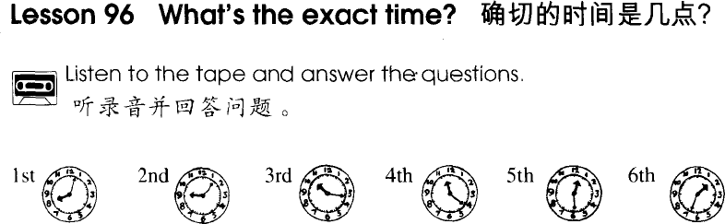

-Have you ever been to…?

-Yes, I have.

-When did you go there?

-No, I haven’t.

-When will you go there?

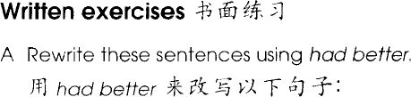

I must stay here. You’d better stay here.

You must wait for him. You’d better wait for him.

##### Lesson 95&96 知识拓展

**提建议的方式：**

1. You’d better…

You’d better call him.

1. Why not + v. ? Why not call him?
2. advise sb. to do…

I advise you to call him.

##### Lesson 97&98 预习

* 1. 语法：物主代词 &belong to；
  2. 课文：形容词的排列顺序；
  3. 知识拓展：“骂人“。

##### Lesson 97 单词讲解

1. **leave [liːv] : v.**

leave-left-left

* 1. 离开

He has left Beijing.

When will you leave the hotel?

* 1. 遗留、落

Please leave the door open. 留着门儿。

I left my bag on the train. 我把包落在火车上了。

##### describe [dɪ'skraɪb] : v. 描 述

Please describe the person you like best.

1. **zip [zɪp] : v. 拉**Please zip your lips. Please shut up.

##### zipper（美式） zip（英式）

1. **label ['leɪbl] : n. 标 签**
2. **handle ['hændl] : n. 提手、把手**
3. **address [ə'dres] : n. 地 址**

What’s your address?

Can you please tell me your address?

##### pence[pens] : n. penny 的复数

1. **belong [bɪ'lɒŋ] : v. 属 于**
   1. **belong-belonged**
   2. **belong to**

**belong to me\ her\ him\ them\ us**

自由属于我。

The freedom belongs to me. 幸福属于我们。

The happiness belongs to us.

##### Lesson 97 语法讲解

|  |  |  |
| --- | --- | --- |
| **物主代词** | **形容词性** | **名词性** |
| **我的** | **my** | **mine** |
| **你的** | **your** | **yours** |
| **他的** | **his** | **his** |
| **她的** | **her** | **hers** |

**形容词性物主代词+n.**

**名词性物主代词可以作主语、表语、宾语It is my address.**

**The address is mine.**

**This is her car.**

**The car is hers.**

**My coat is green.**

**Mine coat is green.**

1. **名词性物主代词复数：**

|  |  |  |
| --- | --- | --- |
| **物主代词** | **形容词性** | **名词性** |
| **我们的** | **our** | **ours** |
| **你们的** | **your** | **yours** |
| **他们的** | **their** | **theirs** |

**形容词性物主代词+n.**

**名词性物主代词可以作主语、表语、宾语**

These are their names.

These names are theirs.

This is our address in Beijing.

This address in Beijing is ours.

This is your air ticket to London.

Yours is to London, too.

##### 物主代词&belong to:

These are their keys to the car.

These keys to the car are theirs.

These keys to the car belong to them.

It is his phone number.

The phone number is his.

The phone number belongs to him.

1. **物主代词&belong to 的否定、疑问:**

The address is not mine.

The address not belongs to me.

The address doesn’t belong to me.

Are these your letters?

Are these letters yours?

Are these letters belong to you?

Do these letters belong to you?

##### Lesson 97 课文讲解

1. **一个蓝色的小箱子:**

**a blue small case a small blue case** 多个形容词的顺序：

限定描绘大长高，形状年龄和新老， 颜色国籍和材料。

限定词：the, this, that, my, your, one, two… 描绘：beautiful, cold, pretty, good

形状：round, square…

材料： wooden, stone, leather…

① 一枚小的圆形英国硬币a small round British coin

② 一件崭新而漂亮的意大利黑皮夹克

a beautiful new black Italian leather jacket

**③** This girl is Linda’s cousin. (2005 北京高考卷)

* 1. pretty Spanish little
  2. little Spanish pretty
  3. pretty little Spanish

√

* 1. Spanish pretty little

##### I left a suitcase on the train to London.

on: on the train\ bus\ plane

the train to London: 开往伦敦的火车

开往莫斯科的列车：the train to Moscow

从上海飞来的航班：the flight from Shanghai

##### I left a suitcase on the train to London the other day.

the other day: 前几天

前几天我把钱包落在了去郑州的火车上。I left my wallet on the train to Zhengzhou the other day.

##### There is a label on the handle with my name and address on it. 上面写有我的名字和地址。

盒子上有个标签,上面标着价格。

There is a label on the with on it. T 恤衫上有个标签,上面标着尺码。

There is a label on the with on it. 他给我一张纸条，上面写着他的电话号码。

He gave me a piece of paper with his phone number on it.

他递给了我一本笔记，里面是他的日记。

He passed me a note book with his diary in it. 他给我一张卡片，上面写着: 我爱你。

He gave me a card with “I love you”on it.

##### A

**Lesson 98 单词句型讲解**

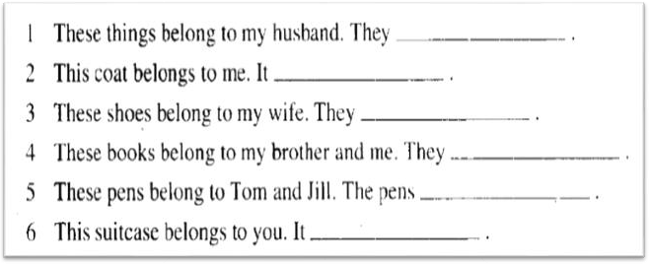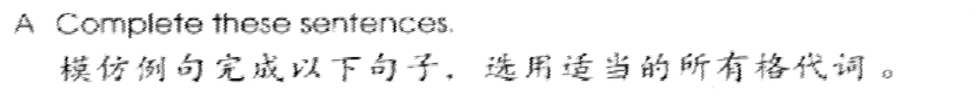

**are his**

**is mine**

**are hers**

**are ours**

**are theirs**

**is yours**

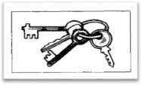**Are these their keys? Are these keys theirs?**

**Do these keys belong to them?**

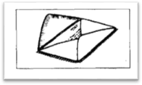**Is this your letter? Is this letter yours?**

**Does this letter belong to you?**

**Lesson 97&98 知识拓展**

**美国人常用粗话：**

1. Fuck！
2. Son of bitch!
3. You make me sick . 你真让我恶心。
4. You are a jerk. 废物！
5. Are you insane? 你疯了吗！
6. Knock it off! 少来这一套。
7. You are out of your mind.

你脑子有病！

1. Get off my back . 少罗嗦。
2. It’s none of your business. 关你屁事。

##### Lesson 99&100 预习

1. 语法：宾语从句；
2. 口语：小心滑倒；
3. 知识拓展：slip.

##### Lesson 99 单词讲解

1. **ow [aʊ] : int.哎哟**
2. **slip [slɪp] : v.滑倒，滑了一脚**

slippery, adj. 滑 的

##### fall [fɔːl] : v.落下，跌倒

1. **downstairs [ˌdaʊn'steəz] : adv.下楼**

go downstairs

##### hurt [hɜːt] : v.伤，伤害，疼痛

hurt- hurt- hurt

* 1. hurt oneself

I hurt myself.

* 1. hurt+ 部 位

She hurts her left arm.

1. **back [bæk] : n.背**my back , 我的背the back door 后 门

##### stand up ['stændʌp] : v. 起立，站起来

1. **help [help] : v.帮助**

Can I help you? Let me help you.

##### at once [æt wʌns] : 立即

right now

##### sure [ʃʊə(r)] : adj.一定的，确信的

Are you sure?

##### X-ray ['eksreɪ] : n. X 光透视

**Lesson 89 语法讲解**

**宾语从句：句子作宾语**

**I love you.**

**主 谓 宾**

**I think (that) he is awful.**

**主 谓 宾**

**主句**

**I think (that) he is awful.**

零部件：

**从句**

1. 主句& 从句
2. 引导词：that

##### She says (that) he loved her.

**主 谓 宾 He knows (that) she has gone.**

**主 谓 宾He is sorry (that) he will leave.**

**主 谓 宾**

**主句**

**从句**

1. **I think (that) he is awful.**
2. **He says (that) he loved her.**
3. **He knows (that) she has gone.**
4. **He is sorry (that) he will leave.**

**结论 1: 主句一般现在, 从句任何时态。**

我知道他会看电影的。

I know (that) he will watch the movie.

我知道他已经看电影了。

I know (that) he has watched the movie.

我知道他经常看电影。

I know (that) he usually watches the movie.

我知道他正在看电影。

I know (that) he is watching the movie.

##### 宾语从句的功能： I think (that) …

**I believe (that) …**

I think (that) it is very good.

Because we learn about what the PM2.5 is and what we must do.

##### 什么是宾语从句？ 句子作宾语。

1. **宾语从句的零部件；**
2. **时态？**

**主句一般现在, 从句任何时态。**

1. **语用功能？**

**表达观点。**

**Lesson 99 课文讲解**

1. **I slipped and fell downstairs.**

slipped- fell

他进来坐下了。

He came in and sat down.

我过来见了他的朋友 Lucy.

I came and met his friend, Lucy.

##### I think that I’ve hurt my back.

**宾 语**

1. **Try and stand up. 试着站起来。**

Try and have a drink.

##### 试着喝一杯。

1. **I’m afraid that… I’m sorry that…**

**The doctors says that… I’m sure that…**

**Lesson 100 单词句型讲解**

**1. licence ['laɪsns] n. 执 照**

license

a driving license：驾照

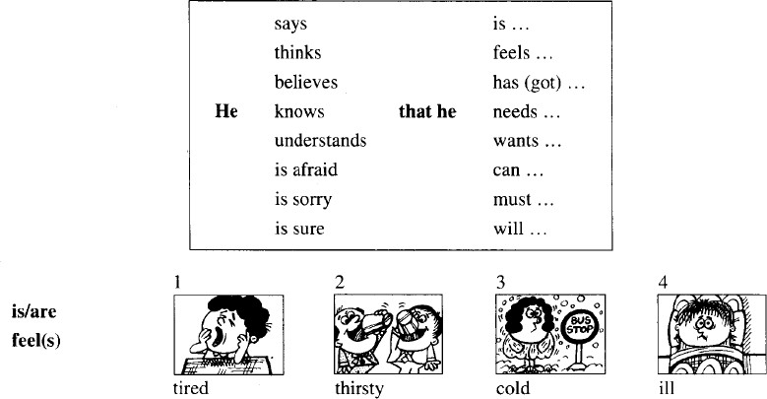

##### Lesson 99&100 知识拓展

**slip [slɪp] : v.滑倒**

slippers：拖鞋

slip my mind: 忘记了slip of the pen: 笔 误slip of the tongue: 口 误

Put on your slippers. 把拖鞋穿上。

It slips my mind. 我给忘记了。

That was only a slip of the pen. 那不过是笔误而已。

##### Lesson 101&102 预习

1. 语法：间接引语，反义疑问句；
2. 知识拓展：书信的格式。

##### Lesson 101 单词讲解

1. **Scotland ['skɒtlənd] : 苏格兰**

the United Kingdom of Great Britain and Northern Ireland

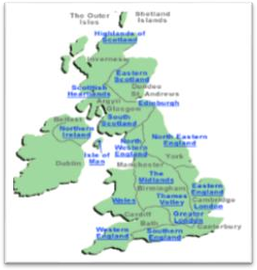

1. **card [kɑːd] : 卡片、明信片**名 片 :：a business card 信用卡: a credit card

银行卡: a bank card

##### youth [juːθ] : 青 年

young: 年轻的

##### hostel ['hɒstl] : 招待所、旅馆

hotel: 酒 店

##### association [əˌsəʊʃi'eɪʃn] : 协 会

the Football Association 足球协会

the Spoken English Association 英语口语协会

##### soon [suːn] : adv. 不久，很快

I’ll be back soon.

##### write [raɪt] : v. 写

write-wrote- written

I’ll write a letter to him.

= I’ll write to him write to sb. 写信给某人

##### Lesson 101 语法讲解

1. **直接引语 & 间接引语：**
   1. **什么是直接引语&间接引语？**

“Anhong, I miss you.”

→ He says he misses you.

##### 变?

* + 1. **人称;**
    2. **指示代词; this-that,**

**these-those**

* + 1. **时间状语;**

now-then, today-that day, yesterday-the day before, tomorrow- the next day

He says to me, “ I’ve found my wallet.”

* + - * He tells me (that) he has found his wallet.

She says, “You can sit here, Jim.”

* + - * She tells Jim (that) he can sit there.

##### 直接引语、间接引语& 宾语从句？

He says (that)his sister was there the day before.

#### 主 谓 宾语

宾语从句：句子作宾语。

主句一般现在— 从句任何时态结论：间接引语属于宾语从句。

##### 反意疑问句:

* 1. **构成：陈述句 + 简短一般疑问句**

It’s a nice day, is it a nice day?

isn’t it?

##### 反：

**肯定 + 否定否定 + 肯定**

It’s a nice day, isn’t it?

It’s not a nice day, is it?

##### 组织步骤:

动 — 反 — 换

Chinese people were hard before, weren’t they ?

Lily is in Tokyo, isn’t she?

Lily goes to school on foot, doesn’t she?

Sam had a meeting last night, didn’t he?

Lily can’t speak French, can she?

Sam must stay at the hotel, mustn’t he?

You have finished your work, haven’t you?

Sam hasn’t had his lunch, has he?

#### be

do 系列

情态动词

have

Lily is in Tokyo, isn’t she？

Chinese people were hard before, weren’t they? Lily goes to school on foot, doesn’t she?

Sam had a meeting last night, didn’t he?

Lily can’t speak French, can she?

Sam must stay at the hotel, mustn’t he? You have finished your work, haven’t you? Sam hasn’t had his lunch, has he?

##### Lesson 101 课文讲解

1. **吉米的明信片: a card from Jimmy**

车库的那辆车：the car in the garage 我俩中间那孩子：the kid between us

楼前那棵树：the tree in front of the building

路上那辆车：the car on the way

##### Read Jimmy’s card to me, please. read sth. to sb. 给…读…

他给他爷爷读了那封信。

He read the letter to his grandpa.

##### You know, he’s a member of the Y.H.A.

a member of… …成员

He is a member of the Ivy League. 他是长春藤联合会的一员。

a member of an association

a league/a party/a group…

##### What else does he say?

Where else…? Which else…? Whose else…?

Where else have you been?

Which else do you like? Whose else do you choose?

##### I hope you are all well.

我希望你们万事如意。

##### Speak up.

= Louder please.

##### Lesson 102 单词句型讲解

**1.. 宾语从句：句子作宾语。**

I love you.

主 谓 宾

I think I love you.

## 主 谓 宾

##### 时态要求：主句一般现在，从句随便。

I think (that) he is awful.

He says (that) he loved her.

He knows (that) she has gone.

He is sorry (that) he will leave.

##### 语用功能：

* 1. 表达观点
  2. 引述话语 I think that…

I believe that… He says that…

##### Lesson 101&102 知识拓展写信日期

**书信格式**

1. **正文前**

**写信人地址**

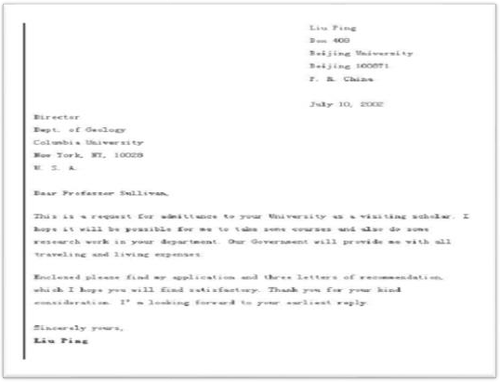

**收信人地址**

**写信日期**

1. **正文**
   1. **称呼**

**Dear…,**

**Dear Mr. …,**

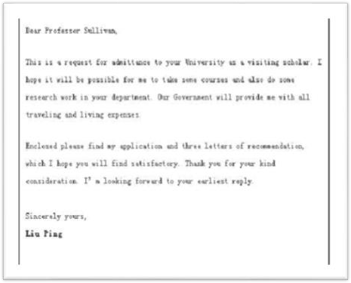

* 1. **书写格式**

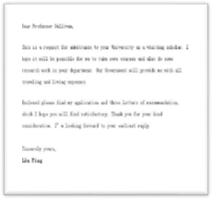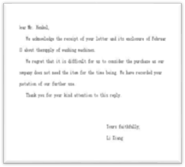

1. **落款**
   1. **位置**

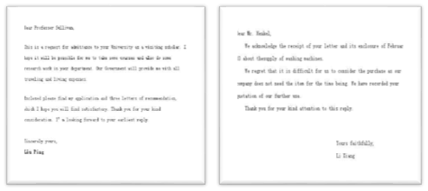

* 1. **写法**

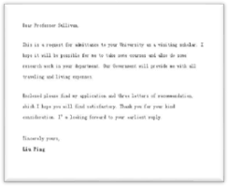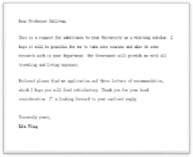

**Yours, Venus**

1. **常用开头语**
   1. I am very glad to hear from you. 很高兴收到你的来信。
   2. I’m writing to tell you that…

我写信想告诉你……

* 1. I’m sorry it has taken me a long time to reply.

很抱歉这么久才给你回信。

##### Your sincerely, Venus

1. **常用结束语**

A.I hope you are all well. 希望你一切顺利。

B. Best wishes to you.

送上我最美好的祝福。

C. I’m looking forward to your reply. 期待你回信。

##### Lesson 103&104 预习

1. 词汇：too，very，enough 的对比；
2. 句型结构：too…to…

##### Lesson 103 单词讲解

1. **exam [ɪɡ'zæm]** /**examination[ɪɡˌzæmɪ'neɪʃn] : n.考试**

an examination room 考 场test 水平测试

TOEFL: Test of English as a Foreign Language

ELTS: International English Language Testing System

##### pass [pɑːs] : v.及格，通过

pass in + 具体科目

##### mathematics [ˌmæθə'mætɪks] : n.数学

math maths

##### question ['kwestʃən] : n.问题

题;做题：answer the question

##### easy 'iːzi] : adj.容易的

1. **enough [ɪ'nʌf ] : adv.足够地**

easy enough enough money

adj.+ enough

enough + n.

##### paper ['peɪpə(r)] : n.考卷

1. **fail [feɪl] : v.未及格，失败**

I will fail math. Our plan will fail.

##### answer ['ɑːnsə(r)] : v.回答

answer the question：回答问题，做题answer the phone：接电话

##### mark [mɑːk] : n.分数

score

high score low score

取得高分，make a high score

##### rest [rest] : n.其他的东西

We'll eat some of the bread and keep the rest for breakfast.

##### difficult ['dɪfɪkəlt] : adj.困难的

1. **hate [heɪt] : v.讨厌**
2. **low [ləʊ] : adj.低的**

a low mark

##### cheer [tʃɪə(r)] : v.振作，振奋

Cheer up!

##### guy [ɡaɪ] : n.家伙，人

gay

##### top [tɒp] : n.上方，顶部

at the top of…

考卷的上方：at the top of the paper at the bottom of...

You can see a fish at the bottom of the lake.

##### Lesson 103 语法讲解too：太…（以至于不能，否定含义）

**very：非常…**



**enough：够… too…**

too young, too simple The boy is too handsome. You are too late.

The baby is too young to eat by himself.

**too+ 形容词/副词+to+动词： 太…以至于不能…**

他走得太慢，不能按时到达那儿。

He walks too slowly to get there on time.

她太漂亮根本找不到男朋友。

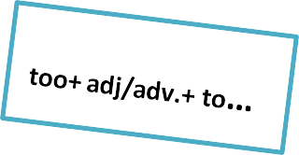

She is too pretty to get a boyfriend. 这孩子太小，没法看着电影。

The kid is too young to watch the movie.

**very…** very pretty very much **enough…**

enough+ n. adj.+ enough 天够冷的。

It is cold enough.

我有足够的时间来读书。

I have enough time to read.

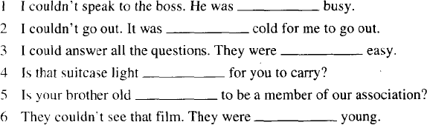

**too**

**too**

**very**

**enough**

**enough**

**too**

##### Lesson 103 课文讲解

1. **Not too bad. 还好啦，凑合。**
2. **I could answer sixteen of the questions. can- could**

16 个问题：sixteen questions

sixteen of the questions: 其中的 16 个问题两位老师：two teachers

其中的两位老师：two of the teachers

1. **They were too difficult for me.** too difficult, 太难（不会, 否定） for me, 对于我来说

##### French tests are awful, aren’t they?

**法语考试非常讨厌，不是吗？**

1. **The guy [next to me]… 坐在我旁边那家伙**

the ones [on the shelf] the beauty [behind me]

##### He didn’t write a word. 他一个字都没写。

他一句话都没说。

He didn’t say a word.

他一分钱都没挣。

He didn’t make any money.

##### Lesson 104 单词句型讲解

1. **clever['klevə(r)] : adj.聪明的**

身体的灵巧思维敏捷

较快地理解掌握所学知识/技能

##### smart [smɑːt] :

思维能力强,办事巧妙,圆滑处理人际关系

1. **stupid ['stjuːpɪd] : adj. 笨 的缺乏理智,先天迟钝、智力低下**silly ['sɪli] :

缺乏常识、判断力,作出令人可笑的行为和举止

##### cheap [tʃiːp] : adj.便宜的

1. **expensive [ɪk'spensɪv] : adj.贵的**
2. **fresh [freʃ] : adj.新鲜的**
3. **stale [steɪl] : adj.变馊的**
4. **low [ləʊ] : adj.低的，矮的**
5. **loud [laʊd] : adj.大声的**

quiet['kwaɪət]

##### high [haɪ] : adj.高的

1. **hard [hɑːd] : adj.硬的**
2. **soft [sɒft] : adj.软的12.sweet[swiːt] : adj.甜的13.sour['saʊə(r)] : adj.酸的**

bitter ['bɪtə(r)] : adj.苦的

##### Lesson 103&104 知识拓展

too

1. Never too old to learn. 活到老学到老。
2. Life is too short to waste.

生命短暂，经不起浪费。

##### Lesson 105&106 预习

* 1. 语法：动词不定式；
  2. 词汇：with，about
  3. 知识拓展：简单地道的口语。

##### Lesson 105 单词讲解

1. **spell [spel] : v. 拼 写**

spell-spelt-spelt

How do you spell “…”?

1. **intelligent [ɪn'telɪdʒənt] : adj. 有智慧的**clever: adj. 聪 明 的 （ 有 时 含 贬 义 ） brilliant: adj. 极端聪明的

talented: 有才能的、有天赋的

##### mistake [mɪ'steɪk] : n. 错 误

a mistake/ two mistakes 犯错误：make a mistake 他在考试中犯了好多错误。

He made many mistakes in the exam.

##### present ['preznt] : n. 礼 物

a birthday present a Christmas present gift [ɡɪft] n. 礼 物

He gave me a ring as an anniversary gift.

他给我一枚戒指作为周年纪念礼物。

1. **dictionary ['dɪkʃənri] : n. 词 典**English-Chinese dictionary Chinese-English dictionary E（electronic）- dictionary He is a walking dictionary.

他是个活字典。

##### Lesson 105 语法讲解

**动词不定式：**

* 1. 构成：to do

want to do want sb. to do tell sb. to do ask sb. to do

* 1. 使用：

他本想买一辆新车。

He wanted to buy a new car. 我想让他移一下他的车。

I want him to move his car. 告诉他快点回来。

Tell him to go back right now.

* 1. 成分：

He wants to buy a new car.

主 谓 宾

I want him to move his car.

#### 主 谓 宾 宾补

##### 不定式的否定：

want sb. to do- don’t want sb. to do tell sb. to do- tell sb. not to do

ask sb. to do- ask sb. not to do

我不想让他担心。

I don’t want him to worry about me. 跟他说不要回来了。

Tell him not to come back .

##### Lesson 105 课文讲解

* + 1. **错误百出**

**full of mistakes**

他的数学试卷错误百出。

His math paper full of mistakes.  His math paper is full of mistakes.

**be full of mistakes**

* + 1. **You’ve typed it with only one “L”.**

**你打字的时候只用了一个“L”。with:**

* + - 1. 和…在一起

I am with my mom.

* + - 1. 带有、具有

a house with a garden

a book with a green cover

* + - 1. 以…方式，用

We hear with our ears. We see with ours eyes.

* + - 1. 对于，至于…

What are you going to do with that vase? What’s the matter with you?

##### I’m sorry about that. about:

* + - 1. 关于…

a book about Chinese history

* + - 1. …怎么样？(询问或提意见) What about you?
      2. 大约

She is about 10 years old.

##### Lesson 106 单词句型讲解

1. **carry ['kæri] : v. 携带、运送**

bring: 带 来take: 带 走

fetch: 去了再回来，取

1. May I my boyfriend here next time，mom?

√

A. bring B. take

C .fetch D. carry

（2）A taxi them to the station yesterday.

A. fetched B. brought

C. took

√D. carried

（3）. Please the umbrella with you. It’s going to rain.

√

A. bring B. take

C .fetch D. carry

（4）. The boss says to her, “Please me my documents in that room”.

A. fetch B. bring

√

C. take D. carry

1. **correct [kə'rekt] : v. 改正，纠正**Please correct the mistake you have made on the paper.

##### keep [kiːp] : v. 保存、保留

keep— kept— kept

I have kept the old photo for a long time. Keep in touch. 保持联络。

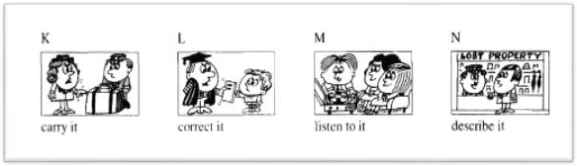

I want you to carry it.

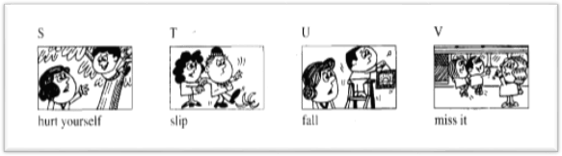He wants you to correct it. He wants us to listen to it. He wants me to describe it.

I don’t want you to hurt yourself. She doesn’t want him to slip.

Tell him not to fall. Tell him not to miss it.

##### Lesson 105&106 知识拓展

1. **常见的缩写：**

**want to…= wanna…**

I want to have a big house in Beijing. I wanna have a big house in Beijing. **thanks=thx**

##### kind of = kinda going to= gonna

1. **简单但地道的口语：**
   1. Got it？ 明白没？
   2. You wish! 想的美！
   3. So what? 那又怎么样呢？
   4. No way! 没门！
   5. Forget it. 就这么着吧。
   6. Eyes front! 朝前看。
   7. Good point！说的好！
   8. All right. 没关系。

##### Lesson 107&108 预习

1. 语法：形容词的比较级最高级；
2. 句型：更客气更委婉的句型；
3. 知识拓展：有用的比较

##### Lesson 107 单词讲解

1. **madam['mædəm] : n.夫人，女士**
2. **as well : 同样， 也**

also: 肯定句，实义前情系后，比较正式too: 肯 定 句 疑 问 句 句 末either：否定句末

as well: 用于肯定句，句末

这个商店也卖婴儿食品。

The shop sells food for babies too.

The shop also sells food for babies.

The shop sells food for babies as well.

##### suit [suːt] : v.适于

It suits you well.

It doesn’t suit me. suitable adj. 适宜的，合适的

##### pretty ['prɪti] : adj.漂亮的

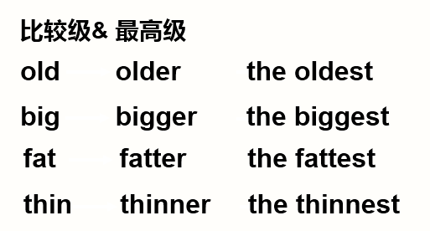**Lesson 107 语法讲解**

**比较级\ 最高级变化规则**

1. 以 e 结尾, 直接加 r, st; late- later- the latest
2. 辅+元+辅 (汉堡包结构)，

双写最后一个辅音字母加 er, est; fat - fatter- the fattest

1. 辅音字母加 y 结尾,变 y 为 i,加 er, est happy- happier- the happiest

##### 比较级的句型结构：

**（1）主语+谓语（系）+比较级 +than…**



他比以前帅。He is cooler than before.



她比从前时尚。

She is smarter than before.

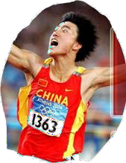

##### 他比其他人都快。

He was faster than any other one.

##### 主语+谓语（系）+ the+ 最高级+ 范围

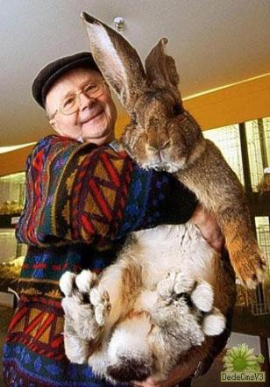

这曾是全世界最大的一只兔子。

It was the biggest rabbit in the world.

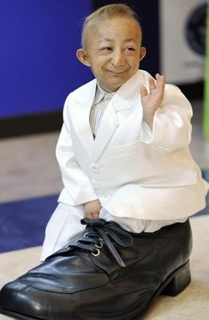

他是全世界最矮的人。

He is the shortest man in the world.

今天是这个月最忙的一天。

It is the busiest day in this month.

他是我们当中个子最高的。He is the tallest of us all.

全世界：in the world

全中国：in China 全北京：in Beijing

全班：in the(our) class

一年中：in a year

一季度中：in a season 一个月中：in a month 我们所有人中：of us all

##### Lesson 107 课文讲解

1. **It’s too small.**
2. **It’s a lovely dress, but it’s too small for me.**

for me, 对于我来说

Math is too difficult for him. 数学对他来说太难了。

##### Short skirts are in fashion now.

in fashion= fashionable out of fashion

Tight jeans were in fashion last year.

去年流行紧身牛仔裤

1. **Would you like to try it?** would like to + v. … 想要做… would like + sth. … 想要…

I would like a new pair of shoes.

I would like to buy a new pair of shoes.

want + n. 想 要 … want to + v.想要做…

##### I’m afraid this green dress is too small for me as well.

as well, 也

…this green dress is…for me too.

…this green dress is also too small for me.

##### I don’t like the color either.

**either, 否定句末**

他也不喜欢咖啡。

He doesn’t like coffee either.

##### I think the blue dress is prettier.

pretty- prettier- the prettiest

##### Could you show me another blue dress? Could you+ v….? (委婉的请求)

Could you lend me some money? Could you give me a hand?

Would you like to show me another blue dress?

##### It must be my size. 必须得是我的尺码。情态动词+动词原形

**It is my size.**

10 点你必须在这儿。

You must be here at 10:00.

##### I haven’t got a larger dress.

**This is the largest dress in the shop.**

haven’t got= don’t have large- larger- the largest

##### Lesson 108 单词句型讲解

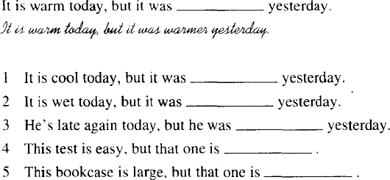

**cooler wetter**

**later easier**

**larger**

**Lesson 107&108 知识拓展**

比较级&最高级的有用句型：

1. East, west, home is best.

金窝银窝，不如自己的草窝。

1. Facts speak louder than words. 事实胜于雄辩。
2. Health is better than wealth. 健康高于财富。
3. It is better to be the head of dog. 宁为鸡头不做凤尾。
4. The sauce is better than the fish.

喧宾夺主*。*

1. 没有最好只有更 好。

There is no best, but better. To make the best even better.

##### Lesson 109&110 预习

1. 语法：比较级和最高级-2；
2. 词汇：英语中的“少”；
3. 知识拓展：提建议的方式。

##### Lesson 109 单词讲解

1. **idea [aɪ'dɪə] : n. 主 意**

a good idea a bad idea

I have no idea.

##### a little : 少 许

1. **teaspoonful ['tiːspuːnfʊl] :n. 一满茶勺**

a teaspoonful of sugar two teaspoonfuls of milk

##### less: 更 少

1. **a few: 少(几个)**
2. **pity ['pɪti] : n. 遗 憾**

What a pity!

##### instead [ɪn'sted] : adv.代替

I’ll have some rice instead.

##### advice [əd'vaɪs] : 建议（不可数）

a piece of advice

##### Lesson 109 语法讲解

1. **少**

little 几乎没有

+不可数名词

a little 有少许

few 几乎没有

+可数名词

a few 有几个杯子几乎没有牛奶了。

There is little milk in the cup.

他几乎不懂几个法语单词。

He knows only few words of French.

这年头好人不多了。

There are a few good men now.

他这里几乎没朋友，感觉寂寞。

He has few friends here, he feels lonely.

我基本不了解他。

I knew little about him.

1. — You look sad, Kate.

— Yeah, I have made mistakes in my paper.

* 1. a little B. little

C. few

√D. a few

1. The twins have never learned French, so they can speak only French.
   1. a few B. few

C√. little D. a little

##### 少——更少——最少的little 几乎没有

+不可数名词

**a little 有少许** less —— the least

##### few 几乎没有

+可数名词

**a few 有几个** fewer —— the fewest

##### 多——更多——最多的

**many 很多 + 可数名词much 很多 + 不可数名词**more —— the most

他赚的比从前更多了。

He makes more money than before. 他吃的比以前多了。

He eats more food than before.

1. The doctor tells Mary to eat _vegetables and _meat because she is getting

fatter and fatter.



A. much, little

√B. more, less

C. many, few D. more, few

##### 越来越…：比较级+and +比较级

warmer and warmer busier and busier taller and taller

1. I have money than you, but I have friends than you.
   1. less; fewer B. fewer; less

C. more; than

√D . less; more

1. If there is traffic on the streets, deaths will be caused. (高考模拟题)
   1. less; less B. fewer; fewer

√C. less; fewer D. fewer; less

##### Lesson 109 课文讲解

1. **提建议的方式：**
   1. **Shall I …?**
   2. **Would you like to…?**
   3. **May I have…?**
   4. **Can I …?**
   5. **Could you…?**

**邀请别人吃饭：**

1. Shall I have dinner with you?
2. Would you like to have dinner with me?
3. May I have dinner with you?
4. Can I have dinner with you?
5. Could you please have dinner with me?

##### make some coffee 泡咖啡

* 1. What make is it? n. 品 牌
  2. make the bed: 整理床铺
  3. I’m going to make a bookcase. 制 作
  4. make a shopping list: 写购物清单
  5. make some friends: 交朋友
  6. make a movie: 拍一部电影
  7. make up one’s mind: 下定决心

##### One and a half teaspoonfuls… 一勺半

half a teaspoonful: 半 勺半小时： half an hour

一个半小时：one and a half hours

an hour and a half 半天：half a day

一天半：one and a half days

a day and a half

##### Have a biscuit instead.

* 1. **adv. 次优选择**

Don’t marry her. Marry me instead. 不要和她结婚，和我结婚吧。

Shall we watch a movie instead? 咱能不能改看电影？

可以改用白色吗？

Shall we use white instead?

##### instead of…+ n.\ pron.（没有）

Oops! I put in sugar instead of salt.

啊！我错把糖当盐放了。

I gave him advice instead of money.

我给了他忠告，而不是钱。我错拿了你的手提包。

I took your bag instead of mine.

##### Eat more and smoke less.

**v. + more/less**

多喝水少吃东西。

Drink more and eat less. 多玩少学习。

Play more and study less.

##### Lesson 110 单词句型讲解

1. most: many much 的最高级，最多的
2. least: little 的最高级，最小的，最少的
3. best: good 的最高级，最好的
4. worse: bad 的比较级，更坏的
5. worst: bad 的最高级，最坏的

好 ： good\well—better— the best 坏 ： bad— worse— the worst

多 ： many\much— more— the most 少 ： little— less— the least

few— fewer— the fewest

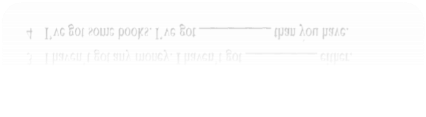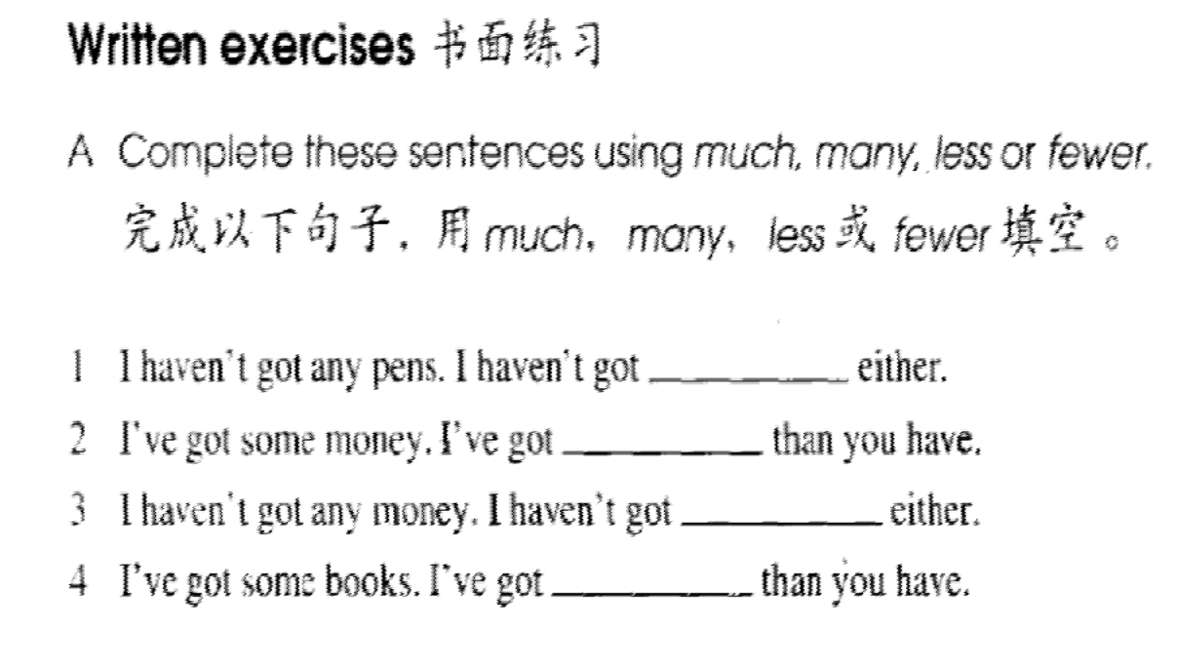

**many**

**less**

**much**

**fewer**

447

##### Lesson 109&110 知识拓展

**表达需求、提建议的方式：**

I want…  Shall I …?

May I …?

Could you please…? Can you…?

Would you like to…?

Why don't you+ v ?

Why not + v. …？ How about ？

What about ？

You should do ...

You’d better…

I was wondering if you would like to .

##### Lesson 111&111 预习

1. **语法：比较级和最高级-3；**
2. **口语话题：分期付款。**

**Lesson 111 单词讲解**

1. **model ['mɒdl] : n.型号，式样，模特**
2. **afford [ə'fɔːd] : v.付得起(钱)**

afford + n. afford to do

I can afford the car.

I can afford to buy the car. I can’t afford…

##### deposit[dɪ'pɒzɪt]: n.预付定金

首付：

pay a deposit of + 金 额

我首付了 5 万，买了这辆车。

I paid a deposit of fifty thousand to buy this car.

##### instalment [ɪn'stɔːlmənt] : n.分期付款

installment

buy sth. on installments: 通过分期付款购买他分期付款买了一套公寓。

He bought an apartment on installments.

1. **price [praɪs] : n.价格**What’s the price? How much is it?

How much does it cost? 不讲价：

one price

##### millionaire [ˌmɪljə'neə(r)] : n.百万富翁

million

##### Lesson 111 语法讲解

**比较级& 最高级**

|  |  |  |
| --- | --- | --- |
| old | older | the oldest |
| big | bigger | the biggest |
| fat | fatter | the fattest |
| thin | thinner | the thinnest |

**比较级\ 最高级变化规则**

1. **以 e 结尾, 直接加 r, st;**

late- later- the latest

##### 辅+元+辅 (汉堡包结构)，

**双写最后一个辅音字母加 er, est;**

fat - fatter- the fattest

##### 辅音字母加 y 结尾,变 y 为 i,加 er, est

happy- happier- the happiest

##### 多音节词的比较级&最高级

|  |  |  |
| --- | --- | --- |
| beautiful | more… | the most… |
| expensive | more… | the most… |
| important | more… | the most… |
| interesting | more… | the most… |

她比从前更漂亮。

She is more beautiful than before.

他的发型比从前时尚。

His hairdo is more fashionable than before.

香港的写字楼是最贵的。

The office buildings in HK are the most expensive.

##### 同级比较：

**as+形容词\副词+as**

一样的帅气：as cool as… 一样的开心：as happy as…

一样的有趣：as interesting as…

##### 同级比较的句型结构： A is as…as B.

他俩一样的帅气。

Mr. Wu is as cool as Mr. Wang.

这块手表和那辆车一样贵。

This watch is as expensive as the car.

这本书和那部电影一样有趣。

This book is as interesting as the movie.

##### not as+形容词\副词+as：不及

A 不及 B 帅气：A is not as cool as B. A 不及 B 开心：A is not as happy as B.

A 不及 B 有趣：A is not as interesting as B. 她不像以前那样胖。

She is not as fat as she was before.

她不像从前那么年轻。

She is not as young as before.

##### Lesson 111 课文讲解

1. **the most expensive model more expensive**

**the most expensive**

1. **How much does it cost?**
2. **It costs five hundred pounds.**

主语是人+ spend

主语是物+ cost \ take

sth. costs (sb.) ＋金钱It takes (sb.)＋时间

You need to spend five hundred pounds.

##### This model’s less expensive than that one.

more expensive：更贵the most expensive：最贵

less expensive：比较不贵（较便宜）

the least expensive：最不贵（最便宜）

这件外套是店里最便宜的。

This coat is the least expensive one in the shop.

This coat is the cheapest one in the shop.

这个包比较便宜。

This is a less expensive bag.

This is a cheaper bag.

##### But, of course, it’s not as good as the expensive one.

**as…as: 一 样**

as hot as: 一样热

as pretty as: 一样漂亮

It is as hot as it was yesterday.

Lily is as pretty as Sara.

##### not as…as: 不 及

我的车不及你的新。

My car is not as new as your car.

我的车不及你的手表贵。

My car is not as expensive as your watch.

##### Millionaires don’t buy things on installments.

**don’t… 一般现在时态，表示习惯…**

Cats don’t eat bones. Dogs don’t drink milk.

##### You can pay a deposit of…and then

**…a month for.. years.**

我要通过分期付款来买这辆车。

先首付 8 万，然后每月 6000 元，还 3 年。I will buy the car on instalments.

I need to pay a deposit of eighty thousand and then six thousand a month for three years.

##### Lesson 112 单词句型讲解

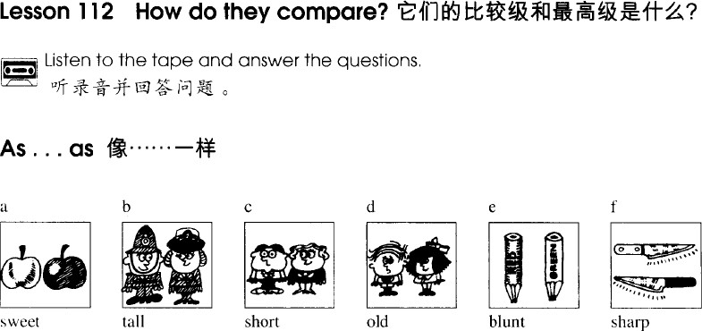

**The green apple is as sweet as the red one.**

**The man is as tall as the lady.**

**The man is as short as the other man.**

**This television is not as expensive as the other one.**

**This bag is not as new as the other one.**

**The box is not as heavy as the other one.**

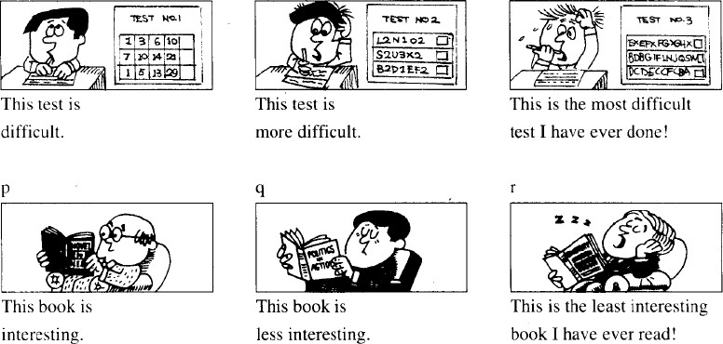

**Lesson 111&112 知识拓展**

那老太太长的比你还难看呢。

The old lady is uglier than you(are). 她没有你难看。

She is not as ugly as you(are). 你比她难看。

You are uglier than she (is).

##### Lesson 113&114 预 习

1. **语法：倒装句；**
2. **口语话题：乘坐飞机时的口语句型；**

**Lesson 113 单词讲解**

1. **conductor [kən'dʌktə(r)] : n. 售票员**
2. **fare [feə(r)] : n. 车费，车票**
   1. 车费：the bus\train\taxi\air fare
   2. 车票：Tickets\ Fares, please.

##### change [tʃeɪndʒ] : 兑换（钱）

* 1. v. 兑换（不同面值）

Can you change a ten-pound note？

* 1. v. 兑换（不同货币）

Where can I change my RMB into dollars?

* 1. n. 找回的钱、零钱（不可数） I want my change.

Do you have any small change?

1. **note [nəʊt] : n. 纸 币**a fifty-pound note a fifty pounds note

two fifty-pound notes

two fifty pounds notes

##### coin: n. 硬 币

nickel ['nɪkl]= five cents 5 美分；

dime [daɪm]= ten cents 10 美分，1 角； quarter ['kwɔːtə(r)]: 25 美分；

##### passenger ['pæsɪndʒə(r)] : n. 乘 客

1. **none [nʌn] : 没有任何东西**

no-not- never- none- negative-neither none= no+ n.

He has no money, no girlfriend, no house.

He has none.

##### neither ['naɪðə(r)] : 也 不

1. **get off [ɡet ɒf] : v. 下 车**

get in the car get on the train

Please get ready to get off the bus. 请做好下车的准备。

##### tramp [træmp] : n. 流 浪 汉

1. **except: 除…之外 prep.**

Everybody is here except Sam.

除了 Sam，大家都来了。（Sam 没来）

Besides Sam there are many who wear glasses.

除了 Sam，还有很多人戴眼镜。（Sam 戴了）

##### Lesson 113 语法讲解

Those kings will always be there to guide you. 那些逝去的国王们将会一直守护着你。

我也会的。

I will always be there to guide you too. So will I.

##### 倒装

1. **构成：肯定— so +…+ 主语**

**否定— neither +…+ 主语**

1. **原则：时态一致，人称一致**

A: I like Lee Hong.

B: I like Lee Hong, too. = So do I.

A: I hate money.

B: I hate money, too. = So **do** I.

C: She hates money, too. = So **does** she.

A: I can do it.

B: I can do it, too. = So **can** I.

C: He can do it, too. = So **can** he.

A: They were young.

B: I was young, too. = So **was** I.

C: She was young, too. = So **was** she.

A: I went to bed late.

B: I went to bed late too. = So **did** I.

C: Sam went to bed late, too. =So **did** Sam.

I didn’t go to school last week.

I didn’t go to school, either. = Neither **did** I.

She didn’t go to school either. = Neither **did** she.

I am not a nurse.

I am not a nurse, either. = Neither **am** I. She is not a nurse, either. = Neither **is** she.

I haven’t had breakfast.

I haven’t had breakfast either. = Neither **have** I. He hasn’t had breakfast either. = Neither **has** he.

I was not a good student.

I was not a good student either. = Neither **was** I.

Sara was not a good student either. = Neither **was** she.

1. A: I will never come to this restaurant again. The food is terrible.

B: .

* 1. Nor am I.

√B . Neither will I.

C. So will I. D. Neither I will.

1. A: I don’t go to the park. B: .
   1. So will I . B. Neither will I.

√C. Neither do I. D. So do I.

##### Lesson 113 课文讲解

* + 1. **n.+ please.**

Fares, please.

##### Trafalgar Square, please.

* + 1. **Haven’t you got any small change?**

Do you have any small change?

##### some of + n. (复数)\ 不可数名词none of + n. (复数)\不可数名词

1. Here some of your favorite books.

这是一些你最喜欢的书。

1. None of the money mine.

这些钱中没有一分是我的。

1. None of the students (know)of the exam.

学生们谁都不知道考试的事。

1. I thought there would be many students in the hall, but when I got in, I found .

√A . none B. no one C. none of D. no

**none= none of the students. no one, 一个人也没有。**

* + 1. **Neither can I.**

= I can’t change this ten-pound note, either.

##### So have I.

= I have got some small change, too.

##### Lesson 114 单词句型讲解

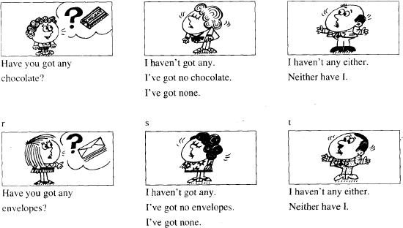

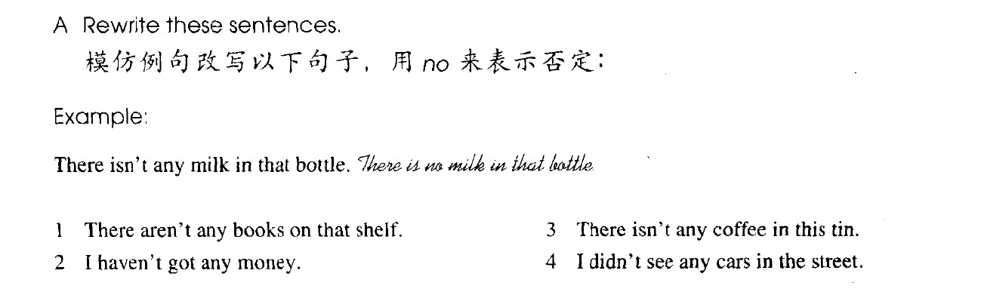

1. **There are no books on that shelf.**

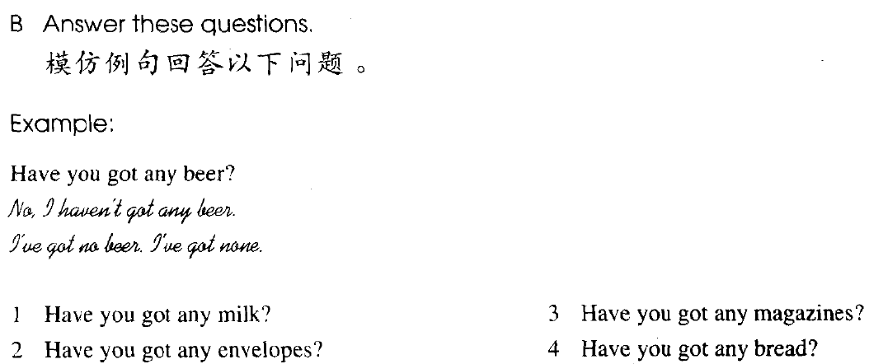

***haven’t got any***

***= got no + n.***

***= got none***

* 1. **No, I haven’t got any milk. I’ve got no milk.**

**I’ve got none.**

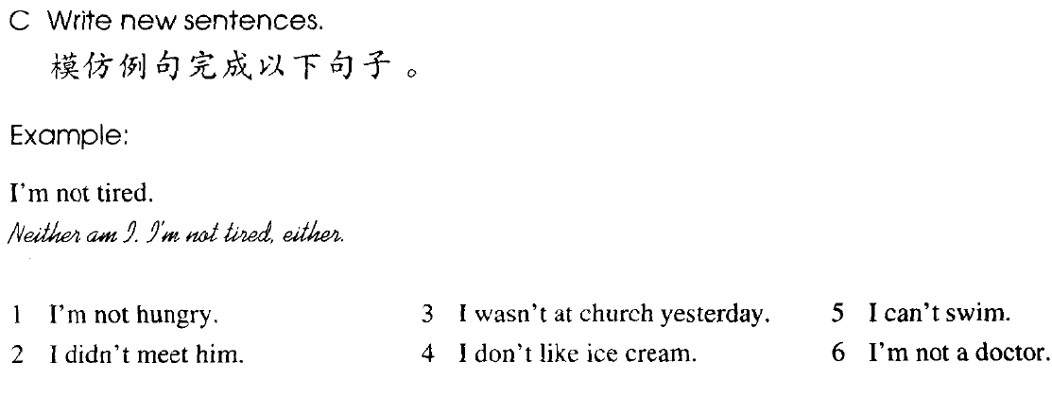

***Neither…I.***

***I…not…, either****.*

1. Neither am I.

I’m not hungry, either.

1. Neither did I.

I didn’t meet him either.

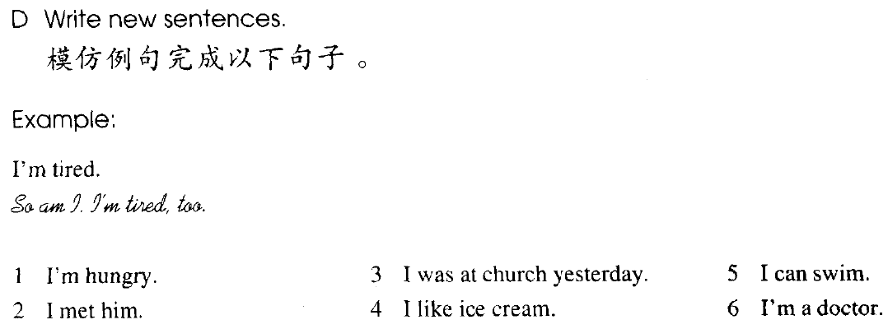

***So…I.***

***I…, too.***

1. So am I.

I’m hungry, too.

1. So did I.

I met him, too.

##### Lesson 113&114 知识拓展

1. 国际航班 the international flight
2. 国内航班 the domestic flight
3. 航班号 the flight number
4. 商务客舱 the business class
5. 经济舱 the economy\tourist class
6. 机票 the air\flight ticket
7. 登机牌 a boarding check
8. 转机 the connecting flight
9. 直飞 the non-stop flight
10. 托运的行李 the checked baggage
11. 随身行李 the carry-on baggage
12. 行李领取处 the baggage claim area
13. 行李牌 baggage tag
14. 行李推车 luggage cart luggage: 外出旅行时所带的物品baggage: 行李的通称。

请给我拿一个枕头&毯子。

##### May I have a pillow & blanket?

您可以把座位升直吗？

##### Can you put your seat upright?

我可以放下我的座椅吗？

##### May I reline my seat?

**Lesson 115&116 预习**

1. **语法：不定代词；**
2. **词汇：否定前缀 im-**

**Lesson 115 单词讲解**

1. **anyone ['eniwʌn] : pron.**

(用于疑问句，否定式)任何人

##### knock [nɒk] : v.敲，打

knock at

knock at the door

##### everything ['evriθɪŋ] : pron.一切事物

Everything is fine. 一切都很挺好。

##### quiet ['kwaɪət] : adj.宁静的，安静的

Everything is quiet. 一切都很安静。

##### impossible [ɪm'pɒsəbl] : adj.不可能的

im+ possible impolite: 不礼貌的imperfect: 不完美的immature: 不成熟的immoral: 没有道德的

##### invite [ɪn'vaɪt] : v.邀请

**invite sb. to do**

**invite sb. to + n.**

他邀请我吃了一顿饭。

He invited me to have a meal.

He invited me to a meal.

##### anything ['eniθɪŋ] : pron.任何东西

1. **nothing ['nʌθɪŋ] : pron.什么也没有**
2. **lemonade [ˌlemə'neɪd] : n. 柠檬水**
3. **joke [dʒəʊk] : v.开玩笑**

She is only joking. 她只是开个玩笑。joke n. 笑 话

讲笑话：

make a joke

##### Lesson 115 语法讲解

**不定代词**

|  |  |  |  |
| --- | --- | --- | --- |
| **every** | **no** | **some** | **any** |
| everyone | no one | someone | anyone |
| everybody | nobody | somebody | anybody |
| everything | nothing | something | anything |
| everywhere | nowhere | somewhere | anywhere |

1. **everyone\everybody\everything\everywhere**

整体

**everyone\ everybody: 大 家everything: 一 切**

**everywhere: 到 处**

Hi, everyone. 大家好！

Everything is quiet. 一切都很安静。

A humorous person is accepted everywhere. 幽默的人到处都受欢迎。

##### no one\nobody\nothing\nowhere

**no one\ nobody: 没有人nothing: 什么都没有nowhere: 没有一个地方**

There is no one at home. 家里一个人都没有。I have nothing to do. 我没事可做。

She has nowhere to go. 她无处可去。

##### some: 一 些

**肯定句**

some: 某 一

**someone\ somebody: 某 人something: 某 事somewhere: 某 地**

There is someone at home. 家里有人。

I have something to do. 我有事要做。She went somewhere. 她去了什么地方。

##### any: 一 些

**any: 任 一**

**anyone\ anybody: 任何人anything: 任何事anywhere: 任何地方**

Is there anyone at home? 家里有人吗？

I don’t have anything to do. 我没事可做。She didn’t go anywhere. 她哪都没去。

##### any& no 的转化

**nothing= not anything**

I did nothing yesterday.=I didn’t do anything.

**nobody= not anybody**

I met nobody.=I didn’t meet anybody.

**nowhere= not anywhere**

I went nowhere.=I didn’t go anywhere.

##### 做主语- 看作单数！

|  |  |  |  |
| --- | --- | --- | --- |
| every | no | some | any |
| everyone | no one | someone | anyone |

|  |  |  |  |
| --- | --- | --- | --- |
| everybody | nobody | somebody | anybody |
| everything | nothing | something | anything |
| everywhere | nowhere | somewhere | anywhere |

大家都知道这事。Everybody knows it.

一切都很顺利。Everything is fine.

那有人吗？

Is there anyone there?

##### Lesson 115 课文讲解

1. **Knock, knock！**
2. **家里有人吗？**

Is there anyone at home? Isn’t there anyone at home?

##### Look through the window.

look at…

look into… look out of…

##### Can you see anything?

Nothing at all.

##### Everyone is in the garden.

大家都在花园里。

##### It’s nice and … out here.

外面这… 里面这：in here

##### Come and have something to drink.

have something to… 吃点东西：

have something to eat 买点东西：

have something to buy 读点东西：

have something to read

1. **There is none left.** none: 什么也没There is none.

**主 系 表**

none + of + n.\pron.

None of the students 学生中没有人… None of us 我们当中没有人…

None of them 他们当中没有人…

##### 8. There is none left.

left:

leave- left- left

left- adj.

none left: 剩下的什么都没有了nothing left

nobody left

nothing important：没什么重要的

##### Lesson 116 单词句型讲解

1. **asleep [ə'sliːp] : adj. 睡觉、睡着（作表语） He is asleep.**

**主 系 表**

**awake [ə'weɪk] : 醒着的alive [ə'laɪv] :活着的**

an asleep baby – 不可以做定语

##### glasses ['glɑːsɪz] : n. 眼 镜glass, 玻璃、玻璃杯

**a pair of glasses**

**Lesson 115&116 知识拓展**

**Impossible is nothing. Anything is possible.**

* Everything has its beauty, but not everyone sees it. 万物皆美，只是缺少发现美得眼睛。
* She wants her son to become somebody. 她希望自己的儿子会成为个人物。
* Be somebody nobody thought you could be.

成为那个别人认为你成为不了的人。

* Nothing could ever stand between you and the free land. 没有什么能够阻挡我对自由的向往。

##### Lesson 117&118 预习

1. **语法：过去进行时态；**

**时间状语从句。**

1. **写作：同位语；**
2. **词汇：洗手间的各种表达。**

**Lesson 117 单词讲解**

1. **dining room ['daɪnɪŋ ruːm] : n.餐厅**

restaurant 餐 馆

##### coin [kɔɪn] : n. 硬 币

note, 纸 币

##### mouth [maʊθ] : n. 嘴 巴

a big mouth

##### swallow ['swɒləʊ] : v. 吞 下

n. 燕 子

He tried to swallow the food.

##### later ['leɪtə(r)] : adv. 后 来

1. **toilet ['tɔɪlət] ： n. 洗手间、厕所**

**Lesson 117 语法讲解**

1. **过去进行时态：**
   1. **功能：过去某一时刻、时段正发生的动作**

**B.结构：主语 + was\were + doing 现在进行：主语+ is/am/are + doing**

**现在 进行**

**主 语 + was\were + doing**

**过去 进行**

She was doing her homework at 10:00 last night.

They were having a date from 7:00- 9:00 yesterday.

##### C. 疑问形式：

**was\ were 提 前**

She was doing her homework at 10:00... Was she doing her …?

##### D. 否定形式：

**was\were+ not**

They were having a date from 7:00- 9:00… They were not having a date …

##### 时间状语从句：

* 1. **概念：句子作时间状语。**

He was calling his girlfriend at 10:00.

He was calling his girlfriend when he was driving.

##### 引导词：

**when\ while\ as\ before\ after…**

when: 万能引导词

while: 多接进行时态

as: “一边一边”，紧接着发生before: 之 前

after: 之 后

##### When you think you know nothing,（从句）ou begin to know something. （主句）

**当你认为自己一无所知的时候，你开始懂事了。**

1. Jane_w_as w_a_i_t_in_g （wait） for me when I a_r_r_ived( arrive).
2. My brother came into the living room while I w_as d_a_n_cing (dance).
3. What _w_as_Jim w_r_i_ti_n_g_ (write) when the teacher came in?
4. When I arrived at his office, he

was speaking( speak) on the phone.

##### Lesson 117 课文讲解

1. **We looked for them, but we could not find them all.**

look for & find look & see listen & hear

Look! Can you see it? Listen! Can you hear it?

Look for it! Can you find it?

I'm him, but I can hear nothing, because there is something wrong with my

.

A. seeing, eyes

√B. listening to, ears

C. finding, eyes

D. hearing, ears

##### While we were having breakfast, our little boy, Tommy found two small coins

**on the floor.**

**our little boy, Tommy 同位语：**

* 1. **功能：解释名词**
  2. **结构：名词+名字，名字+名词**

中国, an ancient country in Asia.

林书豪, a popular basketball player from Taiwan. 海淀, a well-known district in Beijing.

Yangmi, a pretty film star.

我来自中国，一个亚洲古老的国家。

I am from China, an ancient country in Asia.

我居住在海淀，北京的一个知名的区。

I live in Haidian, a well-known district in Beijing.

##### 自我介绍：

Hello. I’m Venus. I’m a teacher.

I’m from Shan’xi province. I live in Beijing now. Hello. I’m Venus, an English teacher.

I’m from Shan’xi province, a nice place in the west of China.

I live in Beijing, the capital city of China.

##### He put both into his mouth.

**We both tried to get the coins, but it was too late.**

* 1. both: 代 词Both are good.

both= the two books

* 1. both: 副词（动词前、情 be 后） We both like English.

They can both sing.

##### …but I haven’t had any change yet.

change:

* 1. 改变
  2. 找零的钱

##### Lesson 118 单词句型讲解

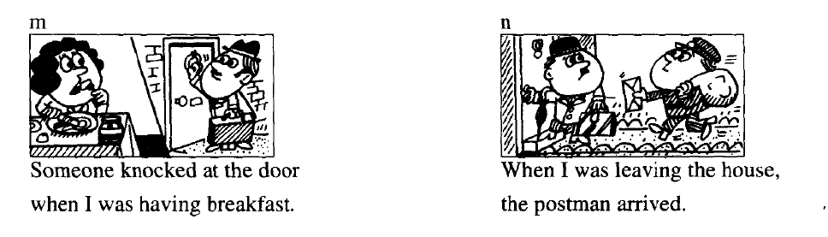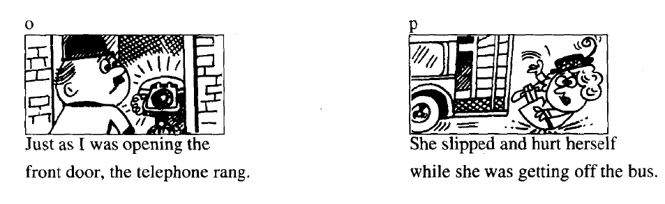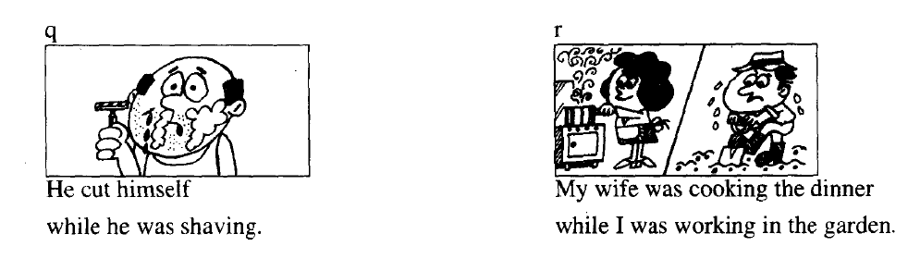

**Lesson 117&118 知识拓展**

* **bathroom**
* **restroom**
* **toilet**
* **washroom**
* **loo**
* **men’ s room**
* **ladies’ room**

**Lesson 119&120 预习**

1. 语法：过去完成时态；

时间状语从句。

1. 写作：学会描述两件事发生的顺序；
2. 句型：as…as possible

##### Lesson 119 单词讲解

1. **story ['stɔːri] : n.故事**

讲故事：tell a story

一个真实的故事：a true story 一个爱情故事：a love story

##### happen ['hæpən] : v.发生

happen to sb. 发生在… 身上It happened to my sister.

##### thief [θiːf] : n. 贼

thief- thieves

##### enter ['entə(r)] : v. 进 入

enter= go into

He entered his bedroom. He went into his bedroom.

##### dark [dɑːk] : adj.黑暗的

It was dark outside. 外面一片漆黑。

##### torch [tɔːtʃ] : n.手电筒

flashlight

##### voice[vɔɪs] : n.(说话的)声音

sound, 声 音voice, 嗓 音noise, 噪 音

##### parrot ['pærət] : n.鹦鹉

**Lesson 119 语法讲解**

**过去完成时态：**

**A.功能：过去某一时刻之前完成的动作、状态B.结构：主语 + had + done**

She had done her homework before 10:00 last night.

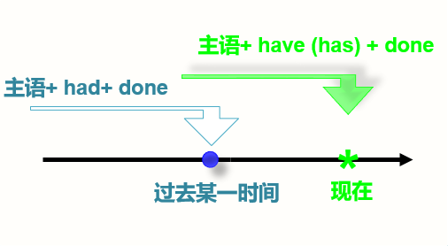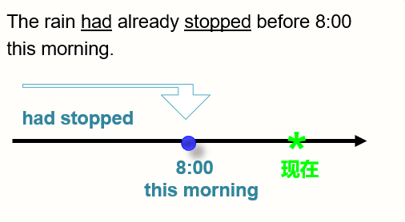

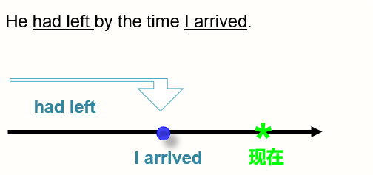

##### 时间状语：

by the end of…

by the end of last year\ last week\ last month… by the time sb. + 动词过去时

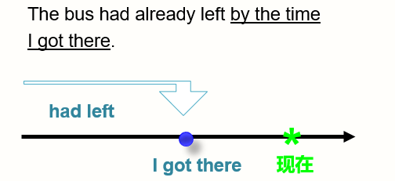by the time he arrived/I graduated…

##### 疑问形式：

had 提 前

He had left by the time I arrived. Had he left by …?

##### 否定形式：

had + not

He had left by the time I arrived.

He had not left by the time I arrived.

##### Lesson 119 课文讲解

1. **Do you love stories? I want to tell you…**
2. **It happened to a friend of mine…**

happen to sb.

a friend of mine

##### 名词 + of + 名词性物主代词，其中之一

a friend of mine: 我的一个朋友

a daughter of theirs: 他们的一个女儿

a nephew of hers: 她的一个外甥

a sister of his: 他的一个姐姐

##### While my friend, George, was reading…

 **同位语**

My favorite star, Wuzun, is very cool.



**同位语**

My hometown, Shaanxi, is a beautiful place.



**同位语**

Yesterday I met Mary, my old friend.

 **同位语**

My hometown is in Beijing. Beijing is the capital city of China.

My hometown is in Beijing, the capital city of China.

Sara is my friend.

She is a doctor.

Sara, my friend is a doctor.

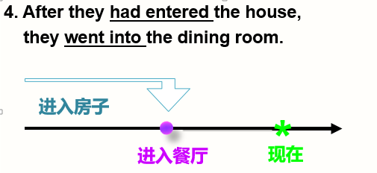

##### The thieves dropped the torch and ran away

as quickly as possible.

**as…as… 像…一样**

**as…as possible: 尽…所能地…**

尽所能地慢：as slowly as possible

尽所能地热情：as warmly as possible 尽所能地努力：as hard as possible **as…as… 像…一样**

**as…as possible: 尽…所能地…**

请尽量慢点开车。

Please drive as slowly as possible.

请尽量热情地给他打招呼。

Please greet him as warmly as possible.

他正在尽全力努力地学英语。

He is studying English as hard as possible.

##### Lesson 120 单词句型讲解

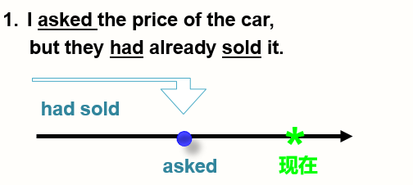

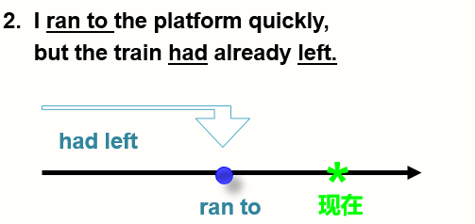

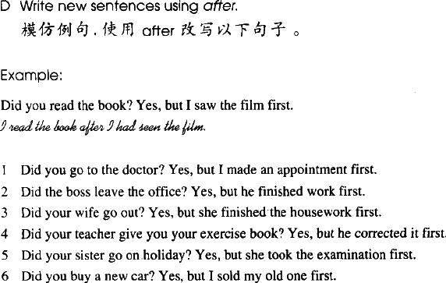

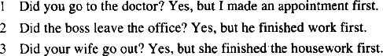

***1.I went to the doctor after I had made an appointment.***

* 1. ***The boss left the office after he had finished work.***
  2. ***My wife went out after she had finished***

**Lesson 119&120 知识拓展**

**叙述两件事情的先后顺序**

* + - When did you come to BJ?
    - I came to BJ in 2007.
    - I came to BJ when I graduated from university in 2007.
    - When did you get married?
    - I got married in 2009.
    - I got married after we had been together for three years.
    - When did you go abroad?
    - I went abroad the year before last.
    - I went abroad after I had got the offer from Harvard University.

##### Lesson 121&122 预习

1. **语法：定语从句；**
2. **写作：学会使用定语写出升级版高档句型；**

**Lesson 121 单词讲解1.customer ['kʌstəmə(r)] : n.顾客**

1. **forget [fə'ɡet] : v. 忘 记**

forgot-forgotforgotten

**forget sth.\sb.**

**forget to do… 要做而忘记做**

Don't forget your friends when you become rich. I forgot to lock the door.

##### manager ['mænɪdʒə(r)] : n. 经 理

1. **serve [sɜːv] : v. 照应、服务、接待**

We must serve the people heart and soul. Do they serve beer?

The waiter is serving another customer.

##### counter ['kaʊntə(r)] : n. 柜 台

count- counter

##### recognize ['rekəɡnaɪz] : v. 认 出

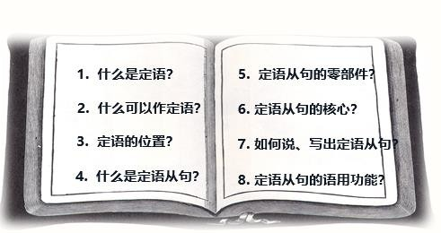**Lesson 121 语法讲解**

1. **什么是定语？**

“的“ (用来修饰名词、代词的词)

##### 什么可以作定语？

a pretty girl: 形容词

a diamond ring: 名 词

a book on the shelf: 介词短语

##### 定语的位置？

a pretty girl: 形 容词 **前**

a diamond ring: 名词 **前**

a book on the shelf: 介词短语 **后**

你占据了我的心灵 You fill up my senses 像林中的夜晚

Like a_**nigh**_**t** in the forest

像春日的群山

Like the **moun**__**tain**_**s** in springtime

像雨中的漫步

Like  **a wa**_**l**_**k in t**_**he rain**

像沙漠中的风暴

Like a storm in the desert 像沉睡中的碧海

Like a _**sl**_**e**_**ep**_**i**_**ng**b lue ocean

a night in the forest 林中的夜晚

a walk in the rain 雨中的 漫步

the mountains in springtime 春日的 群山

a storm in the desert 沙漠中的 风暴

##### 结论：单个词在前，短语或句子放后。

1. **什么是定语从句？**

He is a nice man.

He is the man who loves my friend.

She is a female manager.

She is the manager who served me yesterday.

##### 定语从句：句子作定语。

1. **定语从句的零部件？**

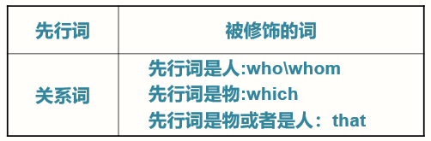

他就是【喜欢我朋友的】那人。

He is the man who loves my friend.

我喜欢 【正在听音乐的】那漂亮的女孩。I like the beautiful girl.

I like the beautiful girl 【who is listening to music】.

【穿裙子的】那位男士就是皮特The man is Brad Pitt.

The man【who wears a dress】 is Brad Pitt.

上帝帮助那些【帮助自己的】人。God helps the people.

God helps the people【Who help themselves.】

【犯错误最少的】将军是最好的将军。

The general who【makes the fewest mistakes】is the best general.

##### 组织定语从句的步骤？ 找定语

**找先行词（被修饰词）**

**颠倒顺序用关系词**

【能使大多数人幸福的】 人是世界上最幸福的人。

People who can make most people happy is the happiest in the world.

你认识 【昨天和我一起看电影的】 那人吗？

Do you know the man who watched a movie with me yesterday?

【我昨天买的】 包非常好。

The bag that I bought yesterday is very nice.

【你给我的】 那块手表走地可准了。

The watch that you gave me keeps perfect time.

##### What is a present?

A present is something that you give your friend on his or her special day.

##### What is a dentist?

A dentist is someone who can see and protect your teeth.

##### What is a mechanic?

A mechanic is someone who repairs car or machine.

##### What is a “Xiaomianbao”?

A “Xiaomianbao” is a van that can carry people.

##### Lesson 121 课文讲解

1. I bought two expensive dictionaries here, half an hour ago, but I forget to take them with me.

forget to do… take…with me…

1. The lady who is standing behind the counter.
2. The books which are on the counter.
3. He says he’s the man who bought these books.
4. The man who I served was wearing a hat.



1. Is this the man that you served?

##### Lesson 122 单词句型讲解

**road [rəʊd] : 路on the road** street, 大 街

in the street

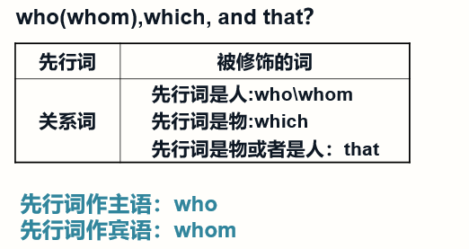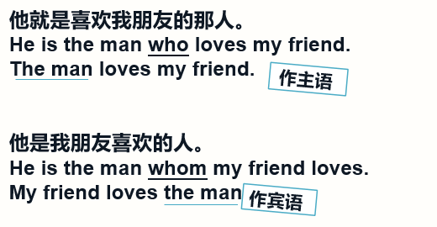

##### Lesson 121&122 知识拓展

**定语从句：**

* 1. **关系词的选择；**
  2. **句子的理解和识别；**
  3. **写作应用：用定语从句升级句型。**

1.-Do you know the man is talking with your father？

-Yes, he’s our headmaster.

* + 1. he
    2. who C. which D. whom

√

1. Can you lend me the dictionary

the other day？

A. that you bought B. you bought it

√

C. that you bought it D. which you bought it

1. 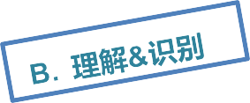He【who doesn’t reach the Great Wall】 is not a true man. 不到长城非好汉。
2. He【who laughs last】laughs best.

谁笑到最后谁笑得最好。

1. He【who learns but does not think】 is lost.

学而不思则罔，思而不学则殆。

1. I have a close friend.



He always takes my advice.

I have a close friend who always takes my advice.

##### 定语从句：描述两句话提到的同一人。2011 年北京市中考作文：

Alice 表示自己的好友 Angela 问自己借钱，但自己不知是否该借给她，担心对方可能不能归还。问刘明是否遇到同样的问题？请刘明给自己一些建议，期待回信。假如你是刘明，给Alice 写一封信…

I think you can lend money to a person.

But choose the honest person. They will return you the money.

I think you can lend money to a person.

But choose the honest person.

They will return you the money.

##### 定语从句升级版：

I think you can lend money to an honest person

who will return you the money.

##### 2008 年北京中考作文:

汶川地震(Wenchuan Earthquake)发生后,9 岁的学生林浩救了两名同学,然后步行了7 个小时到了安全地点, 就他的事迹以“Learn from the Hero” 为题, 写一篇不少于 60 词的作文。

##### 提示词:

a student , nine years old , happen , save , walk , to safety , be deeply moved , brave , give up

I’d like to say Linhao is a hero.

We should learn from him.

##### 定语从句升级版：

I’d like to say Linhao is a hero whom we should learn from.

Linhao is a nine-year old student.

He saved two of his classmates during…

##### 定语从句升级版：

Linhao is a nine-year old student who saved two of his classmates during…

我正在读这本书。这本书很有趣。我正在读的这本书很有趣。

I am reading the book.

The book is very interesting.

##### 定语从句升级版：

I am reading the book which is interesting.

The book which I am reading is interesting.

你认识那人吗？他昨天请我吃饭了。你认识昨天请我吃饭那人吗？

Do you know the man?

He invited me to have dinner yesterday.

##### 定语从句升级版：

Do you know the man who invited me to have dinner yesterday?

##### Lesson 123&124 预习

1. **语法：感叹句、定语从句；**
2. **词汇**

**work & job trip & travel**

**Lesson 123 单词讲解**

* 1. **during['djʊərɪŋ] : prep.在…期间**

during that time

during my summer holiday

##### trip [trɪp] : n.旅行

短途旅行 one-day trip

北京一日游：one-day trip in Beijing

* 1. **travel ['trævl] : v.旅行**traveling (travelling) n. 泛指我爱旅行。

I love travelling.

##### offer ['ɒfə(r)] : v.提供

offer sb. sth.= offer sth. to sb. He offered me a job.

He offered a job to me.

##### job [dʒɒb] : n.工作

**work n.工作**

他有一份很好的工作。He has a good job. **职业 ，可数**

##### 活儿，不可数

* 1. **guess [ɡes] : v. 猜**
  2. **grow [ɡrəʊ] : v. 长，让…生长**

grow- grew- grown grow up, 长 大

##### beard [bɪəd] : n.(下巴上的)胡子，络腮胡子

moustache[mə'stɑːʃ]

##### Lesson 123 语法讲解

1. **感叹句：**
   1. **How + adj.\adv. What + n.**

How beautiful！ What a beautiful day

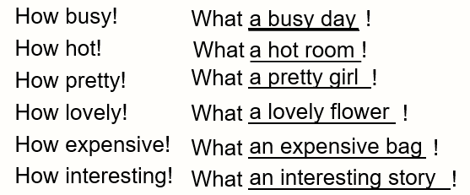

##### a\an

What a cold water! What cold water! What a lovely girls! What lovely girls!

##### What a beautiful ship!

* + 1. he gave!
       1. What a good advice
       2. How a good advice
       3. What good advice

√

* + - 1. How good advice
    1. interesting book!
       1. What B. How
  1. What an

√

##### Lesson 123 课文讲解

* + 1. **A trip to Australia.**

to, 去往…

上海之行：a trip to Shanghai 纽约之行：a trip to New York

a train to London: 开往伦敦的火车开往国王街的公车：

a bus to King Street

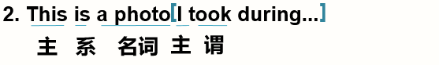

先行词（被修饰的词）：a photo关系词：省略了

翻译：这是一张我在澳大利亚旅行期间照的照片。照相：take a photo

这是 我在美国买的 礼物。

This is a gift

I bought in the US.

**组织定语从句的步骤？**

**找定语 → 找先行词 →（被修饰词）→ 颠倒顺序 → 用关系词**

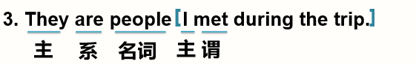

先行词（被修饰的词）：people关系词：省略了

翻译：他们是我在旅行期间见到的人。他们是我在美国学习期间认识的人。

They are people I met during my study in the US

##### 定语从句关系词的省略：

1. 口语
2. 先行词作宾语时

This is a photo I took during...

（I took a photo.）

They are people I met during…

（I met the people.）

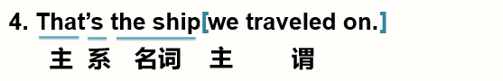

先行词（被修饰的词）：the ship关系词：省略了

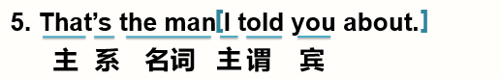翻译：那就是我们乘坐的那艘船。这就是他乘坐的那辆公交车。That’s the bus he traveled on.

先行词（被修饰的词）：the man关系词：省略了

翻译：那就是我跟你谈论过的那人。

那就是我听说过的那消息。That’s the news I heard about.

##### 6. I grew a beard during the trip, but I shaved it off when I came home.

shave off: 刮 掉

shave it off (代词在中间)

shave off the beard shave the beard off

##### Lesson 124 单词句型讲解

1. **kitten ['kɪtn] n. 小 猫**

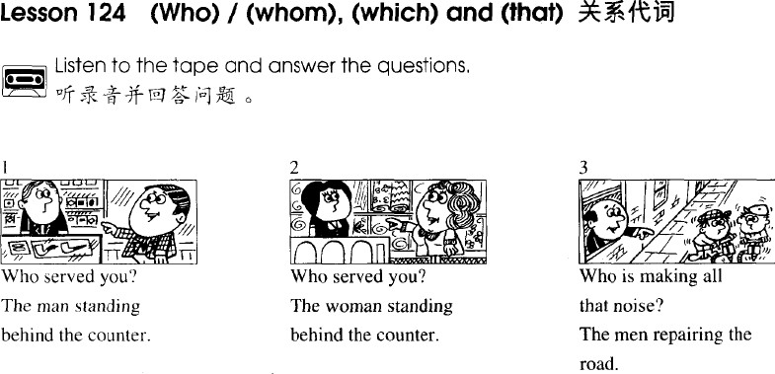*served me. served me. are making*

*all the noise*

**Lesson 123&124 知识拓展**

* + People who like pudding.
  + I fell in love with someone who didn’t love me back.
  + The boy that I was in love with fell in love with another man-Larry

Sugarman.

##### Lesson 129&130 预习

1. 语法：不同时态的情态动词表推测;
2. 词汇：开车驾驶必备词汇。

##### Lesson 129 单词讲解

1. **wave [weɪv] : v. 招 手**wave to sb. 向某人招手She is waving to us.

##### track [træk] : n.跑道

the race track

##### mile [maɪl] : n. 英 里

two miles, 2 英里

1 英里=1.609344 千米(公里) sea mile: 海 里

##### overtake [ˌəʊvə'teɪk] :v. 后面超车overtook- overtaken

I had to walk very fast to overtake you.

overtake sb.\ sth.

##### speed limit: n. 限 速time limit, 限 时

His speech was over the time limit.

他的演讲超出了规定的时间限制。

The speed limit in this town is 40 miles per hour.

本市速度限制是每小时四十英里。

##### dream [driːm] : 做梦，思想不集中

n. 梦想 I have a dream.

v. 做梦 He is dreaming.

##### sign: 标记、牌子

There is a sign on the wall.

##### driving licence: n. 驾驶执照

driving license（美式）

Do you have a driving licence？

##### charge [tʃɑːdʒ] : n. 罚款

charge sb. some money

The police charged him ¥100.

##### darling ['dɑːlɪŋ] : 亲爱的

dear baby honey

sweet heart sweetie

##### Lesson 129 语法讲解

1. **一般现在时态:**

主语+ is/am/are+ 非动词主语+ 动词

##### 情态动词表推测 1：一般现在时态的推测

* + 肯定是 must be…
  + 不可能 can’t be…
  + 可能是 may be…
  + 肯定是 must …
  + 不可能 can’t …
  + 可能是 may …

He must be know that.

+ 非动词

+ 动词

He must know that.

##### 现在进行时态:

主语+ is/am/are+ doing

##### 情态动词表推测 2：现在进行时态的推测；

* + 此刻肯定正在 must be doing…
  + 此刻不可能正在 can’t be doing…
  + 此刻可能正在 may be doing… He must be sleeping now.

He can’t be studying now.

##### 一般过去时态:

主语+ was/were+ 非动词主语+ 动词过去式（did）

##### 情态动词表推测 3：一般过去时态的推测

* + 那时肯定是 must was …
  + 那时不可能是 can’t was…
  + 那时可能是 may was…
  + 那时肯定是 must have been…
  + 那时不可能是 can’t have been…
  + 那时可能是 may have been… 他小时候肯定很高。

+ 非动词

He must have been tall when he was young.

以前他一定很富有。

He must have been rich before.

##### 过去进行时态:

主语+ was/were+ doing

##### 情态动词表推测 4：过去进行时态的推测；

* + 那时肯定正在 must have been doing…
  + 那时不可能正在 can’t have been doing…
  + 那时可能正在 may have been doing… I can’t have been dreaming at class.

1. — That man must be Sarah’s husband.

— No, he be her husband. She is still single.

* 1. can’t B. mustn’t C. may D. must

√

1. Peter come with us tonight, but he isn’t very sure.
   1. can’t
   2. may C. must D. mustn’t

√

##### Lesson 129 课文讲解

* + 1. **Where do you think you are?**

你在哪？ Where are you? do you think: 插入语

Where… you are? 陈述句语序

你以为你是谁啊？Who do you think you are?

你认为他什么时候会来？When do you think he will come？

你认为他会怎么办？How do you feel he will do it？

* + - 1. 【do you think】 has stolen your pen?

A. Who B. Whom

√

C. Whose D. What

* + - 1. What 【do you suppose】 ？

1. will he do
2. he will do

√

1. do he will D. will he

为什么添加插入语后需要陈述句语序？

##### You must have been driving at seventy miles an hour. 你当时一定是以 70 英里的时速开车的。

must have been driving: 过去进行时态的推测时速：…\ an hour

fifty miles an hour

##### I can’t have been.

I can’t have been driving at seventy

miles an hour.

##### I was doing eighty when I overtook you.

I was driving at eighty miles an hour…

##### That’s why I didn’t see the sign. 这就是我没有看见那牌子的原因。That’s why+ 句 子

这就是我学英语的原因。That’s why I learn English.

这就是我讨厌你的原因。That’s why I hate you.

这就是我邀请他我的生日派对的原因。

That’s why I invited him to my birthday party.

这就是我罚你 100 元的原因。That’s why I charge you ¥100.

##### I’ll certainly be more careful.

It will certainly be more expensive.

##### You’d better take my advice.

take one’s advice: 听取劝告

take her advice take his advice take your advice

##### Lesson 130 单词句型讲解

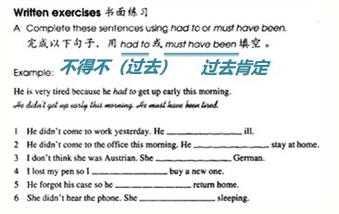

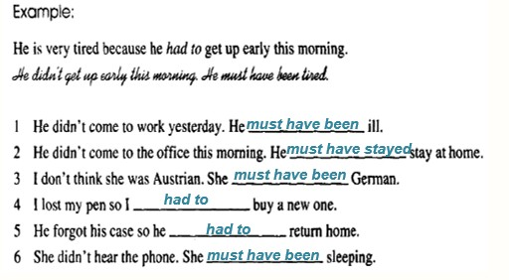

**Lesson 129&130 知识拓展**

a traffic policeman traffic lights

a ticket

No Parking No right turn No U turn

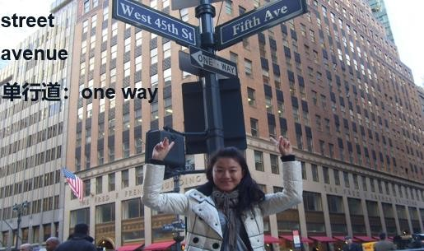

##### Lesson 131&132 预习

1. **语法：推测和事实的区分;**
2. **口语：酒店场景必备词汇和句型。**

**Lesson 131 单词讲解**

1. **Egypt ['iːdʒɪpt] : n.埃及**
2. **abroad [ə'brɔːd] : adv.国外**

出国：go abroad

出国旅行：travel abroad 出国学习：study abroad 国外定居：live abroad

##### worry ['wʌri] : v. 担 忧

Don’t worry. worry about…

Her mother worries about her marriage.

##### Lesson 131 语法讲解

**推测：**

I guess his girlfriend must be pretty.

##### 事实：

Yes, his girlfriend is pretty.

##### 推测：

I guess he must have been busy yesterday.

##### 事实：

Yes, he was busy yesterday.

##### 推测：

I guess he may have been having a date at 8:00 last night.

##### 事实：

Yes, he was having a date at 8:00 last night.

##### 推测：

I guess he can’t be sleeping now.

##### 事实：

Yes, he is not sleeping now.

##### Lesson 131 课文讲解

1. **别那么确定！Don’t be so sure!**

Don’t so sure! Don’t come in! Don’t sit down. **Don’t + v.**

别那么认真！Don’t be so careful!

别那么慷慨 Don’t be so generous!

##### Don’t + v. No + n.

Don’t smoke!

No smoking! Don’t swim! No swimming!

##### Where are you going to spend your holidays this year?

度假：

spend your holidays\vacation have your holidays\vacation

##### We can’t make up our minds.

make up one’s mind 下定决心

##### 你们要乘船去还是坐飞机去？

Will you by sea or by air?

Will you go\travel by sea or by air?

##### 我们可能哪也去不成。

We may go nowhere.

We may not go anywhere.

##### 我妻子总是担心这担心那。

My wife always worries this and that.

worries too much.

##### 最后：in the end

1. **照顾一切：look after everything**

**Lesson 132 单词句型讲解**

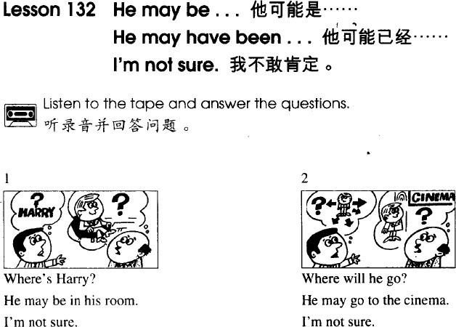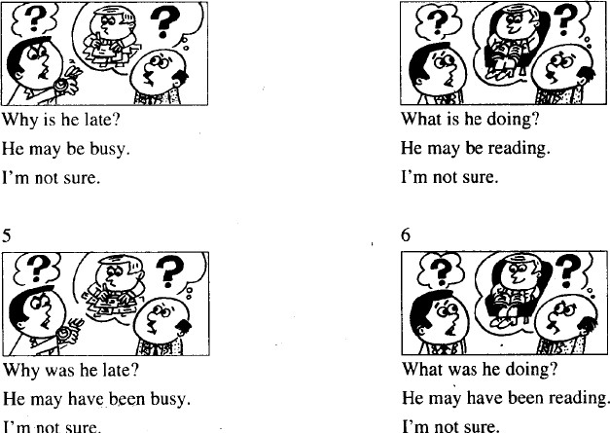

**Lesson 131&132 知识拓展**

**度假：**

1. **度假的动词短语：**

have a holiday\ vacation

spend a holiday\ vacation go for a holiday\ vacation take a holiday\ vacation **be on a holiday\ vacation**

##### 预定机票、酒店

book the air tickets to… book the hotel…

##### 酒店入住：

I’d like to check in. 我想登记入住。

I made a reservation here. 我有预定。

双人房：double room 单人间：single room

大床房：queen bed room

king bed room 双床房：twin room

园景房：garden-view room

湖 景 房 ：lake-view room 海景房：ocean-view room

What is the check-out time? 什么时候退房？

Is breakfast included? 这个包含早餐吗？

May I have a wake-up call? 早晨能叫醒我吗？

Could I have another room key? 我能再要一张门卡吗？

##### 客房用语

淋浴： a shower

洗 发 水 ： a shampoo 沐浴露： a body lotion 梳子： a comb

电热壶：a kettle

电吹风： a hair dryer 电视机： a TV

钥匙： a key

##### Lesson 133&134 预 习

1. **语法：宾语从语-时态的变化;**
2. **口语：新闻相关词汇。**

**Lesson 133 单词讲解**

1. **reporter [rɪ'pɔːtə(r)] : n. 记 者report, 报 告**

**journalist**, someone whose job is to write for newspapers or magazines.

**reporter**, a person who gathers news for radio, televisions or newspapers.

##### sensational [sen'seɪʃənl] : adj. 爆炸性的、耸人听闻的

**不同凡响的、非常棒的**

There is some sensational news on the newspaper. Look at the sensational view!

##### mink coat [mɪŋk kəʊt] : n. 貂皮大衣

Every lady has got a mink coat in the northeast of China.

##### Lesson 133 语法讲解

**宾语从句**

1. **什么是宾语从句：句子作宾语。**

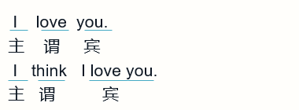

1. **宾语从句的时态：**

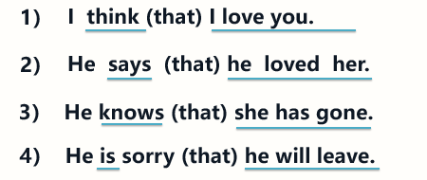

**结论 1：主句一般现在，从句任何时态。**

Miss Marsh:“I feel very tired and I don’t want to make another film”.

**一般现在：主语+ v.**

Miss Marsh told reporters she felt tired and she didn’t want to make another

film.

**一般过去：主语+was\were\did**

**结论 2：主句一般过去，从句相应过去。**

**从句原时态(直接引语) 从句变后时态(间接引语)**



一般现在

一般过去

现在完成

过去完成

一般过去

过去完成

一般将来

过去将来

Susan says:“I am still at home.” **一 般 现 在 ： 主 语 + is\am\are** Susan said she was still at home. **一般过去：主语+ was\were**

Susan says:“I did my job well.”

**一般过去：主语+ did**

Susan said she had done her job well.

**过去完成：主语+ had+ done**

Susan says:“I have had breakfast.”

**现在完成：主语+ have+ done**

Susan said she had had her breakfast.

**过去完成：主语+ had+ done**

Susan says:“I am going to visit Xiamen.” **一 般 将 来 ： 主 语 + is\am\are going to** Susan said she was going to visit Xiamen. **过去将来：主语+ was\were going to**

Miss Marsh:“ Yes, I have just made a new film”.

**现在完成：主语+ have(has)+ done**

Miss Marsh told me that she had just made…

**过去完成：主语+ had+ done**

Miss Marsh:“No, I am not going to make anther”.

**一般将来：主语+ is\am\are going to**

Miss Marsh told me that she was not going to …

**过去将来：主语+ was\were going to** Miss Marsh: “I am going to retire”. **一般将来：主语+ is\am\are going to**

Miss Marsh told me that she was going to …

##### 过去将来：主语+ was\were going to 宾语从句的时态：

**结论 1：主句一般现在，从句任何时态。结论 2：主句一般过去，从句相应过去。**

**Lesson 133 课文讲解**

1. **Have you just made a film?**

make a film: 拍电影

拍照片: take a photo

##### I don’t want to make another film for a long time.

or a long time: 长达很久早就…

##### By our reporter, Alan Jones…

by: 由 …

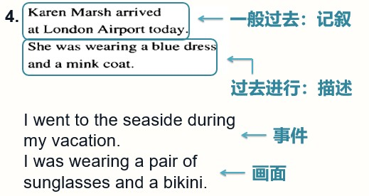This picture book is written by Anthny Brown.

**一般过去时态 → 叙事 → 事件过去进行时态 → 描述 → 画面**

**5. I wonder why.**

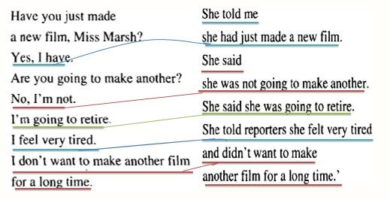wonder: want to know.

##### Lesson 134 单词句型讲解

1. **模仿例句回答以下问题。**
   1. 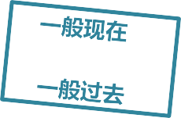**I’m busy. – What did he say?**

***He said he was busy.***

* 1. **She’s cold.- What did he say?**

***He said she was cold.***

1. 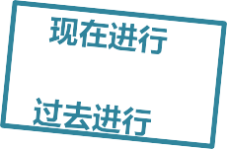**模仿例句回答以下问题。**
   1. **I’m working. -What did he tell you?**

***He told me he was working*.**

* 1. **She’s leaving. – What did they tell you?**

***They told me she was leaving.***

* 1. **They’re joking. – What did she tell you?**

***She told me they were joking.***

1. 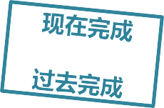**模仿例句回答以下问题。**
   1. **I’ve met him. -What did he tell you?**

***He told me he had met him.***

* 1. **I’ve lost it. – What did he tell you?**

***He told me he had lost it.***

* 1. **It has stopped. – What did she tell you?**

***She told me it had stopped.***

**Lesson 133&134 知识拓展**

**新闻英语：**

1. **新闻：news\ press**
2. **记者：reporter\ journalist**
3. **八卦：gossip**
4. **娱乐新闻：entertainment news**
5. **网络媒体： internet media**

**Lesson 135&136 预习**

1. **语法：宾语从语-时态的变化;**
2. **时态总复习。**

**Lesson 135 单词讲解**

1. **future['fjuːtʃə(r)]: n. 未 来**

**adj. 未来的**

Do you really care about your future?

She is his future wife.

##### get married [ɡet 'mærɪd] : 结婚

They got married last year. 他们去年结婚。娶，嫁：marry- married- married

Will you marry me?

**marry sb. 娶了…嫁给了…** Sam married Lucy last year. Lily married John last week. **married adj. 已婚的**

I’m married.

##### single adj. 单身的

She is single. She is not married.

##### hotel [həʊ'tel] : n.饭店

five-star hotel

five stars hotel

##### latest ['leɪtɪst] : adj.最新的

late- later- the latest the latest news

her latest song his latest movie

##### introduce [ˌɪntrə'djuːs] : v.介绍introduce A to B

He introduced his friend to me. May I introduce myself?

##### Lesson 135 语法讲解

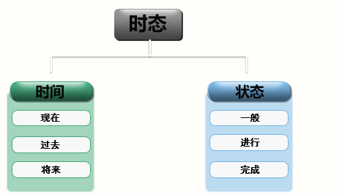

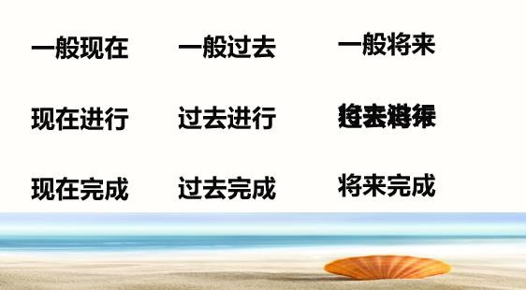

**一般现在时态：**

1. **何时用？**
   1. 经常的状态；
   2. 习惯的动作；
   3. 真理。

##### 结构？

* 1. 经常的状态： 主语+ is \am\ are
  2. 习惯的动作： 主语+ v. （动词）
  3. 真理。主语+ is \am\ are, 主语+ v.（动词） They are very bad.

They often cheat in the exams.

The earth is round.

The sun rises in the east.

##### 动 词 :

**主语+ v.（动词）**

主语为非三单 + 动词原形主语为三单 + 动词 s\es

He loves his girlfriend very much.

Jim and Lily walk to school every day.

They drink beer every night.

My dog watches TV at night.

##### 疑问？

He is an IT worker. Is he an IT worker?

They drink beer every night. Do they drink beer every night?

He loves his girlfriend very much. Does he love his girlfriend very much?

##### 先看词性，再看人称

1. **否定？**

He is an IT worker.

He isn’t an IT worker.

They drink beer every night.

They don’t drink beer every night.

He loves his girlfriend very much.

He doesn’t love his girlfriend very much?

**现在进行时态:**

1. **何时用？**

此时此刻正在做。

##### 结构：

主语+ is\am\are + doing

##### 动词？

* 1. 一般+ing；
  2. 以不发音的 e 结尾, 去 e +ing;
  3. 辅+元+辅（汉堡包结构）,双写辅音字母+ing,除 opening.

##### 一般疑问:

**Is/Am/Are+ 主语+doing？**

Are they walking?

No, they are not.

They are running.

##### 否定句:

**主语+ is/am/are+ not +doing**

They are not walking.

They are running.

**现在完成时态:**

1. **何时用？**
   1. 截止现在已经完成；
   2. 表示持续。
2. 结构：主语 + has\have + done 主语 + has\have + been+非动词

##### 动词？

1. 一般情况+ ed, call—called; air— aired；
2. 以字母 e 结尾+ d, live—lived; love—loved；
3. 以辅音字母+ y 结尾,变 y 为 i +ed, try—tried; study—studied；
4. 辅+元+辅（汉堡包结构),将辅音字母双写+ed,

stop—stopped.

我已经给房间通过风了。I have aired the room.

他已经看完这部电影了。He has watched the movie.

他们住在北京已经 10 年了。They have lived in Beijing for ten years.

##### 疑问句、否定句：

疑问句：have\ has 提前否定句：have\ has + not

你已经给房间通过风了吗？Have you aired the room?

他已经看完这部电影了吗？Has he watched the movie?

他们住在北京 10 年了吗？Have they lived in Beijing for ten years? 你没有给房间通过风。You have not aired the room.

他没有看完这部电影了。He has not watched the movie.

他们没有住北京 10 年.They have not lived in Beijing for ten years.

**一般过去时态:**

1. **何时用？**
   1. 过去经常的状态：
   2. 过去习惯的动作：

##### 结构：

* 1. 过去经常的状态：主语+ was\were
  2. 过去习惯的动作：主语+ v.（动词过去式）

##### 动词?

1. 一般情况+ ed, call—called; air— aired；
2. 以字母 e 结尾+ d, live—lived; love—loved；
3. 以辅音字母+ y 结尾,变 y 为 i +ed, try—tried; study—studied；
4. 辅+元+辅（汉堡包结构),将辅音字母双写+ed, stop—stopped. 我 2010 年在美国学习。I studied in the US in 2010.

公车刚刚停下来了。The bus stopped just now.

##### 疑问句、否定句：

疑问句：was\were 提前

Did + 动 词 ？ 否定句：was\were+ not

did not + 动 词

**过去进行时态：**

* 1. **功能：**过去某一时刻、时段正发生的动作
  2. **结构：**主语 + was\were + doing

She was doing her homework at 10:00 last night.

They were having a date from 7:00- 9:00 yesterday.

##### 疑问形式：was\ were 提前

She was doing her homework at 10:00 last night. Was she doing her …?

##### 否定形式：was\were+ not

They were having a date from 7:00- 9:00 yesterday.

They were not having a date …

**过去完成时态：**

1. **功能：**过去某一时刻之前发生的动作、状态
2. **结构：**主语 + had + done

She had done her homework before 10:00 last night.

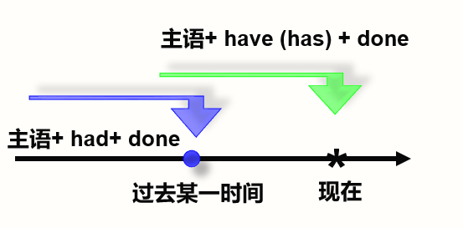

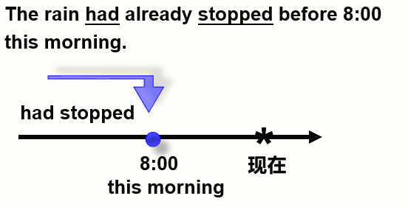

##### 疑问形式：

had 提 前

He had left by the time I arrived. Had he left by …?

##### 否定形式：

had + not

He had left by the time I arrived.

He had not left by the time I arrived.

**一般将来时态：**

* 1. **功能：**表示计划、打算或即将要发生的事；
  2. **结构：** 主语 + is\am\are going to 主 语 + will\shall+ v.

主语+ is\am\are going to

* + - 你会迟到的。You will be late.

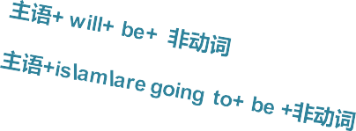

* + - 演讲者将是我们的老朋友约翰。

The speaker will be our old friend, John.

* + - 明天天气晴好。

It’s going to be fine tomorrow.

* 1. **疑问句：**will\is\am\are 提前
  2. **否定句：**will\ is\am\are+ not
     + He will come on time. Will he come on time?
     + The woman is going to talk to you. Is the woman going to talk to you?
     + He will show his true colors someday.

Will he show…?

* + - You will be late.

You will not be late.

* + - The woman is going to talk to you.

The woman is not going to talk to you.

**过去将来时态：**

1. **功能：**表示过去的计划、打算或即将发生的事；
2. **结构：** 主语 +was/were+ going to 主 语 + would+ v.

* 那年他 20 岁了，三年后他是 23 岁。

He was 20 years old at that time.

In three years, he would be 23 years old.

* 他昨天告诉我他会来北京的。

He told me he would come to Beijing.

##### Lesson 135 课文讲解

**直接引语- 间接引语**

**宾语从句**

**从句原时态(直接引语) 从句变后时态(间接引语)**

**一般现在现在完成一般过去一般将来**



**一般过去过去完成过去完成过去将来**

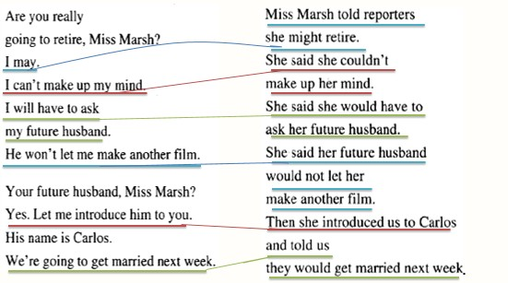**从句原情态动词(直接引语) 从句变后情态动词(间接引语)**

**Can Will**

**be going to may**



**could would would might**

1. **Miss… told reporters, “I may retire”.**

**Miss… told reporters she might retire.**

1. **She said, “I can’t make up my mind”.**

**She said she couldn’t make up her mind.**

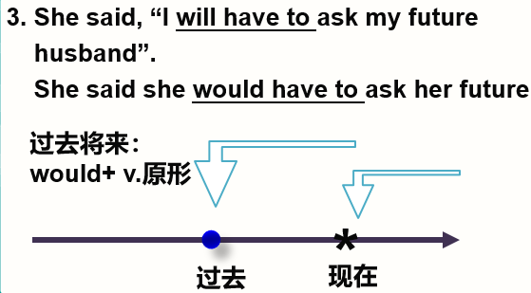

1. **She said, “he won’t let me make another …”. She said her future husband wouldn’t let…** let sb. do: 让…做

Let us go. \ Let me see

##### He’ll be her sixth husband. 他将会是她的第六任丈夫。

**Lesson 136 单词句型讲解**

1. **1. Penny will open the window. What did he say?**

He said Penny would open the window.

##### 1. I can understand English. What did he tell you?

He told me he could understand English.

##### 1. They may arrive tomorrow. What did they say?

They said they might arrive tomorrow.

##### Lesson 135&136 知识拓展

**酒店相关：**

1. 五星级酒店：five-star hotel
2. 度假村: resort
3. Do I need to pay a deposit？我需要付押金吗？
4. Do you offer pick-up service? 请问有接车服务吗？

##### Lesson 137&138 预 习

**1. 语法：状语；条件状语；条件状语从句**

**Lesson 137 单词讲解**

1. **football ['fʊtbɔːl] : n. 足 球**

**soccer**

 **football**

##### pool [puːl] : n. 赌 注

**a swimming pool: 游泳池**

1. **win [wɪn] : v. 赢**win- won- won win-lose

They have won the game.

##### world [wɜːld] : n. 世 界

in the world: 在世界上

He is the shortest man in the world.

##### poor [pʊə(r)] ：adj. 贫穷的、可怜的

1. **depend [dɪ'pend] : v. 依 靠depend on sb.\ sth.**

He is a man whom you can depend on.

Children depend on their parents for food and clothing.

##### Lesson 137 语法讲解

**条件状语从句**

1. **什么是状语：用来修饰、说明谓语的部分。主语**



**谓语**

**宾语**

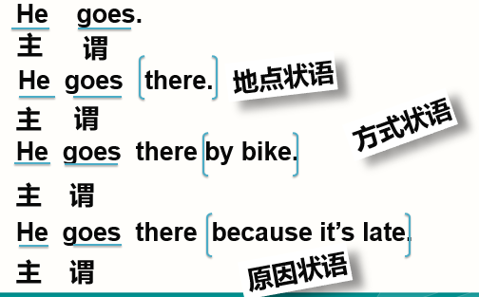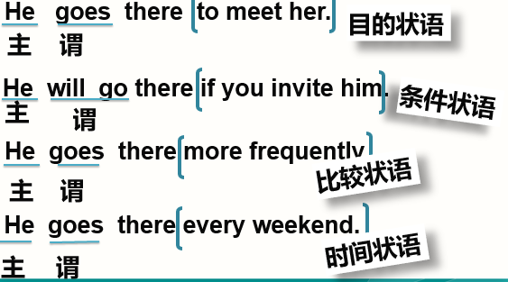

1. **条件状语从句：句子作条件状语**

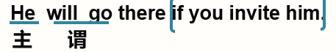

If you invite him, he will go there.

##### 主句+ if+ 从句If+ 从句，主句

If there is anything you need , I will not be far away . 如果你需要，我就在你身边。

If money is not your servant, it will be your master.

如果钱不是你的奴仆，它将成为你的主人。

##### 条件状语从句的时态时态 1：主将从现

**如果明天不下雨，我们就出发。**

If it doesn’t rain tomorrow, we will start out.

##### 如果下周有时间，他就来看你。

If he has enough time next week, he will come to see you.

##### If you are the smartest person in the room, you must be in the wrong room.

如果你是这个房间里最聪明的人，你一定呆错房间了。

##### If you promise to keep a secret, I can tell you the truth.

如果你能保守秘密，我可以告诉你真相。

**时态 2：主情从现**

**If you want something said, ask a man.**

**If you want something done, ask a woman.**

**Margaret Thatcher**

**时态 3：主祈从现**

**Lesson 137 课文讲解**

1. **Are you doing the football pools?**

doing the football pools: 下赌注

##### You always say that. 你老是这么说。

You always do that\so.

##### What will you do if you have a lot of money? I will (_一般将来) if (_一般现在) .

**If I will .**

如果我有很多钱，我就去环游世界。

I will travel round the world if I have ... 如果我有很多钱，我就什么都不做。

I will do nothing if I have ....

##### I don’t want a mink coat.

我才不想要貂皮大衣呢！

##### We will travel round the world and stay at the best hotels.

travel round the world: 环球旅行stay at the best hotels: 住最好的酒店住：live, I live in Beijing. (长期居住)

##### Everything depends on “if”.

一切取决于时间。

Everything depends on time. 一切取决于钱。

Everything depends on money.

##### Lesson 137 单词句型讲解

**B. 模仿例句回答以下问题：**

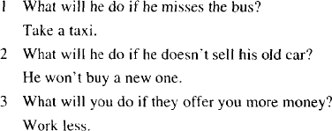

1. If he misses the bus, he will take a taxi.
2. If he doesn’t sell his old car, he won’t buy a new one.
3. If they offer you more money, you will work less.

##### C. 模仿例句改写以下句子：

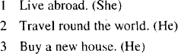

1. She can live abroad if she is rich.
2. He can travel round the world if he is rich.
3. He can buy a new house if he is rich.

##### Lesson 137&138 知识拓展

1. The football match will be put off if it next week.
   1. will rain
   2. rains

#### 

√

* 1. rained D. is going to rain

1. Difficulties will be nothing if we not afraid of them.

√

* 1. will B. shall C. are D. were

#### 

1. Be careful, if you want to make mistakes.
   1. won’t B. don’t C. didn’t

√

#### 

1. There is going to a sports meeting next week. If it , we’ll have to

cancel it.

* 1. be; will rain B. have; will rain

√

C. be; rains D. give; is going to rain

#### 

##### Lesson 139&140 预 习

**1. 语法：宾语从句（语序，引导词，识别，否定前移）**

**Lesson 139 单词讲解**

1. **extra['ekstrə]: adj.额外的extra work： 额外的工作**加班：do some extra work

I have to do some extra work today.

##### extra class： 课外班

The boy has a lot of extra classes.

##### engineer [ˌendʒɪ'nɪə(r)] : n.工程师

an engineer

##### overseas [ˌəʊvəˈsiːz] : adj.海外的，国外的

an overseas friend\company abroad, adv. 在国外

go\ study\ travel\ live abroad

##### engineering [ˌendʒɪ'nɪərɪŋ] : n. 工 程

不可数

art\ music\ science\ chemistry…

##### company ['kʌmpəni] : n.公司

1. **line [laɪn] : n.线路**subway Line 13 subway Line 10

##### Lesson 139 语法讲解

**宾语从句**

1. **什么是宾语从句：句子作宾语。**
2. **宾语从句的时态：**
   1. **主句一般现在，从句任意时态**
   2. **主句一般过去，从句相应过去**
3. **宾语从句的种类：**

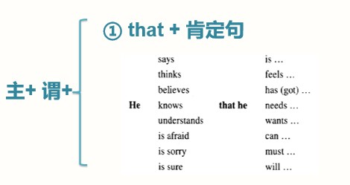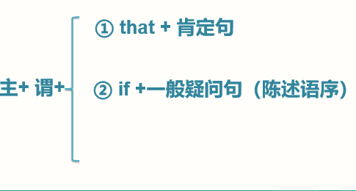

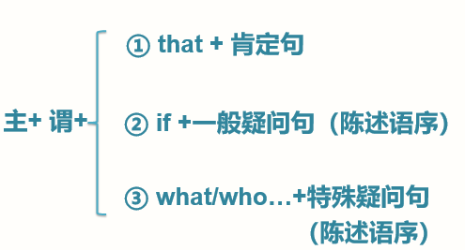

1. **语序：陈述句**

**If+一般疑问句（陈述语序）** 他是医生吗？Is he a doctor? 我想知道他是医生吗.

I want to know _**if** he is a doc.tor

他们以前在北京吗？Were they in Beijing? 我想知道他们以前在北京吗.

I want to know _**if** t_h_ey_were in B. eijing

他打算去吗？Will he go there? 我想知道他打算去吗.

I want to know **if** he w_i_l_l _go. there.

你看过这部电影吗？Have you watched the movie? 我想知道你看过这部电影没.

I want to know  **if** y_ou h_av_e wa_t_c_h.ed the movie.

你喜欢红色吗？Do you like red? 我想知道你喜欢红色吗.

I want to know _**if** y_ou l_ike_.red

他昨天去上海了吗？Did he go to SH yesterday? 我想知道他昨天去上海了没.

I want to know **if** h_e we_nt_t.o SH

**What/who…+特殊疑问句（陈述语序）**

他是谁？Who is he? 我想知道他是谁.

I want to know _wh_o he is .

你昨天在哪？Where were you yesterday? 我想知道你昨天在哪.

I want to know _wh_ere yo_u we_r_e y_e_.sterday

他什么时候回来？When will he come back? 我想知道他什么时候回来.

I want to know _wh_en h_e wi_ll come__ba.ck

你读过什么书？What books have you read? 我想知道你读过什么书.

I want to know _wh_at_bo_ok_s y_o_u ha_v_e__r_e_a_d_.

他喜欢哪辆车？Which car does he like? 我想知道他喜欢哪辆车.

I want to know _wh_i_ch car_he li_k_es__.

你喜欢什么礼物？What present do you like? 我想知道你喜欢什么礼物.

I want to know wha_t p_r_e_s_en_t y_o_u l_i_k_e.

##### 如何识别宾语从句：

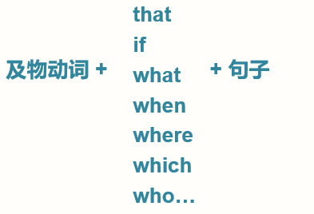

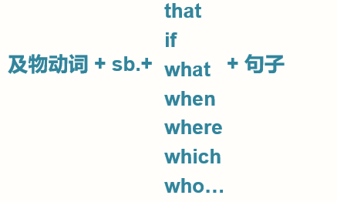

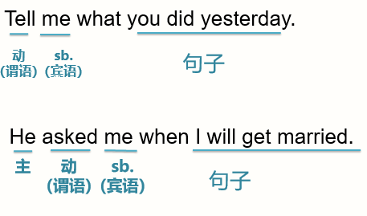

1. **宾语从句总结:**
2. 什么是宾语从句： 句子作宾语。
3. 宾语从句的时态：
   1. 主句一般现在，从句任意时态
   2. 主句一般过去，从句相应过去
4. 语序：陈述句
5. 宾语从句的种类：that /if /what /who…
6. 如何识别宾语从句？
7. 否定前移

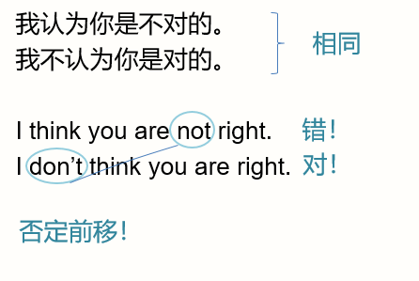

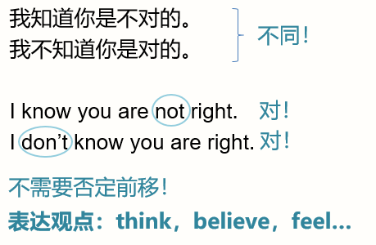

##### Lesson 139 课文讲解

1. **电话用语**

**你是 Lucy 吗？**Are you Lucy? Is that Lucy? Is that you, Lucy?

##### 我是 Venus. I’m Venus. This is Venus. \ It’s Venus.

-Is that you, …?

-Yes, speaking. 是的，请讲。

##### Tell Mary we'll be late for dinner this evening.

**宾语**

**be late for…**

He is late for class.

They were late for meeting yesterday.

##### I'm afraid I don't understand.

I’m sorry…

##### Hasn't Mary told you?

Has … told you?

1. **I said I would be at your house at six o'clock**.

**宾语**

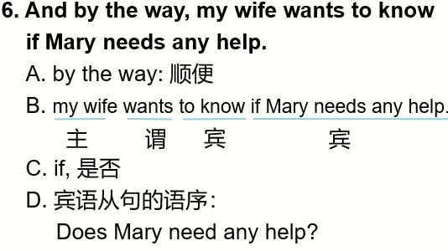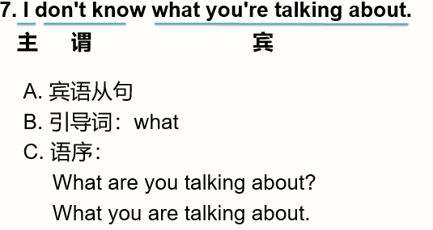

**Lesson 140 单词句型讲解**

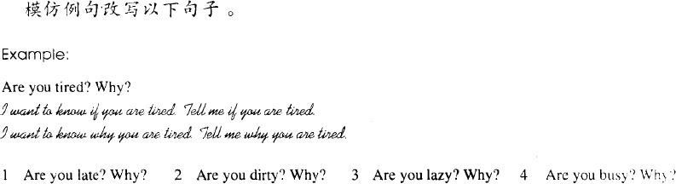

**1. I want to know if you are late.**

**Tell me if you are late.**

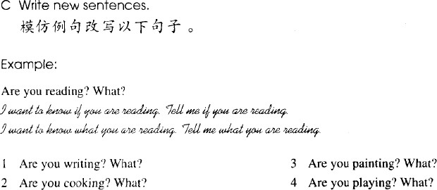**I want to know why you are late. Tell me why you are late .**

**1. I want to know if you are writing. Tell me if you are writing.**

**I want to know what you are writing.**

**Tell me what you are writing .**

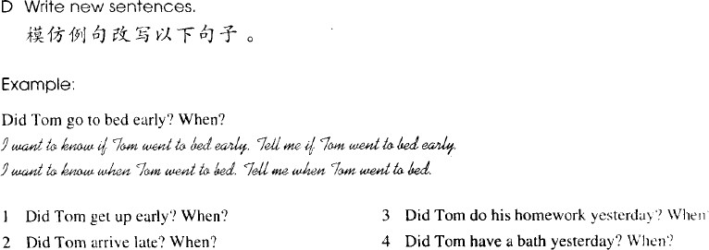

**1. I want to know if Tom got up early. Tell me if Tom got up early.**

**I want to know when Tom got up. Tell me when Tom got up.**

**Lesson 139&140 知识拓展**

**宾语从句在口语中：**

1. **我不知道你在说什么。**

**I don’t know what you are talking about.**

1. **我忘记早饭吃了什么。**

**I forget what I had for breakfast this morning.**

1. **我想知道她在干嘛。**

**I want to know what she is doing.**

**Lesson 141&142 预 习**

1. **语法：被动语态；**
2. **词汇：-ing，-ed 形容词。**

**Lesson 141 单词讲解**

1. **excited [ɪk'saɪtɪd] : adj. 兴奋的exciting [ɪk'saɪtɪŋ] : adj. 令人兴奋的**
   * interested; interesting

（感兴趣的；令人感兴趣的)

* + moved; moving

（感动的; 令人感动的）

* + surprised; surprising

（惊讶的; 令人惊讶的)

He was excited. 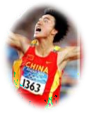 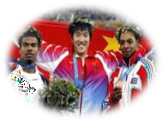

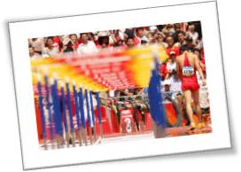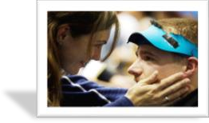It was surprising.

ａmoving moment

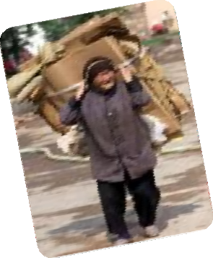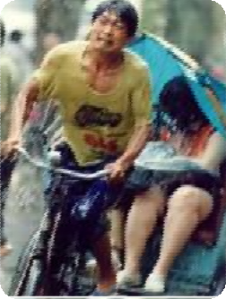

moving pictures…

这部电影真让人感动啊. This movie is moving. 她感到特别惊讶. She is surprised.

这个人真有趣! This man is interesting.

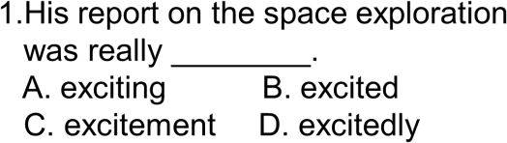

√

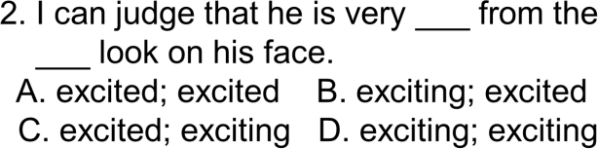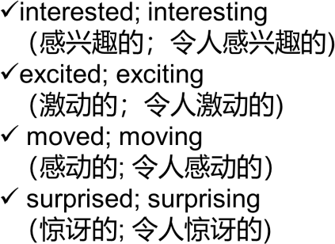√

##### get on: 登 上

get in: 上 车

##### middle-aged ['mɪdl eɪdʒd] : 中年的

一位中年女士：a middle-aged lady 老年的：elderly people.

##### opposite ['ɒpəzɪt] : 在…的对面

prep. 介 词

He is sitting opposite me.

##### curiously ['kjʊəriəsli] : adv.好奇地

curious: adj. 好奇的

He was curious about everything he saw.

**be curious about…**

1. **funny ['fʌni] : adj. 可笑的、滑稽的**

稍有贬义色彩

He closed his speech with a funny joke. 他用一则有趣的笑话结束了演讲。

##### powder ['paʊdə(r)] : n. 香 粉

I'm just going to powder my nose.

##### compact ['kɒmpækt] : n. 带镜的化妆盒

1. **kindly ['kaɪndli] : adv. 和 蔼 地**

She smiled kindly.

##### ugly ['ʌɡli] : adj. 丑陋的

1. **amused [ə'mjuːzd] : adj. 有趣的**

I had an amusing experience last year. interesting: 激发人兴趣的

##### smile [smaɪl] : v. 微 笑

He said with a smile.

##### embarrassed [ɪm'bærəst] : adj. 尴尬的，窘迫的

**embarrassing [ɪm'bærəsɪŋ] : 令人尴尬的**

**Lesson 141 语法讲解**

**被动语态**

1. **什么是被动语态：**

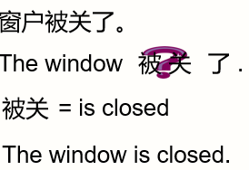

1. **被动语态的构成:**

be+done

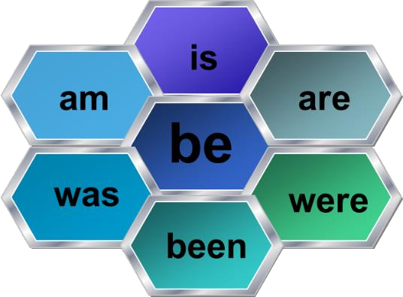 +done



**being**

##### 被动语态的时态： 一般现在时的被动

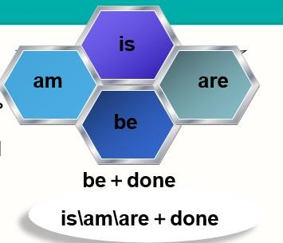

**他被杀了**

**He 被 kill 了 。被 杀 =is killed He is killed.**

**一般过去时的被动**

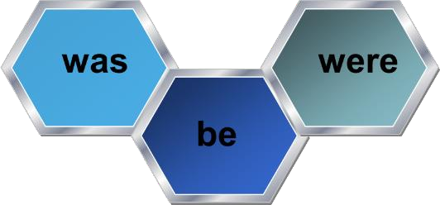**+done**

**他昨晚被杀了**

**He 被 kill 了 last night. 。昨晚被杀=was killed**

**He was killed last night.**

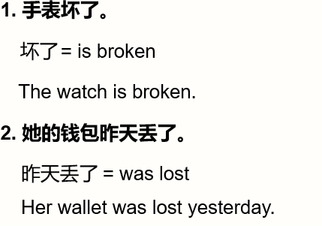

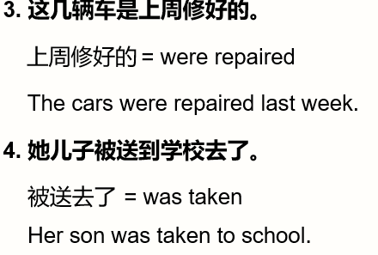

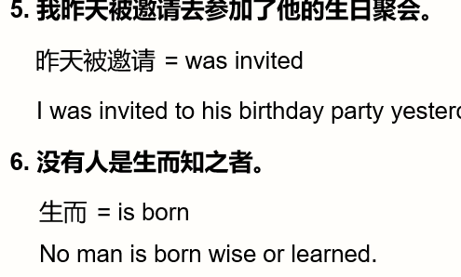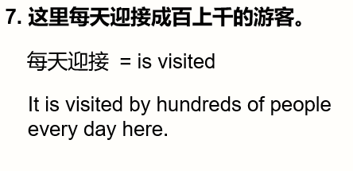

**何时使用被动语态：**

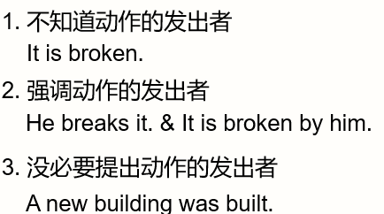

1. **惯用的被动语态：**

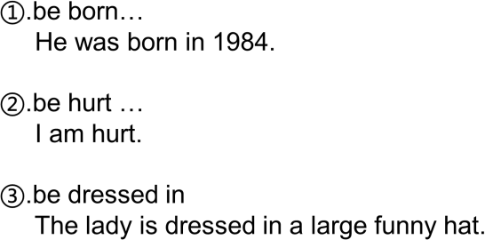

**Lesson 141 课文讲解**

1. **my four-year- old daughter 我四岁的女儿**

My daughter is four years old.

##### a children’s party: 儿童聚会

工人俱乐部：a workers‘ club

学生阅览室：a students‘ reading room.

##### I decided to take her by train. 我决定带她坐火车去。

**decide to do … 决定做……**

She decided to rent out a room to get extra income.

她为获得额外收入决定租出一个房间。

##### Sally was very excited, because she had never traveled before.

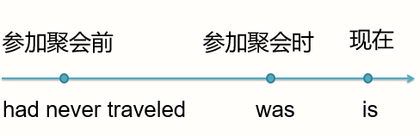

1. **She sat near the window and asked questions about everything she saw. everything she saw: 她所见到的一切**

他所做的一切: everything he did 他所说的事情: something he said 他所留下的一切: everything he left

##### The lady was dressed in a blue coat and a large funny hat.

**be dressed in… 穿着…**

He was dressed in a pair of black jeans.

##### After the train had left the station, the lady opened her handbag and took out her powder compact.

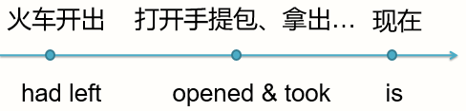

1. **She then began to make up her face. make up one’s face: 化 妆**
2. **To make myself beautiful.**

**为了把自己打扮的漂亮。to… 表示目的**

I am coming to see you.

I learn English to go abroad.

He did that to make her happy.

##### Lesson 142 单词句型讲解

1. **worried ['wʌrid] : adj. 担心，担忧的**

worry: v. 担心，担忧

Don't be worried about the exam. Don’t worry about the exam.

##### regularly ['reɡjələli] : adv. 经常的、定期的

usually: 通 常

It’s important to exercise regularly**.**

##### 用主动语态和被动语态两种形式来回答以下问题。

* + 1. Does anyone ever air this room? Someone airs it regularly.

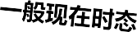

This room is aired by someone regularly.

* + 1. Does anyone ever clean these rooms? Someone cleans these rooms regularly.

These rooms are cleaned by someone regularly.

* + 1. Does anyone ever empty this basket? Someone empties it regularly.

It is emptied by someone regularly.

* + 1. Does anyone ever sharpen this pencil? Someone sharpens it regularly.

It is sharpened by someone regularly.

##### 模仿例句回答以下问题。

* + 1. Did anyone water these flowers? Someone watered these flowers regularly. They were watered by someone regularly.
    2. Did anyone repair this car?

Someone repaired this car regularly. It was repaired by someone regularly.

* + 1. Did anyone dust this cupboard? Someone dusted it regularly.

It was dusted by someone regularly.

* + 1. Did anyone correct these exercise books? Someone corrected them regularly.

They were corrected by someone…

##### Lesson 141&142 知识拓展

1. a new building in our school last year?

√

* 1. Is, built B. Was, built

#### 

C. Does, built D. Did, build

1. — Did you go to Jack’s birthday party?

— No, I .

* 1. am not invited B. haven’t invited

C. wasn’t invited D. didn’t invite

√

#### 

**被动语态的否定句：be+ not+ done**

**被动语态的疑问句：be 提前**

屋子收拾干净了没？ Was the room cleaned?

那封信还没有发出去。

The letter was not sent out.



This seat is taken.

The tea is served. Lost time is never found again.

岁月流逝，一去不返。

A liar is not believed when he speaks the truth.

说谎者即使讲真话也没人相信。Rome is not built in a day.

冰冻三尺非一日之寒。

##### Lesson 143&144 预 习

1. **语法：被动语态；**
2. **总结。。**

**Lesson 143 单词讲解**

1. **surround [sə'raʊnd] : v.包围**

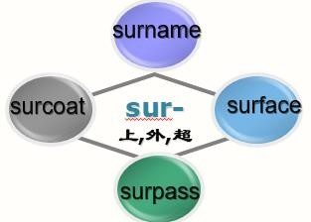

**be surrounded by**

The village is surrounded by many tall trees.

##### wood [wʊd] : n.树林forest 森 林

1. **beauty spot : 风景点**

**There are many beauty spots in Beijing.**

1. **hundred ['hʌndrəd] : n.百**

one hundred two hundred

hundreds of …成百上千的

thousands of…成千上万的

millions of…不计其数的

##### city ['sɪti] : n.城市

cities

##### through[θruː] : prep.穿过，立体across 平面

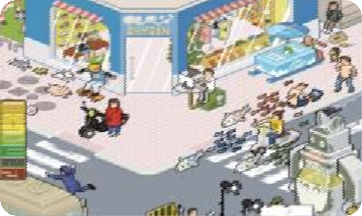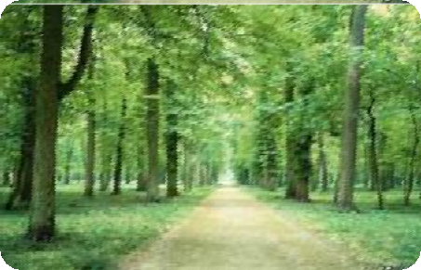

across the street through the forest

##### visitor['vɪzɪtə(r)] : n.参观者，游客，来访者

visit- visitor

##### tidy ['taɪdi] : adj.整齐的

untidy

##### litter ['lɪtə(r)] : n.杂乱的东西 v. 乱扔

1. **litter basket : 废物筐**
2. **place [pleɪs] : v.放**

put

Put it on the table.

I’ll place the table in the middle of the room.

1. **throw [θrəʊ] : v.扔，抛**throw- threw- thrown throw away sth.

You can throw away the old books.

##### rubbish['rʌbɪʃ] : n.垃圾

trash n. (美式)

##### count[kaʊnt] : v.数，点

The baby can count from one to twenty. count sb. in: 把…算进去

Count me in. 算我一个。Count Sam in. 把 Sam 算进去。

##### cover['kʌvə(r)] : v.覆盖

be covered with…

The trees are covered with heavy snow.

##### piece[piːs] : n.碎片put it into pieces

1. **tyre['taɪə(r)] : n.轮胎18.rusty['rʌsti] : adj.生锈的19.among[ə'mʌŋ] : prep.在…之间**

between, 两者之间

Just between you and me.

北京，上海，广州，你最喜欢哪个城市？ Which one do you like best among…?

##### 20. prosecute ['prɒsɪkjuːt] : v.依法处置

被依法处置： be prosecuted

He is prosecuted.

They were prosecuted last week.

##### Lesson 143 语法讲解

**被动语态**

1. **被动语态的结构**

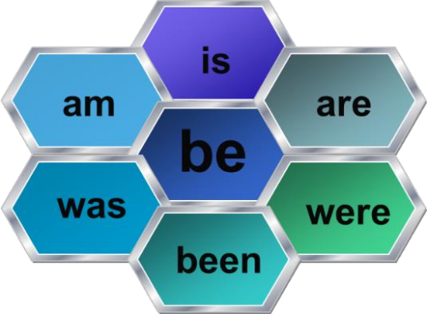 **+ done**



**being**

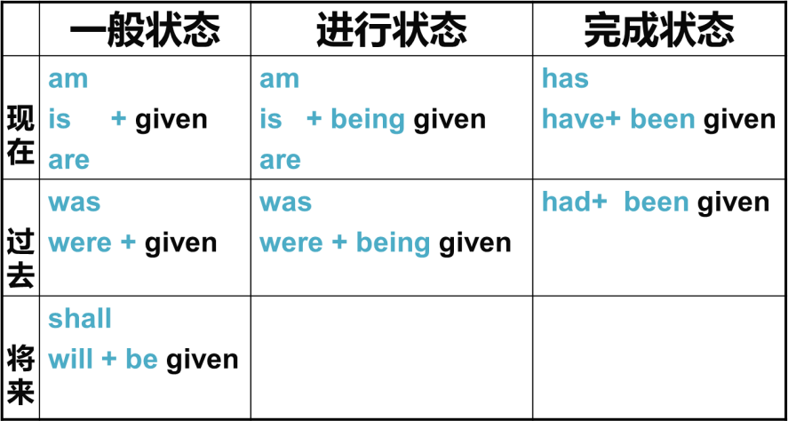

##### 被动语态的时态

**现在完成时的被动：have/has +been+done 他已经被杀了**

**He 已 经 被 kill 了 。被杀= ？ killed**

**He has been killed.**

**一般将来时的被动：will + be +done 他将要被杀了**

**He 将 要 被 kill 了 。被杀= ？ killed**

**He will be killed**

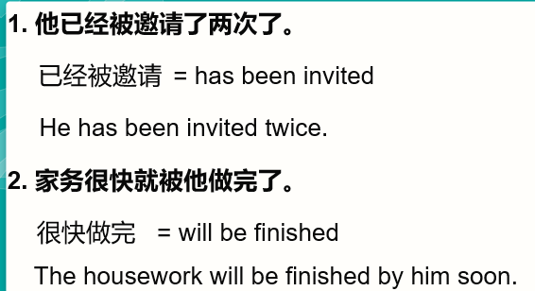

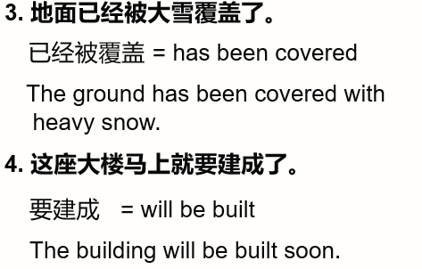

**Lesson 143 课文讲解**

1. **a walk through the woods**

林中漫步

a walk on the road

##### 我住在一个古老的镇上。这个镇被一个美丽的小树林围绕。

I live in an old town. The town is surrounded by beautiful woods.

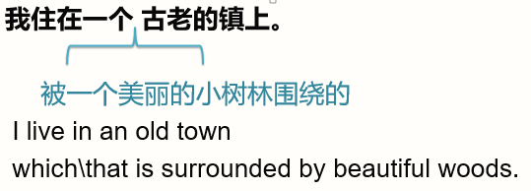

##### On Sunday 在周日

**On Sundays 每逢周日**

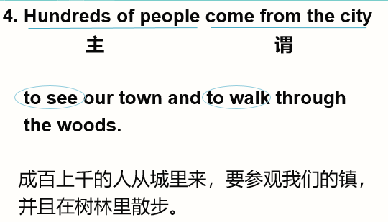

1. **Visitors have been asked to keep the woods clean and tidy.**

have been done :已经被keep sth. + adj. 保 持 … 保持教室干静整洁

keep the classroom clean and tidy.

##### Litter baskets have been placed under the trees, but people still throw their rubbish everywhere.

have been done: 已经被…

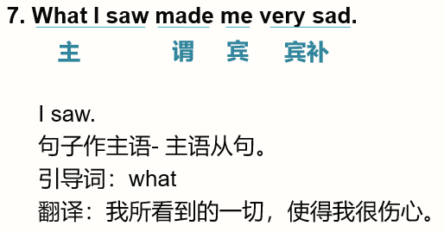

##### 我所听到的一切，使我很愤怒。

**What I heard made me very angry.**

**他所做的一切，使我很开心。**

**What he did made me very happy.**

**他所学到的一切，使他很智慧。**

**What he studied made him very intelligent.**

1. **The litter basket was empty and the ground was covered with pieces of**

**paper, cigarette ends,…**

**be covered with… 被覆盖**

The ground was covered with snow.

cigarette ends 烟 头

##### I found a sign which said, “ ” 我发现一个牌子，上面写着…

我收到一张明信片，上面写着 “我想你”。

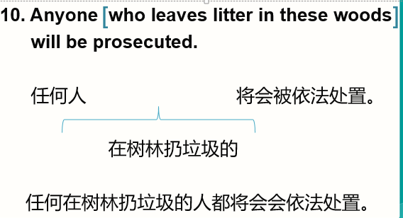I got a postcard which said, “ I miss you”.

##### Lesson 144 单词句型讲解

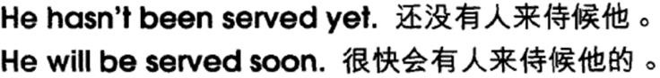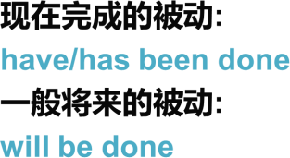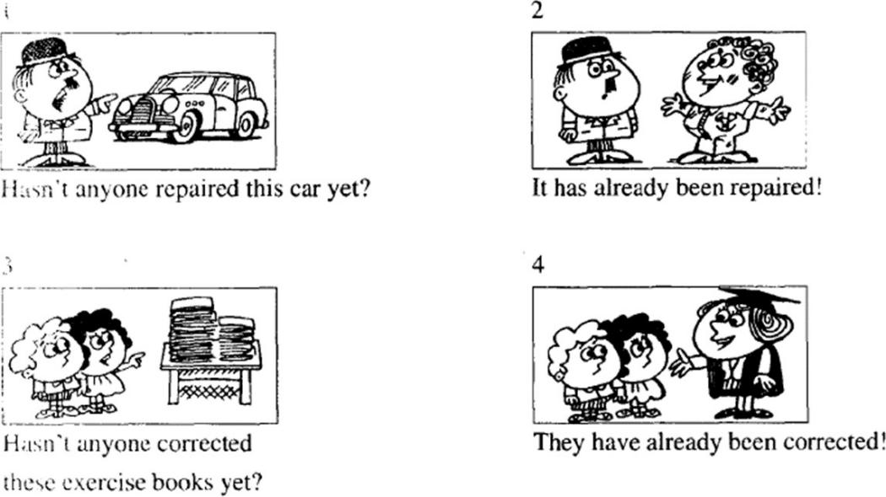

**Lesson 143&144 知识拓展**

**新概念一册学习总结：**

1. 整本书的体系：

1- 30 、31-98、99-144

1. 重点：词法,句法,时态；
2. 单词：慢慢记；
3. 练习：题+ 口译笔译。